A literature review for cognitive science in education.

_________________________________________________________________________

ANALYSIS OF INTRINSIC MOTIVATION DURING

A PROBLEM-SOLVING ACTIVITY
_________________________________________________________________________

French version of the text
Lola Denet
Inria Mnemosyne Team
Translation into English
Axelle Napala
Ginna Kurmen
INSPÉ- Côte d'Azur University.
MSc SmartEdTech.



Table of contents
Introduction 3
1 From cognition to human learning 4
1.1 Learning: a process and the object of a multidisciplinary study 4
1.1.1 Neurosciences 4
1.1.2 Educational sciences 5
1.1.3 Neuroeducation 5
1.2 Cognition: generalities 6
1.2.1 Cognition and learning 6
1.2.2 Knowledge and belief 6
1.2.3 Cognizance and Knowledge 8
1.2.4 Cognizance, competence, and experience 10
1.2.5 Cognizance and information 11
1.2.6 Knowledge and cognition: conclusion 11
1.3 Cognition: mental functions 12
1.3.1 Perception 12
1.3.2 Attention 15
1.3.3 Memories 17
1.3.4 Reasoning 23
1.3.5 Executive functions 33
1.3.6 Language and motor skills 35
1.3.7 Emotions 38
1.3.8 Mental functions: conclusion 43
1.4 Metacognition 44
1.4.1 General information 44
1.4.2 How metacognition works 45
1.4.3 Metacognition: conclusion 47
1.5 De la cognition à l’apprentissage humain: conclusion 47
2 The role of motivation in learning 48
2.1 Learning process 48
2.1.1 Theories of human learning 48
2.1.2 Acquisition methods 56
2.1.3 Problem resolution 58
2.2 Motivation 66
2.2.1 General Information 66
2.2.2 Extrinsic motivation 71
2.2.3 Intrinsic motivation 73
2.3 The role of motivation in human learning: conclusion 75
3 Modeling intrinsic motivation in learning 75
3.1 The involvement of curiosity in learning 76
3.2 Computational models of curiosity 78
3.2.1 Intelligent Tutoring Systems 78
3.2.2 Contextualization of the algorithms 80
3.2.3 Presentation of algorithms 82
3.3 Modeling intrinsic motivation in learning: conclusion 88

Table of figures

1 | The three worlds of cognition | 12
2 | Processing of stimuli (elaboration) | 14
3 | Model of how memory works | 18
4 | Perceptual memory according to the 5 sensory modalities | 19
5 | The interactions of the different memories | 21
6 | Memories and their locations | 22
7 | Memorization process | 23
8 | Guide to the choice of uncertainty theory | 34
9 | Fundamental emotions | 40
10 | Theories of emotional mechanisms | 42
11 | Theory of cognitive evaluation | 43
12 | Cycles of control-monitoring-control of metacognition over time | 47
13 | Fechner's behavioral model | 51
14 | Learning according to constructivism | 54
15 | 21st century skills | 56
16 | The stages of problem-solving according to Gestalt theory | 61
17 | Stages of problem-solving according to the cognitivist theory | 63
18 | Problem-solving based on the General Problem Solver theory Test-Operate-Test-Exit Model | 67
19 | Problem solving based on the General Problem Solver theory and the Test-Operate-Test-Exit model: improved version | 68
20 | Integrative model of motivation | 73
21 | Edward Deci and Richard Ryan's theory of self-determination | 75
22 | Relationship between learning and curiosity | 80
23 | Selection of an activity in the activity space | 99
24 | Zone of proximal development and Flow | 100
25 | Example of an activity graph with evolution of the zone of proximal development | 100

Introduction

This literature review is part of the work carried out within the AIDE (Artificial Intelligence Devoted to Education) exploratory action. The team at the origin of this work allows researchers from digital sciences (computer science and applied mathematics), cognitive neurosciences and education sciences to join forces within this exploratory action to try to understand, within a specific framework, how learners learn.

To do so, a problem solving task (CreaCube) is proposed to the learners in order to collect observable data concerning the task itself, the medium which is used as a learning support in the task, but also the behavior of the learner during the resolution of the problem. The collected information is then formalized in a symbolic way through the development of an ontology. Lisa Roux and her collaborators (Roux et al., 2020) have developed this ontology in order to propose a model of the learner that takes into account the stimuli received, the discovery of affordances , the making of assumptions and the contextual knowledge. In her research report, Lisa Roux (Roux et al., 2020) defines the concepts of beliefs, exploration and exploitation, but also the different types of memories involved in this human learning task. The notions of goals and commitment are also discussed.

In addition, the FLOWERS (FLOWing Epigenetic Robots and Systems) team works on artificial intelligence algorithms whose goal is to propose, in collaboration with educational teams, learning tasks adapted to the learner's level in order to encourage his or her commitment and thus improve his or her progress. At the heart of their approach is the notion of intrinsic motivation.

The work carried out by the FLOWERS team on the implications of intrinsic motivation in human learning offers a new dimension to be integrated into the modeling of the learner initiated by the AIDE exploratory action. This joint work could lead to a better understanding of the functioning of human learning, with the aim of limiting educational inequalities while promoting the involvement of the learner in his education.
The purpose of this review is to explore the research conducted on the learner's intrinsic motivation during learning in order to understand to what extent it is involved. This will contribute to the improvement of the learner model and thus come closer to understanding the mechanisms of human learning.
On the other hand, it is carried out in the context of a research internship in bio-computing with the aim of "analyzing intrinsic motivation during a problem-solving activity". It is, therefore, neither exhaustive nor general, but specific to the domains treated during this internship.

1 From cognition to human learning

How do we learn? This is one of the questions that the AIDE exploratory action tries to answer, in a specific paradigm. But what is learning? How can studying the functioning of the brain have an impact on education? What about digital technologies? To what extent does it intervene in the field of neuroscience and is it at the heart of educational sciences? At this stage, a contextual and conceptual clarification is necessary.

1.1 Learning: a process and the object of a multidisciplinary study

It is complex to define what "learning" is because this process can be analyzed from different perspectives, both epistemological and methodological. Indeed, Sylvain Connac reminds us that the act of learning is "complex, in the sense of an interweaving of different intellectual activities and of knowledge from various disciplines". At the neuro-biological level, he reminds us that the act of learning "is expressed through the intermediary of nearly 100 billion neurons, each neuron being potentially in synaptic connection with 10,000 others, neighboring or distant in the brain" (Connac, 2018).

With the emergence in recent years of artificial intelligence in the field of education, the notion of learning is enriched with a new meaning: the ability for an algorithm to adapt its parameters from data to automatically provide a calculation with the expected properties (Rougier, 2015).

The collaboration between the different fields of research at the origin of this work is then essential to try to understand this complex process. These different disciplines meet in a common interest which is to understand the cognitive mechanisms of the act of learning therefore allowing the professionals of education to better understand this act of learning, with the aim of improving the effectiveness of the tasks proposed to the learners to support their learning.

1.1.1 Neurosciences

In 2018, Jean Frayssinhes and Florent Pasquier (Frayssinhes & Pasquier, 2018) define neuroscience as the set of disciplines related to the study of the brain and identify those that play an important role in educational research. They cite cognitive neuroscience, computational neuroscience, neuropedagogy, and affective and social neurosciences. While cognitive neuroscience attempts to link the nervous system (brain mechanisms) and cognition, neuro-pedagogy allows us to understand the construction of intelligence in the brain as well as the effects of fundamental learning. Regarding affective and social neurosciences, they study the role of emotions and the importance of the social aspect in learning.

Finally, computational neuroscience seeks to develop models to simulate brain function. In the research context of this review, the working hypothesis is that this last discipline (in association with the others) can allow to model the learner during a learning task and consequently to understand the neural-mechanisms involved in learning.

1.1.2 Educational sciences

Philippe Meirieu bases himself on the history of the educational sciences to identify the disciplines they cover. He recalls that the sciences of education were born between 1967 and 1970, in the case of France , with the aim of bringing these disciplines together. Before the creation of the educational sciences, it was pedagogy that focused more on the concrete, practical aspect of education, in a way that cut across disciplines. Then, education was based on development from the point of view of psychology. Today, the educational sciences allow us to work together on the question of "how to learn". Psychology, sociology, anthropology, linguistics, economics, history and philosophy are involved in the educational sciences because they participate in the study of learning. This is in line with what Louis Marmoz of the University of Caen wrote in a concept note for the French review of pedagogy published by the French Institute of Education. The sciences of education therefore constitute a multidisciplinary field of research concerning "educational realities".

1.1.3 Neuroeducation

Cognitive Neuroscience and Sciences of Education merge together through work in neuroeducation related to educational issues. The objective is to better understand how the brain works during learning and to determine better educational methods. On the other hand, neuroeducation allows us to overcome "myths in education, recognized as false beliefs, assertions without empirical basis" (Connac, 2018).

According to the Neuroeducation Research Association, neuroeducation "is a complementary approach to approaches such as cognitivism, constructivism and behaviourism. [...] What distinguishes neuroeducation from other approaches is that it situates its analysis of educational problems at the brain level, using brain imaging techniques".

The areas of research outlined above then take on their full meaning in the establishment of a model of the learner, within a specific task. Indeed, it is necessary to understand what constitutes a learner in his or her globality and complexity in order to try to understand how the learning process works in a specific case.

It is in this sense that the Mnemosyne and FLOWERS teams are joining forces within the AIDE exploratory action. Mnemosyne researchers are working both in the field of neuroscience to better understand how the brain works and in the field of digital science to improve artificial intelligence algorithms based on human functioning.

As part of its research work, the FLOWERS team creates artificial intelligence algorithms in the context of educational sciences. The aim is to promote learning by adapting the level to each learner through the use of these algorithms during dedicated tasks defined in collaboration with teachers.

The association of these teams and their work could lead to a model as close as possible to the human learning process and thus to a better understanding of how learning works in order to try to improve its methods.

1.2 Cognition: generalities

1.2.1 Cognition and learning

The word "cognition" or "cognitive processes" comes from the Latin cognitio which means knowledge or the action of learning (Lieury, 2017). Cognition includes major mental functions such as perception, memory, language, reasoning, executive functions, motor skills, etc. It is also involved in learning and emotions. (Connac, 2018).

Sylvain Connac quotes this definition for the act of learning: "Learning is all at once grasping by the mind, acquiring knowledge, integrating new data into an existing structure, constructing by the transformation of new representations and new knowledge, and modifying a behavior" (Connac, 2018).

Cognition referring to the concept of "knowledge"provokes the following question: what is knowledge? At first, this question may seem useless because this term is commonly used and certainly everyone thinks he or she knows what knowledge is or at least what this word means. However, to define, to give a univocal meaning to the concept of knowledge is more difficult than it seems because according to the point of view, the discipline or the beliefs, knowledge is polysemous. When the subject of research is to understand how a learner learns and when it is approached by different fields of research as it is the case here, including in relation to machine learning, it seems essential to find a univocal definition for this concept in order to establish a common base on which to build and avoid misunderstandings.

1.2.2 Knowledge and belief

According to Christian Godin, knowledge could be: "a mental faculty producing an assimilation by the mind of an objective content previously translated into signs and ideas" (Godin, 2004). This definition refers to the mental functions discussed in the definition of cognition.

In connection with knowledge, Marie Gasc defines the symbolic function as "the capacity to evoke objects or even absent events through mental representations and by means of signifiers to express signifieds" (Gasc, 2016). For this, it is based on the initial definition of Jean Piaget: "specific connection between signifiers and signifieds". An object, an event or a conceptual scheme are examples of signifieds whereas language, a mental image or a symbolic gesture are examples of signifiers.

Another aspect of the definition of knowledge written by Christian Godin specifies for the symbolic function, that it would be "the result of this operation. Knowledge is a symbolic possession of things. It includes an infinity of degrees" (Godin, 2004). The symbolic function would intervene then as the process allowing a signified to become a knowledge in the case where this one can be qualified by signifiers.

It is possible to establish a link with the point of view of Jean Piaget recalled by Jean-Michel Besnier. According to him, knowledge would be "the linking of a subject and an object by the means of an operative structure" (Besnier, 2021).. This can make us think of the structure of a RDF (Resource Description Framework) triplet, a symbolic formalism used during the ontological modeling of the learner in the work introduced previously. In an RDF triplet, the subject is the resource to be described, the predicate is the property applied to the subject and the object is a data property value. Following this reasoning, it would then be possible to represent knowledge in a symbolic way using this method.

Jean-Michel Besnier specifies that "the structures in question may belong: 1/ to the subject; 2/ to the object; 3/ to both the subject and the object; 4/ exclusively to their relation; or 5/ to neither of them". This represents a logical way of explaining the act of knowing that does not completely suit the theory of knowledge because it does not limit itself to describing the structure that conditions the production of truth; it also seeks to evaluate the part that belongs to the subject and the object in the constitution of a knowledge" (Besnier, 2021). In philosophy, an alternative then arises: "either knowledge is only the result of the registration in the subject of information already organized in the external world, or it is produced by the subject who possesses the faculty to arrange the immediate data of perception" (Besnier, 2021).

There are several opposing philosophical currents concerning knowledge and its implications. According to the empiricists, knowledge is not innate, it comes entirely from experience through the intermediary of senses, impressions, ideas. Conversely, rationalists such as Kant and Schopenhauer believe that knowledge is intrinsic to the individual: "It pertains to the Being and the singular" (Frayssinhes, 2019). The positivists indicate that "the knowing subject is unrealistic (outside of reality), knowledge being an extraction of the content of this one" while the constructivists estimate "that the knowing individual creates his own reality, so that it is not external" (Frayssinhes, 2019).

By pursuing research from the philosophical point of view, there is no consensus on a definition of knowledge in a general way (even if it will be possible to arrive at an operational definition a little further on). A definition has however been identified and then refuted by Plato. Knowledge would then be a "true and justified belief" (Chappell, 2019). Philosophers who have tried to complete this definition have come up against various inconsistencies that have caused them to return to the initial definition, even though it is considered incomplete. Plato had refuted it because it is possible that a belief is true without the individual being able to demonstrate it.

Serge Goldman studies the different aspects of belief and makes the link with cognition. He gives a first definition of belief from the point of view of cognitive neuroscience. Belief would then be "a conscious process [intentional] by which a subject adheres to perceptions or elaborations not verified by the senses" (Goldman, 2005). Belief implies the active adoption of a choice". This choice is influenced by the intervention of mental functions such as perception or memory (to mention only these two). Belief takes on different aspects depending on the mental function involved. It is not only influenced by the environment and learning but also by previously acquired knowledge.

The definition of knowledge previously identified says that knowledge is "a true and justified belief". As knowledge would be linked to belief, it results from mental functions and context (environment, socio-cultural milieu, etc.). Belief is therefore subjective, specific to the individual or to a group of individuals. It can be a hypothesis that is objectified by verification, demonstration or observation. Once objectified, it would then become knowledge.

If a belief can become knowledge, it can also remain a belief whether it is true or false. In this sense, it can be perceived as true for the person who believes. Does this then make it individual knowledge that exists only through the prism of that person? More precisely, can a belief perceived as true by a person be qualified as knowledge in an objective way if it is true only for the person who believes it to be true? Moreover, does knowledge necessarily pass through the stage of belief? These different aspects show the difficulty of giving a univocal meaning to knowledge since it is visibly dependent on the context, on prior knowledge and on the mental functions engaged and specific to the individual.

The point of view of the educational sciences on knowledge is also addressed by Jean Frayssinhes in an article in which he distinguishes between different concepts that are often confused: cognizance, knowledge, competence and experience.

1.2.3 Cognizance and Knowledge

According to him, cognizance is constructed by the individual learner (as a knowing subject) and is not absolute. The knowing subject, faced with an external reality, internalizes, understands and appropriates knowledge according to his mental states (thought). Jean Frayssinhes writes that the learner "transforms this knowledge into cognizance" (Frayssinhes, 2019). He specifies that by "building this cognizance, it allows him to have an exact idea of a reality, of its situation, of its meaning, of its characters, of its functioning" (Frayssinhes, 2019). Consequently, cognizance cannot be perfect since it is not identical from one individual to another. “The dissimilarity of the perception of reality by the thought intrinsic to each one" (Frayssinhes, 2019) shows that there are several degrees of reality which implies several degrees of cognizance. This confirms that "cognizance is constructed through our experiences and is not transmitted". It is however possible that several individuals have knowledge on the same reality. Cognizances evolve through experience and reflexivity and can be influenced by prior cognizances. It depends on the context and can be contradicted or "transposed from one problem to another '' (Frayssinhes, 2019).

Jean Frayssinhes defines knowledge as "a data, a concept, a procedure or a method that exists at a given time, outside of any knowing subject, and that is generally codified in reference works" (Frayssinhes, 2019).. Constituted knowledge is cognizance that has been established by a community. "Knowledge is depersonalized, decontextualized, de-temporalized. It is formulated, formalized, validated and memorized. It can be linearized, which corresponds to its textual nature" (Frayssinhes, 2019).The author specifies that there are four types of knowledge that "represent the optimum of what an individual can learn":

- Knowledge and procedures are formalized knowledge.
- Know-how and experiences refer to acting knowledge.
- The appropriation or elaboration of concepts is intellectual knowledge.
- Know-how-to-be refers to what allows an individual to adapt to various situations.

Cognizance is thus an active process of production according to a situation, whereas knowledge is the result of this process and depends on the institution. "The quality of knowledge depends on the process of cognizance used to produce it, and the value of knowledge depends on the epistemic quality of the process that generated it". Therefore, "valid theoretical-empirical processes produce true knowledge, and those that are not, false or uncertain knowledge" (Frayssinhes, 2019).

Wikipedia contributors have used the work of Ryle Gil-Bert and Bertrand Russell to define three types of knowledge in order to show a form of consensus in philosophical views. They are propositional cognizance, know-how and object cognizance (or acquaintance).

"Propositional cognizance is the fact of knowing that a certain proposition is true, for example, "”knowing that the Earth is round”". This cognizance is objectively true without having been individually verified. "Know-how is the fact of being able to succeed in an action, for example, “"to know how to make a waffle"”. This is similar to the definition of Jean Frayssinhes quoted above. "Object cognizance, also called acquaintance, is the fact of knowing a particular thing, for example, "”knowing Paris"".

Here, the distinction between knowing and taking cognizance is put forward. Indeed, in the first two types of cognizance defined, knowledge is cognizance established either by the community (the Earth is round) or by actions conforming to a reference (knowing how to make a waffle). In the last definition, it is not a question of knowledge but of cognizance because it depends on individuality (two people can know Paris without necessarily basing themselves on the same references).

Knowledge is a state fixed by a community in the respect of its discipline and its social practices. Cognizance is characterized by properties of cognition unlike knowledge which has semantic and syntactic properties.

1.2.4 Cognizance, competence, and experience

Beyond cognizance, Jean Frayssinhes quotes the High Council on Education which defined competencies as "a combination of cognizances, aptitude and attitudes". He dissociates three types of competences:

- Academic competencies are also referred to as cognitive knowledge.
- Technical and methodological competences or know-how.
- Behavioral or social competences (soft skills) are associated with knowing how to be.

Competence is built over time by mobilizing different resources. It is the "capacity to act effectively in a defined type of situation, a capacity that is based on knowledge, but is not reduced to it. It is realized in the action. It does not pre-exist it" (Frayssinhes, 2019). Competence is learned through individual and social capacities. It cannot be dissociated from an activity (operative and finalized competence). It is structured by action (knowing, wanting and being able to act). It is not directly observable but has manifestations and consequences that are (abstract and hypothetical competence). Competency-based learning makes it possible to define the prerequisite knowledge required by the learner, as well as the degree of mastery of that knowledge in a particular context.”Competencies thus provide an abundant semantic reference, which is essential for the relevant adaptation of learning to the learner's expectations and needs" (Frayssinhes, 2019). Indeed, the learning objective, the means to be implemented to reach it as well as the process allowing the treatment of knowledge can thus be specified by this semantic referencing.

Experience can be distinguished according to two definitions. According to Jean Frayssinhes, experience is the "fact of acquiring [...] or developing knowledge of beings and things by their practice and by a more or less long confrontation of oneself with the world. [Experience] can also be an observed fact [intended] to verify a hypothesis or to study phenomena" (Frayssinhes, 2019). Experience can be constructed by induction, based on practice, analysis, and reflection, or by deduction when it is based on theories or concepts and is transformed into action after their implementation. Jean Frayssinhes quotes Oscar Wilde saying that "experience is the name that everyone gives to their mistakes" (Frayssinhes, 2019). This implies that it is dependent on time, situations, repeated practice, trial and error, and that it cannot be transferred to another person. Competencies acquired through action, and whose results and performances reach an identified level of requirement can then be qualified as experiences.

By dissociating and clarifying these terms, Jean Frayssinhes sheds light on what differentiates them but also on what links them. This highlights the fact that learning is a complex process made up of nuances and concepts that are as different as they are close.

1.2.5 Cognizance and information

Anh Nguyen-Xuan's expertise in the field of cognitive psychology and artificial intelligence brings a new perspective to the understanding of the mechanisms of cognition and cognizance.

She studies the human cognitive system as "an information processing system" (Nguyen-Xuan, 2021). To do this, she explains that it is essential to define certain fundamental concepts. She starts with the concept of information. An information would be a data which brings cognizance. It is then dependent on a situation, on the actors who participate in it and their prior knowledge.

Bruno Chaudet differentiates the terms data, information and knowledge that make sense in the previous definition. According to him "a data is a raw element, which has not yet been interpreted, put into context" (Chaudet, 2009). He continues by specifying that an analyzed, interpreted data becomes an information, which would make knowledge "an understood information, that is to say assimilated and used, which allows it to lead to an action". He bases himself on the work of Nonaka and Takeuchi (two experts in knowledge management) to dissociate tacit knowledge from explicit knowledge. Tacit knowledge is linked to experience or intuition: "it is not formalized and difficult to transmit". On the contrary, explicit knowledge is "formalized and transmissible".

According to the theory of knowledge, Edgar Morin says that "relevant knowledge is that which is capable of situating any information in its context, and if possible in the whole in which it fits. [Knowledge progresses mainly [...] through the capacity to contextualize and globalize [...] Knowledge is knowledge only as an organization that puts information in relation and in context" (Morin, 1999, Morin, 2011). This joins the points of view previously presented on the source of knowledge. However, here there is only one type of knowledge, whereas Bruno Chaudet presents two.

In addition, Anh Nguyen-Xuan makes the link between knowledge and memories, citing in particular declarative knowledge and procedural knowledge in connection with memories of the same nature, while we could add the notion of episodic knowledge which is made up of memories of events experienced with their context (date, place, emotional state).

1.2.6 Knowledge and cognition: conclusion

After exploring different points of view and aspects of knowledge in the context of cognition, without reducing things to a single, restricted vision, each contribution allowed us to move towards a more global understanding of what is involved in human learning.

Moreover, it is possible to identify points common to these various points of view. Whether it is a question of the couple signifier/signified or subject/object, there is in both cases a duality: duality between the concept associated with the sign and the form or aspect of the sign, versus duality between the subject who constructs cognizance on the object. This duality is linked by a relation, which defines a process or a structure that allows the formalization of knowledge, of a subject in relation to an object, or of meta-knowledge on the subject's knowledge. This observation leads us to consider the interest of ontological formalism to model the concepts introduced in this report: it is a question of representing binary relations between these concepts. The environment can also be interpreted as the reality external to the individual. On the other hand, an agreement is found on the individual character of knowledge, whether it is influenced by thought in the sense of mental states or by belief. Moreover, it is constructed and can evolve over time.

In the course of this reflection, the involvement of mental functions in cognizance and cognition has often been mentioned but never specified. For example, Anh Nguyen-Xuan declines the concept of knowledge according to the different types of memories. It now seems relevant to define the different mental functions that constitute cognition and that are involved in the human learning process. This will also allow us to understand the link that Anh Nguyen-Xuan makes between knowledge and memories.

On the other hand, the phenomenological presentation of these notions contributes to the elaboration of an ontology with the aim of being able to manipulate them formally. This formalization was initiated by Lisa Roux in 2020 (Roux et al., 2020) within the framework of the exploratory action AIDE. Still in this context, Chloé Mercier is revising and continuing the work initiated (Mercier et al., 2021b).

1.3 Cognition: mental functions

Mental functions or cognitive processes are at the origin of the processing of information allowing, among other things, learning. The information processing process concerns both the perception of information and its analysis or even its processing through the various memories.

1.3.1 Perception

According to Alain Lieury, perception "designates the set of neurobiological and psychological mechanisms whose function is to take information from the environment or from the organism itself" (Lieury, 2017). This definition joins the point of view of cognitive psychology. According to Marianne Habib and her collaborators, perception "corresponds to the cognitive activity by which the human being becomes aware of his environment, that is to say by which he receives and interprets the information that surrounds him" (Habib et al., 2018). In order to be processed by the cognitive system, information must first be perceived in order to reach the final stage which is mental representation.

A representation is "a symbolic unit constructed and stored in the cognitive system. Any information stored in the cognitive system is a representation. The same object can give rise to a multitude of representations: pictorial representation, verbal representation, perceptual representation..." (Habib et al., 2018). Perceptual representations encompass several types of representations linked to perception by the senses. They can be related to the perceptions of a single sense (a single modality) or be multi-modal by combining several sensory perceptions.

Perception is possible thanks to the existence of different sensory receptors that allow us to perceive both external and internal stimuli. A stimulation (or stimulus) corresponds to "any external element, i.e. belonging to the physical world, which has the power to excite specific receptors of a given sensory modality" (Habib et al., 2018). The sensory systems are in fact the senses. Each sense has a particular sensory input modality (visual, auditory, tactile, gustatory or olfactory) used to perceive stimuli. The perception is then dependent on the sensation, that is, the sensory receptors which receive the stimulus from the external environment. In this, perception can be different from one individual to another because the sensory receptors are individual. Thus, the same stimulus can be perceived differently by two individuals located in the same external environment.

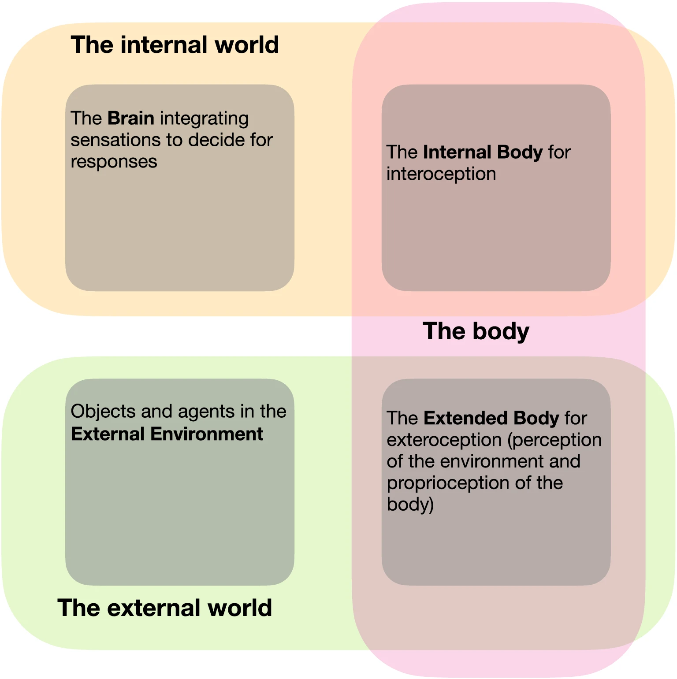
Figure 1 - The three worlds of cognition.
This figure is a diagram drawn by Frédéric Alexandre (Alexandre, 2021). It represents the three worlds involved in cognitive functions and consequently in learning. Perception is thus embodied.

In addition, Frédéric Alexandre highlights the relationships that exist between the external environment, the internal environment and the body, a third world at the border of the two previous ones. He explains that it is essential to take into account these three worlds (brain, body, environment) to study cognitive functions (Alexandre, 2021).

In Figure 1, Frédéric Alexandre shows that the learner is not only a brain interacting with an external environment but also a body through which the internal environment is related to the external environment. External perception is composed of perception and proprioception . It allows the body to interact with the external world and is expressed by external responses. As for interoception, it allows the body to feel internal states, which triggers internal responses.

The person is then made up of a brain + body system (acting and learning) present in the external environment. The internal states represent the needs of this person manifested in the internal environment of the body. It is the flow of sensory and motor information between these worlds that allows the satisfaction of needs.

This makes sense with the notion of sensory receptors mentioned earlier. Indeed, the receptors at the origin of perception are located on the extended body and allow the reception of stimuli sent by objects or agents present in the external environment. On the other hand, the internal environment can also transmit stimuli through sensations perceived in the internal body (interoception). These stimuli may correspond to fundamental needs related to the homeostatic functioning of the internal body. The emotions are responses to these internal or external stimuli. They are also involved in learning (these notions will be discussed in more detail later).

Moreover, Figure 2 shows that there are two types of processing of a stimulus. Indeed, it can be bottom-down (ascending) or top-down (descending). In the first case, "the information processings are guided by the stimulation, the environment, which find their origin" while in the second, the processings "are guided by the knowledge of the individual, they find their origin in the previously learned knowledge of the individual" (Habib et al., 2018).

The authors point out that a cognitive process involves both types of processing in most cases but at different levels. The latter can be qualified as "high level" in the case where the processing is mainly top-down. The quantity of mental operations is then important and the more important it is, the higher the level of elaboration because it calls upon the learner's prior knowledge. Conversely, bottom-down processing is mainly based on the environment and stimuli, which reduces the number of mental operations. It is therefore associated, most of the time, with a low level of elaboration. In all cases, it is the number of mental operations involved in the process that determines the level of elaboration.

This supports the fact that a stimulus can be perceived differently from one individual to another since its processing can be influenced by prior knowledge.
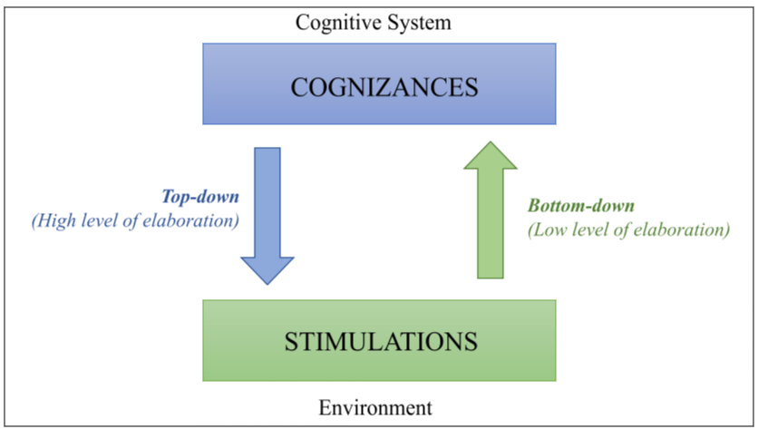
Figure 2 - Processing of stimuli (elaboration).

This diagram is inspired by a figure made by Marianne Habib and her colleagues [Habib et al.,2018]. It represents the two types of processing that can be applied during a cognitive process.

On the other hand, perceptual processing may differ according to the intention. When it comes to recognizing an object, the cognitive system links "a perceptual representation of the object (which does not yet have meaning) with information contained in semantic and episodic memory" (Habib et al., 2018). The authors state that it is not always necessary to recognize an object in order to act on it. Moreover, the perceptual treatments used to recognize an object would be independent of those that guide the action.

There are different types of perception that integrate several modalities other than the sensory ones. This is the case in the perception of space, time and quantity which interact with each other. Indeed, experiments have shown that the perception of quantity is related to the perception of space "observable on the motor responses of the subjects" (Habib et al., 2018).

"These behavioral data are supported by brain imaging and electrophysiological studies that have been able to reveal shared physiological bases for encoding digital and spatial magnitude" (Habib et al., 2018). For example, the parietal cortex is involved in both these bases and in action guidance.

Similarly, the perception of time and space are linked because spatial representations can impact the perception of time.

These three dimensions of perception are thus linked to each other. Consequently, a modification of one could generate modifications on the others. This can be observed by the modification of the action performed in response (for example: increase or decrease of the reaction time).

There are other dimensions of perception that do not depend only on sensory modalities and can incorporate "proprioceptive representations, contextual information, emotions, etc." (Habib et al., 2018). Furthermore, it is established that action is not only a motor response (output) and that it can also influence perceptions. Action and perception cannot therefore be considered independently of each other.

These notions allow us to shed light on the interpretation of the learner's behavior when participating in a problem-solving task such as CreaCube. It will then be possible to link the stimuli provoked by the task and the learner's behavior when perceiving these stimuli. An ontology established on this basis could also make it possible to infer the learner's perceptions given the observations collected. The inferences made at this level are intended to allow the modeling of the learner to better understand learning (Mercier et al., 2021b). In the longer term, they could allow the adaptation of the task by optimizing the elements shared with the learner, as is the case for applications with algorithmic assistants carried by the FLOWERS Project-team (Clément et al., 2014b).

1.3.2 Attention

The behavioral reactions observed in the above-mentioned experiments concerning the study of perception are also related to attentional processes. Indeed, attention is a spontaneous cognitive process that allows the sorting of perceived information (entering the cognitive system) in order not to overload the cognitive system by identifying relevant and useful information in a given context. However, it does not only have a sorting function. Pascale Toscani and her collaborators recall the neuroscientific point of view that proposes three main functions with identified circuits: that of alertness (or vigilance), that of filtering (or orientation) and that of executive control (Toscani et al., 2017).

Vigilance allows a rapid reaction to an event in connection with noradrenaline (neurotransmitter with accelerating effects on the body). This form of attention "has a particular rhythm, circadian, endogenous, which can vary during the seasons and especially can be disturbed by our daily activities" (Toscani et al., 2017). Cognitive functions used in daily activities can be less efficient and generate fatigue if the rhythm of these activities does not match the personal rhythm of alertness. "The fatigue generated particularly alters our attention and memory" (Toscani et al., 2017). Conversely, over-concentration (over-solicitation of attention) can alter personal rhythm by disrupting sleep, for example. On the other hand, this form of attention allows for a quick reaction of the individual in case of stress.

The filtering function refers to what was discussed in the first part of this paper concerning attention. Indeed, this function makes it possible to identify the most relevant stimuli according to personal objectives. This function is also called orientation because the body reacts spontaneously (eye movement for example) in the direction of the stimuli identified as pertinent. This process is not intentional. In addition, it uses different filters that allow the selection of stimuli. They can be innate (shapes, colors, movements), linked to "pre-wired" neural circuits or acquired (learned by experience, for example the first name), thanks to learning. Thus, attention is shaped over time by the environment and experiences. Besides, "the voluntary detour of attention and management of distractors is acquired progressively from 4-6 months of age. The ability to direct attention is developed in conjunction with sensory acuity during the first year and then continuously from childhood to adolescence" (Toscani et al., 2017). Therefore, it is possible to say that a learner with the goal of solving a task will be able to voluntarily direct his or her attention to the task and identify the elements that constitute it. These abilities could vary from learner to learner depending on age, environment, experience and prior knowledge.

Executive attention "allows us to regulate our attention by selecting mental processes. It can involve consciousness and time-program our cognitive functions (such as working memory, cognitive flexibility, and cognitive inhibition that allows for the management of cognitive conflicts" (Toscani et al., 2017). This process differs from the first because it is conscious , i.e., intentional. The learner can then choose to direct his or her attention to certain stimuli identified as useful for solving the task. This form of attention differs from the filtering function in that it is slower acting due to the involvement of the prefrontal regions of the brain, which are further away from the regions dedicated to perception, which are rather in the parietal areas. It can however "influence perception [...] by creating filtering biases, forcing the search for certain features" (Toscani et al., 2017), which is an example of the top-down process previously mentioned.

Pascale Toscani reminds us, moreover, that attention and memorization develop together. She cites this example: "by acting on perception, attention will influence the encoding of the context of memories and conversely the context associated with a memory will influence the way in which we pay attention to it during recall" (Toscani et al., 2017). The influence it addresses concerns both long-term memory and working memory by increasing the number of items retained for a few seconds. This allows "to keep in mind the goals to be pursued, the projects to be carried out and the information related to them" (Toscani et al., 2017).

Attention has its limits. Indeed, Pascale Toscani cites distraction and inattentional blindness as these limits, opposed to each other: "on the one hand, hyper distractibility makes us unfit for a given task but allows us to take in all solicitations, and on the other hand, hyperfocusing allows us to be efficient on the task but blind to what surrounds us" (Toscani et al., 2017)

In addition, Patrick Lemaire explains that the resources allocated to attention are limited, which implies that it can only be distributed over a very limited number of tasks. He mentions the possibility of automating processes through learning. Thus the repetition of certain processes can lead to the automation of this one (driving for example). This allows the distribution of attentional resources differently from one task to another since an automated process requires much less attentional resources. To avoid overloading the cognitive system, it is recommended to distribute attentional resources over time. For example, it will be possible to combine an automated and a non-automated process (driving and holding a conversation, for example) over the same period of time, but there will be an overload of the cognitive system if the two tasks in progress are not automated (reading a manual and holding a conversation, for example) (Lemaire & Didierjean, 2018). Moreover, Pascale Toscani agrees with this point of view and specifies that this distribution of attentional resources is called attentional flexibility and that it "allows switching from one task to another" (Toscani et al., 2017) insofar as part of these tasks is automated. The author specifies that "competing tasks must be maintained in working memory, which implies an additional cognitive load" (Toscani et al., 2017).

These limitations imply that the instructions given to the learner during a problem-solving task should not be multiplied. In the context of the CreaCube task (presented in the introduction), it is relevant to state the instruction even before presenting the cubes that will be used to solve it in order to avoid multiplying the stimuli and to not overload the learner's cognitive system (listening to and understanding the instruction + recognizing the shapes and colors of the cubes). The distribution of these tasks over time will allow the learner to better understand the problem to be solved in his environment.

1.3.3 Memories

The stimuli perceived in the external and internal environment through the body are identified and filtered by the attentional process. These are the first steps in information processing. On several occasions, the involvement of memory in the different processes discussed above has been mentioned. Indeed, the storage of identified and filtered information is made possible thanks to memory. The duration of storage is different according to the type of memory involved. It is admitted that there is not one but several memories characterized by the duration of storage and also by the cerebral regions involved and the type of processing which is carried out there. It is then a question of short-term memory and long-term memory which are themselves differentiated into other "subtypes" of memory.

Short-term memory and working memory

General Information

According to Marianne Habib, short-term memory "concerns all the processes that allow us to maintain active and manipulate the information necessary for current activities here and now" (Habib et al., 2018). She differentiates 3 types of information that feed short-term memory: information perceived by sensory modalities, information from long-term memory (previous experiences) and information resulting from cognitive activities taking place within short-term memory. This information can be used for reasoning for example, or be directed to long-term memory in order to be mobilized later. Short-term memory is a crucial cognitive function because it is involved in all other functions even though its storage time is of the order of a few seconds. This is represented in figure 3.

In the literature, the terms "short-term memory" and "working memory" are often used interchangeably. However, the former refers to the length of time that information is stored in memory. Working memory is "short-term" because the information is stored for only a few seconds. Furthermore, there is also talk of "perceptual memory" which is not always differentiated. These divergences do not cast doubt on the short-term memory functioning but rather on the differences in the classifications of concepts.

Here, the choice is made to consider the perceptive memory and the working memory as short-term memories. This will allow us to make the stages of information processing clearer.

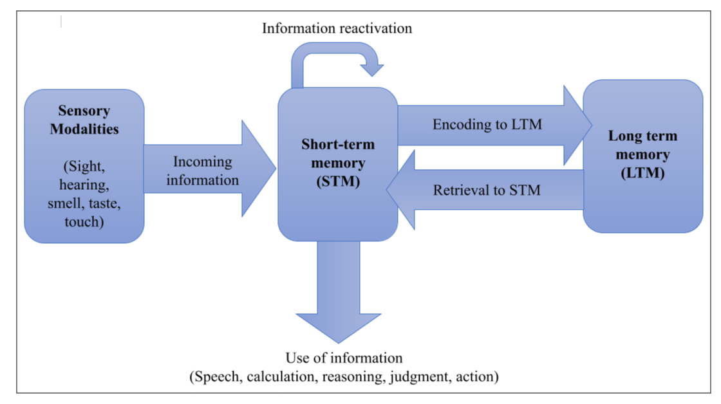Figure 3 - Model of how memory works.
This figure is a reproduction of the diagram by Marianne Habib [Habib et al., 2018]. It represents the general functioning of memory.

Perceptual memory

Perceptual memory is, as its name indicates, linked to perception, to sensory modalities. It is thus differentiated according to these five modalities. This is represented in Figure 4. It allows us to retain sensory stimuli for a very short time in order to be able to process them later in the working memory. It functions automatically, without the individual's knowledge.

It allows us to memorize what results from perception without necessarily knowing its meaning (which results from semantic memory). According to Joseph Stordeur this memory is implicit and "keeps a trace of any percept encountered rather quickly. This is what is called the phenomenon of priming. That is to say that the initial presentation of a percept [...] facilitates the subsequent recognition of this percept, even in a more complex context" (Stordeur, 2014). It is then possible to say that it interacts with semantic and episodic memory.

Lisa Roux (Roux et al., 2020) refers to perceptual (or sensory memory) as the place where incoming information is encoded. It is only when this information is filtered as useful that it can be stored in working memory.

Working memory

Lisa Roux specifies that working memory (operational memory) is not only limited to a storage of information limited in time but also to its processing. The latter "makes it possible to keep the information useful for the processing operations involved in the performance of the task, by updating them as they progress" (Roux et al., 2020).

Pascale Toscani makes the same observation. The latter would be "characterized by a very limited retention, a reduced capacity (empan between 5 and 9 items to be processed at the same time) and a sensitivity to interference (noise ...)" (Toscani et al., 2017). According to the author, the working memory would be considered as "a cognitive system that is used to perform more complex tasks such as calculating, understanding, comparing, deciding, identifying, solving, checking... [...] it mobilizes important attentional resources" (Toscani et al., 2017).

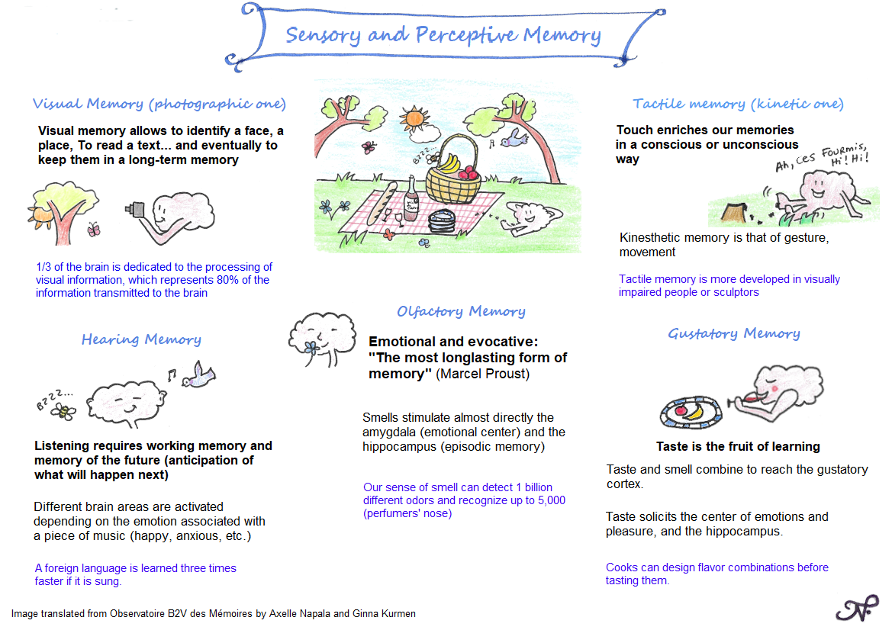

Figure 4 - Perceptual memory according to the 5 sensory modalities.
This figure is a diagram created by the B2V Memory Observatory. It represents the perceptive memory according to the five sensory modalities.

Moreover, Éric Tardif explains that working memory develops over the years in connection with the maturation of the central nervous system, beyond cognitive development and therefore in connection with neurological developments. During the latter, the loss of information between the encoding of a piece of information and its recall would be decreased, the storage capacity would be increased as well as the processing speed (Tardif & Doudin, 2016).

Long-term memory

Marianne Habib indicates that unlike short-term memory, long-term memory allows the storage of information for several years, even throughout life (for a memory having had a strong emotional "impact" for example or which was requested by the recall with strong memory traces). It is also not possible to set a quantitative limit on the storage capacity of this type of memory. She distinguishes three types of long-term memory: procedural memory, semantic memory, and episodic memory.

Procedural memory

According to Marianne Habib, procedural memory allows the storage of know-how. Pascale Toscani specifies that this type of memory "is acquired by repeating a task" (Toscani et al., 2017). These skills are acquired as a result of "motor procedures" (Habib et al., 2018,) and allow various activities to be carried out. It is an implicit and non-declarative memory, that is to say it is automatic and it is difficult to explain an activity that uses procedural memory (cycling, walking, driving ...) . Its automatic nature allows it not to mobilize a lot of cognitive resources. As mentioned when defining the concept of attention, the cognitive resources or attentional resources that can be mobilized simultaneously are limited. So it is difficult to accumulate tasks unless one of these tasks is an "automatic" activity (pertaining to procedural memory).

Semantic memory

Pascale Toscani explains that semantic memory "allows knowledge to be linked together to make sense of it" (Toscani et al., 2017). According to Marianne Habib, the information stored in semantic memory is not linked to a context (place or period) and is abstract. It is an explicit and declarative memory because it is possible to put words to the stored information (Habib et al., 2018) (being able to define a word and relate it to related information, for example). Éric Tardif says that "semantic memory constitutes our repertoire of knowledge of the world" (Tardif & Doudin, 2016). Marianne Habib describes it as "a kind of dictionary (of common and proper names)" (Habib et al., 2018). Moreover, Joseph Stordeur specifies that "to function well, semantic memory must be organized, hierarchical, structured" (Stordeur, 2014). According to him, this is essential in order to be able to efficiently access the knowledge stored there.

Episodic memory

According to Marianne Habib, episodic memory stores events and is linked to time and space. It is declarative and explicit. Éric Tardif adds that episodic memory can be accidental or voluntary (Tardif & Doudin, 2016). Moreover, the memories stored there "have a narrative structure (with a beginning, middle and end) and involve mental representation" (Habib et al., 2018). The author states that this mental representation is a function of sensory perceptions and emotions. "The affective component is closely related to episodic memory, and memories associated with affect are more robust than neutral (non-affective) memories" (Habib et al., 2018). This is in contrast to the other two types of long-term memory for which emotions have no or little influence. Furthermore, episodic memory allows one to consciously relive an experience and the associated sensations and related affects.

Interactions between episodic and semantic memory

On the other hand, the author mentions the fact that episodic and semantic memories are dependent on each other and work together. Indeed, through her experiences, the individual will acquire semantic knowledge by associating words with these experiences. This semantic knowledge can be acquired by generalizing certain properties shared by an element. "This generalization process involves what is called induction, a form of reasoning that the human mind relies heavily on.This process of induction allows the human mind to create semantic categories, based on a mechanism for generalizing properties" (Habib et al., 2018). This allows us to save cognitive resources. As for episodic memory, it also calls upon semantic memory to make sense of the events experienced. "This [semantic] knowledge makes it possible to qualify the memory, to give it substance, and to make it intelligible" (Habib et al., 2018).

Joseph Stordeur refers to episodic memory during learning. He explains that it is possible to remind the learner of a real-life situation in order to help him solve a problem. The learner will then draw on his episodic memory (in association with semantic memory) in order to transpose what he has already learned during a previous task (Stordeur, 2014). Moreover, Pascale Toscani explains that episodic memory cannot be called upon before the acquisition of language because, for this, the individual must be able to "evoke his memories with language" (Toscani et al., 2017). This would be corroborated by "infantile amnesia" (individuals would have very few memories dating before the age of 5 years).

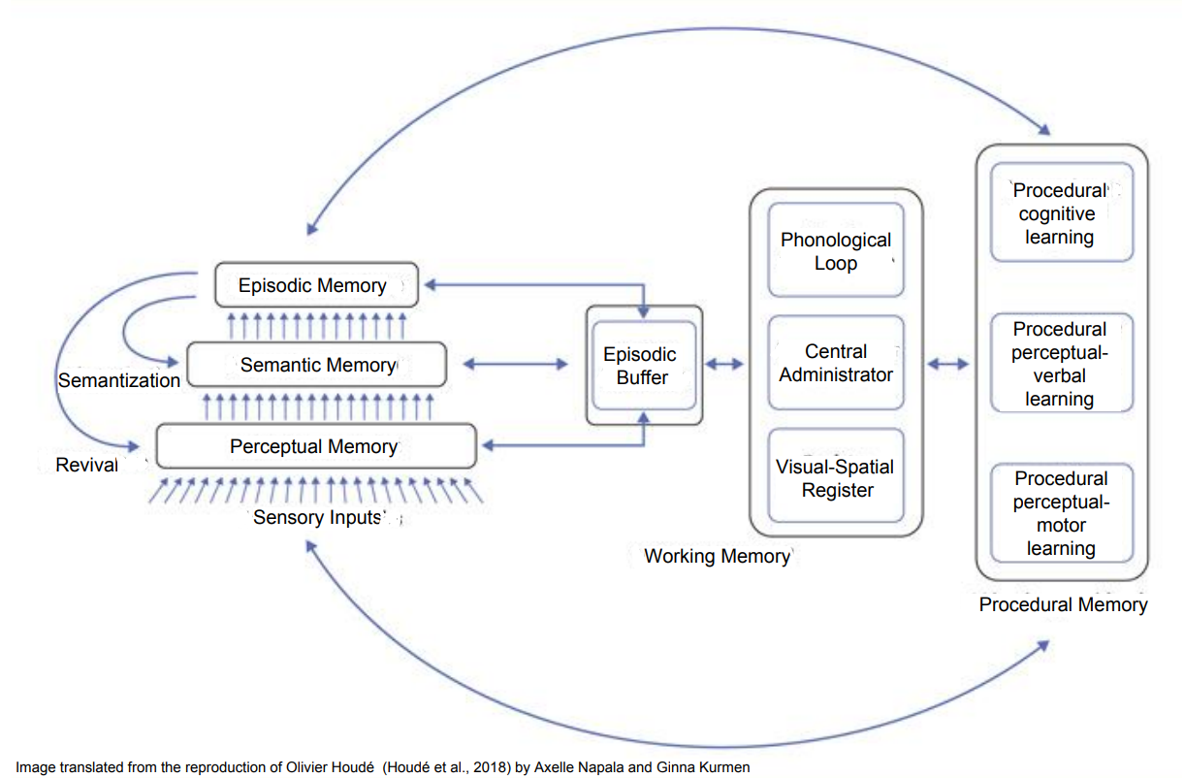
Figure 5 represents a synthesis of the interactions between the different memories according to the MNESIS model. It is described in detail by Olivier Houdé. To begin with, he explains that working memory, at the center of this model, "includes components specific to the processing of verbal material (the phonological loop), visual-spatial (visual-spatial register), multimodal (episodic buffer), all coordinated by the central administrator" (Houdé et al., 2018). These different elements constituting the working memory are involved in procedural learning and in the updating of the procedural memory in charge of storing the constituents of procedural learning (cognitive, perceptual-verbal, perceptual-motor). The working memory also intervenes in "the functioning of the memory systems manipulating mental representations: the perceptive memory, the semantic memory [...], and the episodic memory". The author specifies that in order to store a memory in the episodic memory, it is necessary to go through the perceptual and semantic memories in order to encode the percepts and the meaning. Furthermore, he explains that "memories can become semantic over time, particularly via repetition, and become knowledge" (Houdé et al., 2018)(as with learning, for example). Conversely, "other memories will remain very vivid, enamelled with numerous perceptual-sensory details and recalled with a feeling of reviving" (Houdé et al., 2018).

Figure 5 - The interactions of the different memories.
This figure is taken from the Inter-Systemic NEo-Structural Model (MNESIS) model by Alan Baddeley. It has been reproduced by various authors and in particular by Olivier Houdé (Houdé et al., 2018)
Memorization

The process of memorization mobilizes different types of memories acting in a network, and it is interesting to present a synthesis of these memories with their location, before addressing more precisely their interactions and the functioning of memorization. Figure 6 summarizes the main elements discussed above and specifies the brain areas involved for each of the memory functions.

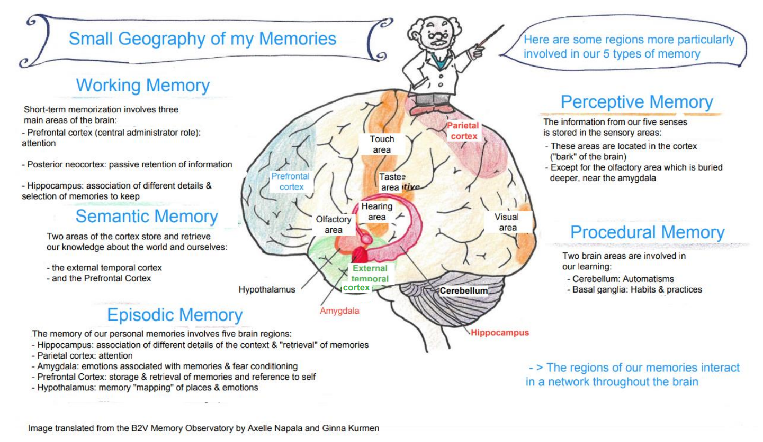

Figure 6 - Memories and their locations.
This figure comes from the B2V Memory Observatory. It cites the different memories, locates the brain areas involved and recalls the functions of each.

Jean-Philippe Abgrall (Abgrall, 2012) and Patrick Lemaire (Lemaire & Didierjean, 2018) cite four stages in the memorization process:

- Encoding is the first step. It concerns the transmission of the information "by the hippocampus to one or more specialized lobes which will process it and make a 'memory trace': a nervous circuit in the brain" (Abgrall, 2012). The author specifies that the precision of the encoding determines the depth of the memory trace. The greater the depth, the better the recording of the information. Moreover, he mentions that the depth of the memory trace is an increasing function of the emotional state and of the motivation at the time of encoding. Grzegorz Markowski defines encoding as "the processing and elaboration of information to create a true memory of it or the processing consisting in establishing associations of ideas, images, between various information that will allow , with the help of these mental links, to find information”.

- The storage of information takes place in different areas of the brain involved in the memorization process depending on the type of information. These areas are all connected to and through the hippocampus. A memory is therefore composed of several elements linked together by the memory traces created during encoding. The author specifies that by multiplying the types of information stored (several sensory modalities at the same time, each of which is stored in the corresponding sensory areas), the links are also multiplied, which makes it easier to reconstitute the memory, but not without posing the problem of binding , i.e., the matching of several pieces of information during the reconstitution of this distributed representation.

- Recall or restitution is a process that can be voluntary or involuntary, occurring when a cue involved in the encoding of stored information is perceived. "The more a memory is coded, elaborated, organized, structured, the easier it will be to retrieve ".

- Forgetting is cited by the author not as a stage of memorization but to help understand the stage of recall. He cites four theories concerning forgetting: the theory of decline, of motivated forgetting, of hindrance and of interference. The first concerns the degradation of memory over time by biological processes, by the absence of recall, of reactivation of memories, thus causing the deterioration of memory traces. The second concerns non-intentional mechanisms aimed at forgetting unpleasant memories. This mechanism is closely linked to emotions. The third theory concerns information that has not been sufficiently encoded (insufficient or incorrect cues) or replayed. The last theory refers to memories that cannot be recovered because others prevent this recovery process. This is the case when a new memory does not allow the updating of an older memory. It goes without saying that in reality all these mechanisms are likely to intervene.

Figure 7 summarizes this memorization process and resumes these steps.
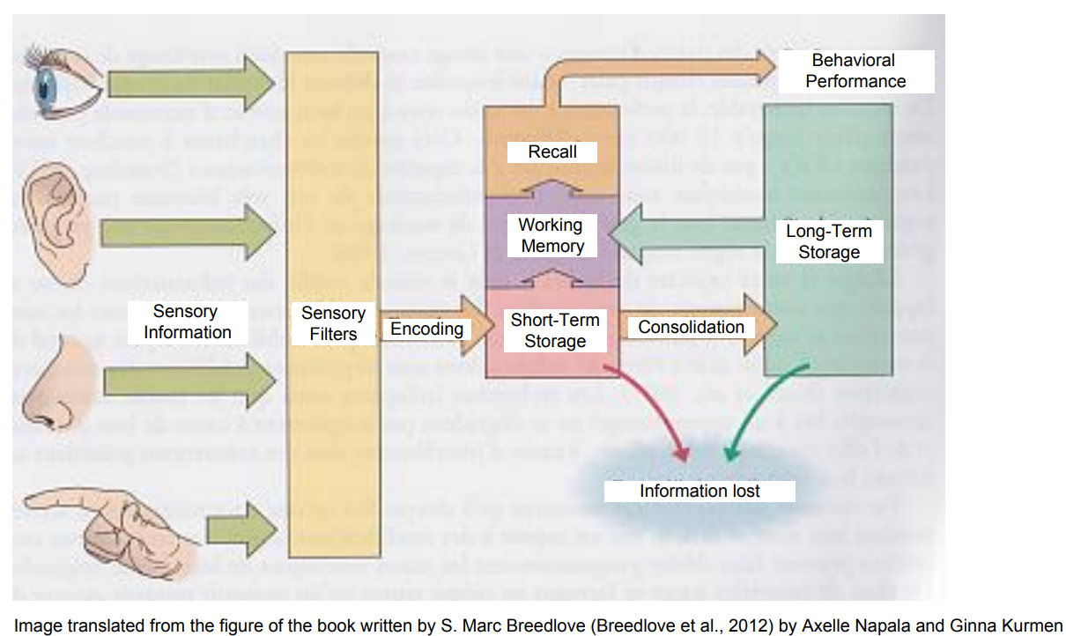

Figure 7 - Memorization process
This figure comes from the book written by S. Marc Breedlove (Breedlove et al., 2012). It presents the mechanisms of memorization

Given all these elements concerning memories, it is possible to say that they are at the center of cognitive functions and consequently of learning. The different types of memories are mobilized during learning, to different degrees. This allows us to understand what is at stake in a problem solving task like CreaCube.

Working memory will be used throughout the task, while episodic, procedural and semantic memory will be used at certain times. In this context, the learner will mobilize his semantic memory to understand and integrate the instruction. This memory can be associated with episodic memory to obtain a mental representation of what a vehicle is and what its components are. Procedural memory will also be called upon when handling the cubes and trial and error.

In addition, in this part, we will discuss language, motor functions, reasoning and emotions. These cognitive functions are obviously linked to memories and are involved in the memorization process, so they will be discussed next.

1.3.4 Reasoning

According to Marianne Habib, "reasoning helps us to understand and interpret our environment, to make predictions about future events and behaviors, and ultimately to make decisions" (Habib et al., 2018). Reasoning enables understanding and control of the environment. The author cites three types of reasoning: abductive, inductive and deductive. She also mentions creative reasoning.

Abductive reasoning

According to Marcel Kadosch, analogy is at the origin of abduction, a term first used by Peirce. He defines analogy as "the foundation of the possibility of passing from one term to another without negation of one term by the next. It was defined as an identity of relations, to distinguish it from resemblance which would be only a relation of identity" (Kadosch, 2019). He also explains that Bateson (wrongly) called this type of reasoning "syllogism of metaphor" (Kadosch, 2019). The "syllogism of metaphor” would be an "operation that selects from different fields the features they have in common" (Kadosch, 2019).

As for Ji Han, he defines analogy as a cognitive process used to generate inferences and new ideas using prior knowledge and experience. He argues that the ability to perceive and use relational similarity in different contexts are the constituents of analogy. According to him, the ability to perceive and use relational similarity in different contexts are the constituents of analogy. He points out that these constituents are also fundamental to creativity in science and art.

In his work, the author links the use of reasoning by analogy with the use of ontologies to study creativity. This aspect will allow the deepening (later in this document) of the notion of ontology which is at the heart of the work of the AIDE exploratory action.

The work of Ji Han (Han et al., 2018) brings to light the notion of "proximity" between two "analogous" notions, which is essential to understand this mechanism of analogy. It seems that we must first distinguish the notion:

- semantic similarity (the brain groups together elements that appear similar, that is to say, sharing a number of both descriptive and functional properties) which therefore only quantifies the difference between the two,

- that of semantic proximity (the brain groups together the elements which often appear together, which are close in the same perceptual zone), between two constituents.

In this second case, there is one more ingredient, the constituents are implicitly seen as located in an abstract space: the distance between these two constituents is associated with a shortest path that connects one to the other, quantifying proximity (Mercier et al., 2021a).
Formally these two notions are related , in particular, with the notion of edit distance, which is defined as the minimal number of elementary trans-formation operations to move from one element to another (e.g., changing a value or adding or removing a component) (Mercier et al., 2021a). The "cost" is therefore defined as a number of operations that quantifies the proximity and a minimal transformation path between the two constituents that defines the proximity.

With this spatialized notion, it is then possible to speak of analogy: two concepts, distant in the absolute, can be considered as analogous, in two different contexts, if their relative proximity to a reference constituent of each context is strong.

Christian George quotes Peirce as the author who analyzed abduction: "abduction is the process of forming an explanatory hypothesis. [It] infers from facts of one kind facts of another kind" (George, 1997). This type of reasoning calls for the activation of knowledge present in memory. This knowledge must be expressed in the form "If A then B" where A is a factor absent from the premises and B is the target fact. Without knowledge expressed in this way, the hypotheses will be elaborated from other knowledge "which can lead to the use of various sub-reasoning processes, notably by specification or analogy" (George, 1997). After the activation process, it is the evaluation of the plausibility of the hypotheses that intervenes in order to identify the one that is the most probable, given the knowledge mobilized. If the latter do not allow this identification, then "it is the internal coherence of the story, its capacity to integrate all the information into a credible sequence, which becomes the indicator of the plausibility of the cause invoked in conclusion" (George, 1997).

Abductive reasoning is also called hypothetical reasoning because the product of this reasoning is a hypothesis. Indeed, an individual faced with an event for which he knows one of the possible causes and for which he favors one cause over another is using abductive reasoning. Marianne Habib gives the following example: "For example, a doctor observes that a patient has a cough (= observed event). He knows that a cold (= possible cause) causes the cough. He concludes that the patient has a cold (= cold causes cough)" (Habib et al., 2018). However, this is only a hypothesis (hypothesis of cause and effect), one possible cause among others that has been favored because it is more likely to have a cold than lung cancer when the symptom is a cough. This reasoning implies the principle of parsimony: "the simplest hypothesis is the most probable" (Habib et al., 2018). This type of reasoning is used on a daily basis by an individual and involves a search in memory either episodic by trying to match the current episode to a previously experienced one, or semantic by trying to apply inductively, as discussed later.

Moreover, Simone Morgagni specifies that "affordances emerge during a global process of abduction" (Morgagni, 2011). She cites Gibson's definition according to which an affordance designates "any possibility of interaction offered to subjects by their environment" (Morgagni, 2011). Lisa Roux joins this definition and completes it (in reference to the definition of Donald Norman). According to her, the learner discovers potentialities in his material environment "in relation to the general prior knowledge he has" (Roux et al., 2020). The notion of prior knowledge is fundamental for the concept of affordance because it is what allows us to detect them. Indeed, without this knowledge the learner cannot detect affordances. Moreover, the evolution of this knowledge can also allow the detection of new affordances. Moreover, the author specifies that affordances "participate in the construction of memory traces, since they are what allow him [the learner] to discover, little by little, his material environment and its logic, in order to know how to use it to solve the problem he is facing" (Roux et al., 2020). Simone Morgagni adds that "our manipulations and actions can produce new affordances that were not previously available and that show us to what extent creating a certain affordance consists in an activity of imagining its feasibility" (Morgagni, 2011). In this sense, affordances are subjective since they depend on prior knowledge, on the cognitive processes involved in their processing, but above all on the learner's perception of his environment.

The author explains Norman's point of view according to which "the power of affordances is to implicitly show where to go and how to do it. They simply construct a privileged path for optimizing behavior, without the subject even needing to be aware of it" (Morgagni, 2011).

Lisa Roux distinguishes two types of affordances: perceptible affordances and functional affordances. The first ones are "directly suggested by sensitive information obtained through the discovery of objects" (Roux et al., 2020). The second are "discovered during the interaction of an object with others” (Roux et al., 2020).

Simone Mogagni refers to Zhang and Patel who originated the theory of distributed cognition. According to this theory, affordances could be distinguished into five types: biological ("built on biological processes"), physical ("built on physical structure"), perceptual ("built by spatial paths"), cognitive ("built by cultural conventions") and mixed ("constituted by a combination of several of the categories just listed") (Morgagni, 2011).

Finally, according to Simone Morgagni, "affordances would be [...] nothing else than actions made possible and salient by the cognitive activity itself and could be conceived as conceivable responses to a practical action" (Morgagni, 2011).

During the CreaCube task, the learner can find, for example, the affordance suggested by the "wheel" on one of the cubes in relation to the "vehicle" concept stored in memory. This leads him, by reasoning, to put the cube with wheels in contact with the horizontal plane on which the vehicle must move.

Creative reasoning is a form of abductive reasoning. Marianne Habib approaches it as the ability to "find creative solutions to problems that [human beings] face in their environment" (Habib et al., 2018). By creative solution, she means a novel solution that allows for the resolution of a problem or a solution that replaces a less suitable one.

According to Joy Paul Guilford's point of view, creativity is the capacity of an individual to imagine or build and implement a new concept, a new object or to discover an original solution to a problem. This originality is defined in a given context. The author explains that the creative process (Guilford, 1956) begins with the recognition of a problem. It is from there that a process of divergence begins. It is from there that a process of divergence begins. The latter corresponds to an exploration (from known elements) of new combinations or deformations. It ends, by convergence, in a new solution of the problem, by a mechanism of verification and evaluation of the new proposal.

Creative cognition encompasses the cognitive processes that contribute "to the production of creative ideas and creative reasoning" (Habib et al., 2018). It corresponds to a set of competencies, operations, and methods that lead to new, original, and contextualized ideas. It requires access to concepts stored in memories in a flexible way in order to create new associations. These association processes are automatic and allow for the reorganization of prior knowledge in a new and useful way. "The more distant these associations are, the more creative the ideas generated" (Habib et al., 2018). Expertise thus facilitates this process because the amount of data accumulated in a domain makes it easier to combine knowledge and thus lead to a new solution. Given these elements, the following definition of creativity is given: "Creativity consists, in particular, in calling upon and bringing together old knowledge in a new way, in order to generate new properties from the old" (Habib et al., 2018).

Memory thus appears to be essential to creativity but can paradoxically become a bias to this creative thinking. It is a fixation effect that intervenes in creative reasoning. This effect is caused, for example, by spontaneous reactions to everyday objects for which it would be necessary to "divert" the use. "It refers to a blockage or a hindrance in the access to a mental activity, an element that blocks the accomplishment of the creative thought" (Habib et al., 2018). The usual representations that are easily accessible in memory are at the origin of this. This corresponds to functional rigidity. However, it is possible to circumvent this rigidity, this fixation effect.

Certain executive functions allow us to bypass this problem of fixation. Cognitive control and mental flexibility allow us to resist habitual behaviors that occur spontaneously, thus avoiding the production of unoriginal responses, which favors the proposal of more creative alternative solutions.

Moreover, Marianne Habib states that "reasoning by analogy could contribute to the production of creative ideas" (Habib et al., 2018). This is because it is based on previous knowledge or experience and transfers it to a new situation. The author cites three steps that are essential to circumvent the fixation effect during a problem-solving task. "It would involve first resisting fixation, then redefining the problem, and finally using cues or leads to provoke new ideas" (Habib et al., 2018). Reasoning by analogy (or abductive reasoning) would allow for the restructuring of thought "by linking the structure and attributes of one object or situation (the source) to another object or situation (the target)" (Habib et al., 2018).

In the context of the CreaCube task, creativity is one of the criteria observed during problem solving. Indeed, it is observed that certain automatic responses can occur concerning the manipulation of the cubes, for example, one automatic response would be to stack them. However, the creation of a vehicle in the form of a tower inevitably causes balance problems when moving it, leading to a failed attempt. This is due to the fact that memory is required to access prior knowledge about the concept "cube".

It is quite possible that the study of executive functions, in section 1.3.5, could provide a more precise understanding of how the learner bypasses the fixation effect in order to solve the task and to what extent these functions impact creativity.

Inductive reasoning
Like abductive reasoning, inductive reasoning is hypothetical because it does not lead to a certain conclusion. On the other hand, it is not based on the same principle. Indeed, "inductive reasoning implies a generalization from observations or knowledge (when a glass falls on a hard surface, it breaks; when a plate falls on the same surface, it breaks; then if a vase falls on a hard surface, it will break)" (Habib et al., 2018). Understanding and mastering probabilities is necessary in this type of reasoning: it is very likely that the vase will break but it is not certain. Inductive reasoning is probabilistic reasoning.

Patrick Lemaire specifies that inductive reasoning always leads to new information, unlike deductive reasoning. Moreover, the author explains the functionalist conception of reasoning: "to do inductive reasoning is to find regularities between events [which] allow us to formulate predictions about the occurrence of future events and to reduce our uncertainty about our environment and what is happening in it" (Lemaire & Didierjean, 2018). This allows for adaptation to the environment. Regularities can take different forms: "a rule, a law, a hypothetical, an equation, a concept or a category" (Lemaire & Didierjean, 2018).

Deductive reasoning
Deductive reasoning is logical reasoning. The conclusions drawn from this type of reasoning "are necessarily correct if the statements are true and the inferences are drawn in a rigorous manner" (Habib et al., 2018). Unlike the previous types of reasoning, this one does not require the creation of new information but a reorganization of the information already present. “In sum, inferences are a way of reformulating information that was already present in an implicit way" (Habib et al., 2018).
In addition, Patrick Lemaire differentiates two theories concerning deductive reasoning: the theory of mental models and that of mental logic. He specifies that these two theories are completely different even if "they share the common postulate according to which the performance of subjects on different tasks of deductive reasoning can be explained by the implementation of common and general processes" (Lemaire & Didierjean, 2018).

Three processing steps would be implemented in the reasoning according to the theory of mental models:

- Comprehension: the knowledge of language and environment are mobilized to understand the premises which allows to "deconstruct [...] mental models. These mental models are elements or individuals particular to the groups described in the premises and relations between these elements" (Lemaire & Didierjean, 2018).

- Inference: the individual briefly describes the elements of the situation (which may include a step of reformulation of the statement). This description leads to a first conclusion concerning terms not related in the premises.

- Refutation (or falsification): this step allows the search for alternative models that validate or invalidate the conclusion established in the previous step. If no alternative model is found then the conclusion is considered valid. In the opposite case, the alternative model is studied during a new inference step in order to reach a new conclusion which will also go through the refutation step until the individual does not find any alternative model.

This theory can lead to two types of error: encoding and inference. An encoding error would occur during the comprehension stage ("some A's are B's" instead of "all A's are B's", for example). The inference error is caused by the individual's difficulty in looking for alternative models (counterexamples) to the first conclusion established. This difficulty would be linked to the limit of working memory because certain types of reasoning consume more resources than others. It would be during these more resource-intensive reasonings that the search for alternative models would become more difficult. Moreover, the individual's cognitive abilities also play a role in the difficulty of establishing alternative models.

The theory of mental logic agrees with the point of view cited by Marianne Habib. It is based on three postulates:

- The cognitive system would possess the fundamental rules of logic.

- The triggering and application of these rules constitute the mechanism of reasoning.

- Logical rules that are not available in the cognitive system can be derived from the recombination of other rules that are themselves available. The reasoning would then be done sequentially by activating the rules to be applied.

In this theory, information would first be stored in working memory in the form of propositions encoded by a comprehension mechanism. The premises are then represented in an abstract form similar to a logical rule (if A, then B). The logical rules would then be applied to these stored pro-positions. However, if the reasoning does not lead to a direct conclusion based on the logical rules then the answers provided will be biased or erroneous and approximate.

This theory also implies the possibility of making mistakes. They can occur during the comprehension stage in connection with a misrepresentation of the premises, but also during inference in connection with a misuse of a rule, either erroneous (for example, that A is necessarily true because A or B is true), or that does not apply (error in the premises). Moreover, errors can also be of cognitive origin (errors of inattention or of maintaining information in working memory, for example).

These two theories diverge because one is "is based on the principles of logic (mental logic), the other on semantic principles (men-rate models)" (Lemaire & Didierjean, 2018). The logical rules used for reasoning under the theory of mental logic are independent of content. Conversely, mental model theory postulates that "human reasoning takes place by mentally imagining the situation described in a reasoning problem and trying to consider alternative models" (Lemaire & Didierjean, 2018).

These notions of "logic" and "model" are found in mathematical logic. In this context, a set of logical propositions can be true, false or undecidable, at a certain level. It can also have models or not. The purpose of verifying this set of propositions by a model, or models, is the interpretation of syntactic structures in mathematical structures so as to associate them with semantic concepts .

Logic, rationality and intuition
Marianne Habib warns about the meaning of the word "logic". She explains that this term is abused in everyday language to the detriment of intuition. She specifies that "logic allows us to verify the validity of an argument, by testing its coherence" (Habib et al., 2018). It is based on formal rules, themselves "at the basis of all rationality" (Habib et al., 2018).

Human reasoning is based on logical and probabilistic rules. It is considered that the more the individual conforms to this framework, the more rational he is. Michel Métayer defines rationality as "the characteristic of a thought that links its ideas in a conscious, ordered and controlled way to reach a determined goal, based on good reasons" (Métayer, 2012). The terms of this definition are clarified by Mathieu Gauvin in a video capsule. For this, he differentiates three types of thoughts:
intuitive thinking, rational thinking and irrational thinking.

Rational thinking involves the establishment of means, which the individual is able to justify, to achieve a goal. It is controlled and requires cognitive effort. Conversely, intuitive thinking has no goal or constraint but is rather dictated by imagination, creativity, emotions and spontaneity. Intuition does not appeal to reasoning but is closely linked to Perception. As for irrational thinking, it is observed when an individual has a goal to achieve but does not give himself the means to achieve it. It then multiplies decisions that take it away from its goal or are based on unfounded justifications.

In this sense, it is possible to say that reasoning is motivated by the achievement of a goal. During a problem-solving task like CreaCube, the learner sets up a number of means that he is able to justify in order to achieve his goal: to assemble the cubes so that it forms a vehicle. This aspect therefore refers to reasoning, logic and rational thinking. However, it is also possible that the other two types of thoughts are involved. When the learner is in a context of intuitive thinking, he performs actions which are not motivated by a goal but which could potentially lead to it being achieved. For example, he could manipulate the cubes and put them together as he pleases because he feels pleasure in doing so without even having the purpose of feeling that emotion. In the context of irrational thinking, the learner knows the goal to be reached in order to solve the task but "sabotages" the means used to get there and fails.

Heuristics and reasoning biases
Paradoxically, "human deductive reasoning often does not conform to the rules of logic" (Habib et al., 2018). Instead, the author states that individuals tend to use heuristics (simplifications) that would amplify the influence of beliefs or superficial aspects of the problem, at the expense of "algorithms corresponding to logic or mathematical and probabilistic rules, to solve reasoning problems" (Habib et al., 2018). Therefore, heuristics can be seen as reasoning biases. Jonathan Evans explains that a reasoning bias "occurs when the majority of people (more than 50%) fail to give the correct answer to a logic problem and provide the same incorrect answer. These biases thus consist of massively irrational conduct in the adult in the area of reasoning" (Evans, 2011).

There are two types of processing that can explain the occurrence of cognitive biases. The first is reminiscent of the intuitive thinking presented above. It allows for the processing of "a large amount of information independently of working memory load and cognitive capacities" (Habib et al., 2018). The answer resulting from this processing may appear to be correct without having an explanation. The individual is then unable to explain the process that led him to give this answer. Conversely, the second type of processing involves algorithms, slower processes requiring efforts involving rational thought. This second type of processing can also be mobilized as a relay for the first type. Moreover, these two types of processing can also come into conflict, leading the learner to provide an erroneous answer to the problem posed. This conflict occurs when an erroneous intuitive response is opposed to an analytical logical response. However, it is possible to detect this conflict even if the heuristic strategy is more easily favored during processing conflicts (the learner knows that the outcome of his intuition is opposed to the result of the analytical strategy but still chooses the fastest answer even if it is wrong). On the other hand, it is possible to use an inhibition process to discard the intuitive response in favor of the logical analytical response.

Reasoning and emotions
It was mentioned earlier that emotions can play a role in reasoning. Marianne Habib explains that indeed emotions can negatively influence reasoning by acting on cognitive performance, but she also explains that it is possible to control this and that there can be a beneficial effect of emotions on reasoning.

The author refers to a study which demonstrated that logical performance was impacted by an emotionally negative condition, either by the use of words "semantically emotional (for example: death, suffering or illness)" (Habib et al., 2018), either by the induced mood (positive or negative). "This suggests that beyond their referential value (ie, the word table refers to a piece of furniture which has four legs and is used to place objects), the emotional value of the contents about which participants reason influences reasoning " (Habib et al., 2018). She explains that emotions and stress generally have a negative effect on cognitive performance and in particular on "alertness, selective attention or memory" (Habib et al., 2018). This is explained by the consumption of a large amount of cognitive resources necessary for processing emotional content. These resources cannot therefore be dedicated to type 2 reasoning (using algorithms) and this would affect the rationality of the reasoning. Thus, the learner would favor the use of heuristics "at the expense of responses based on logic or on probability" (Habib et al., 2018).

Secondly, Marianne Habib explains that "the negative effect of emotions on reasoning can diminish, or even be reversed and become positive, in certain situations" (Habib et al., 2018). One study showed that emotions relevant to the emotional content being processed promoted logical reasoning. In this situation, the individuals presented intense emotional states related to the subject treated, this subject calling upon events that were significant for these people. The latter reasoned more efficiently, were less affected by their beliefs because they were emotionally concerned by the subject at hand. Individuals who were not concerned showed much less intense emotions but were paradoxically less efficient than the individuals mentioned above. The emotional states considered relevant correspond to the person's experience. Thus, a person who has participated in a war (for example) will perform better cognitively on topics referring to it than people not concerned by this type of subject. "We understand by this that the affective reactions evoked by the semantic contents of the reasoning problem were consistent with emotions experienced in the past following personally significant events" (Habib et al., 2018).

The semantic content, the affective feeling and the associated affective history thus have a strong impact on reasoning performance. On the other hand, the concordance between these elements is less true when the object contents of reasoning are neutral or when the "emotional contents are not linked to a past experience" (Habib et al., 2018). In this case, emotions have a deleterious effect on reasoning. It is “the relevance of affective reactions to the semantics of the contents in the context of the task and the affective history" (Habib et al., 2018) that significantly modulates the impact of emotions on the individual's intrinsic motivation and ability to reason effectively.

From human reasoning to its modeling
In order to model the learner and considering what has been discussed above, it is essential to be able to model the reasoning. This can be made possible by the use of artificial intelligence systems that would allow the automation of reasoning.

Imène Khanfir Kallela devoted her thesis to this subject and explored the different theories that would allow to achieve this modeling while taking into account the uncertainty of the information interacting with the model. "This is why artificial intelligence, because of its concern for faithful and adequate representations of the real world, has been led to take an interest in different frameworks for dealing with uncertainty in information, ranging from probability theory, to even more recent theories of interest such as those of possibilities,belief functions, and imprecise probabilities" (Khanfir Kallel, 2019).

These theories will not be detailed here, but they allow us to put forward elements pointed out by the author, such as the notions of possibility and necessity present in the "theories of uncertainty" and which would allow us to manage the in-certainties, imprecisions, incompleteness, conflicts and ambiguities of the information processed during the reasoning. In this sense, the author has created a table to help choose the most suitable theory for dealing with the imperfections mentioned above. It is presented in figure 8.

The different forms of uncertainty treatment have an important stake in the representation of knowledge and the formalization of reasoning by artificial intelligence methods. In order to understand these theories, it is necessary to proceed to a theoretical and conceptual clarification, in particular concerning the differences between imprecision, uncertainty, graduality and granularity. These elements are cited for information purposes and have been discussed more specifically by Salem Benferhat, Thierry Denoeux, Didier Dubois and HenriPrade. It distinguishes, in particular, the notions of imprecision (for example, a measurement made to within one millimeter linked to the precision of the tool) which is a notion relative to the scale of measurement and the use made of the value, and uncertainty which corresponds more to unpredictable events in relation to a model (surprising event). The notion of a random event (whose operation can be known, like a throw of a dice) is distinguished from that of a partially known event (which may not be random). Distinguishing these notions at the theoretical level is important when it is necessary to understand the cognitive processes that depend on them, while different formalisms allow to formalize them.

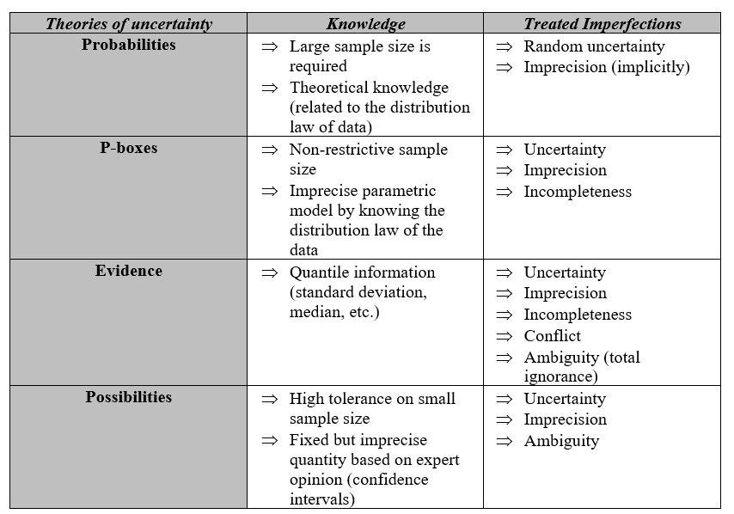
Figure 8 - Guide to the choice of uncertainty theory.
This table is taken from the work of Imène Khanfir Kallel (Khanfir Kallel, 2019). The author summarizes the reasons for choosing one theory of uncertainty among others.

The theories cited fit into the principle of modal logic that Nicolas Szczepanski defines as "a logic to which we have added modifiers, which we could understand in natural language as adverbs" (Szczepanski, 2012). The latter are modalities used to modify a proposition by presenting the stated fact as "necessary, possible or true" (Szczepanski, 2012). Possibility and necessity are modal operators that can be used for modeling human reasoning using artificial intelligence systems.

1.3.5 Executive functions

Jean-Philippe Lachaux defines executive functions as "a set of processes that prevent our behavior from being a simple succession of reflex reactions to our environment" (Lachaux, 2018). He specifies that it is thanks to them that the human being is able to envisage the steps to reach a goal that he has set himself. They allow us to control ourselves (gestures, emotions...), to control "our own mental life" (Lachaux, 2018), mainly thanks to the prefrontal cortex. Ève Leleu-Galland explains that these cognitive processes allow "to intentionally regulate thought and actions in order to achieve a specific goal" (Leleu-Galland et al., 2021) and that they “play a key role in fundamental learning, reading, writing, counting, reasoning and for socio-emotional skills" (Leleu-Galland et al., 2021).

Marianne Habib (Habib et al., 2018) agrees with Ève Leleu-Galland (Leleu-Galland et al., 2021) and Olivier Houdé (Houdé et al., 2018) in citing three functions that make up the executive functions: motor and cognitive inhibition, mental flexibility (shifting) and updating in working memory (updating). Ève Leleu-Galland and Olivier Houdé specify that higher-level executive functions are built on the basis of these: "planning, problem solving and reasoning" (Houdé et al., 2018; Leleu-Galland et al., 2021). According to the author, “executive functions are the capacities of the prefrontal cortex, more precisely of a parieto-frontal circuit, which control the execution of behaviors, the choice of strategies and decision making" (Leleu-Galland et al., 2021).

Sandrine Censabella also agrees with these points of view and quotes other authors who have mentioned other executive functions. She concludes on this variety by considering that the executive functions cover "a whole set of processes whose main function is to facilitate the adaptation of the person to the demands and sudden fluctuations of the environment and, in particular, to new situations" (Censabella, 2007).

Motor and cognitive inhibition
According to Olivier Houdé, there are three modes of thought in the brain: "the heuristic system, corresponding to automatic thoughts, the algorithmic system, that of logical-mathematical thinking, and the inhibition system, which intervenes when there is a conflict between the first two systems" (Houdé, 2018b). In the case of a conflict, the heuristic system is interrupted by the inhibition process in order to privilege the system of algorithms. In this sense, Ève Leleu-Galland defines cognitive inhibition as "the process of the brain that allows us to resist the perceptual and cognitive heuristics that short-circuit efficient reasoning" (Leleu-Galland et al., 2021). This control function is intentional and concerns thoughts, behavior and impulses. Marianne Habib agrees, writing that inhibition "allows for the temporary suppression of a habitual, dominant, over-learned or automated response" (Habib et al., 2018).

According to Sandrine Censabella, there are two types of inhibition: motor and cognitive. They concern motor and cognitive processes respectively. The first type of inhibition refers to the control of automatic or predominant motor behaviors. Cognitive inhibition refers to the control of processed information (automatic, irrelevant or conflicting information). Olivier Houdé explains that inhibitory control intervenes at different moments in the processing of information, whether during its selection or the selection and execution of the response. It also acts on "different types of information (perceptual, motor, cognitive, emotional)" (Houdé et al., 2018) and allows attention to be focused voluntarily and guided by the goal to be achieved.

A repertoire of actions ready to be executed is found within the cortico-thalamic loops involving the basal ganglia, and the selection of one of these actions is done precisely by the lifting of one of the inhibitions, in this case motor (Alexandre, 2021). This is also the case for cognitive processing.

Sandrine Censabella specifies that "in reality, the two sides of inhibition [mentioned above] are strongly linked and are not always easy to distinguish, at least on the theoretical level (for example, is it the behavior itself, the motor act, or rather the planning and execution of it on the cognitive level that is inhibited?)” (Censabella, 2007). It is for this reason that, in her writing, she prefers to consider "not the type of process but rather the type of response that is inhibited" (Censabella, 2007). In this sense, Olivier Houdé adds that inhibitory control acts "on all our behavioral responses as a 'stop' signal that allows our organism to wait before acting, making a decision or giving a response" (Houdé et al., 2018). It is impulsivity, behaviors, emotions and actions that are thus controlled by inhibition.

Updating in working memory
According to Marianne Habib, updating in working memory "makes it possible to update the information maintained by ensuring the follow-up of successive information, the filtering of some of them, the substitution of information that has become inappropriate by a new one" (Habib et al., 2018). Olivier Houdé and Ève Leleu-Galland (Leleu-Galland et al., 2021) agree in explaining that working memory "allows us to actively maintain information and to manipulate it for a few tens of seconds in order to achieve a goal defined a priori" (Houdé et al., 2018).

It is used in problem solving to organize information. It is divided into two types: verbal working memory and visual-spatial working memory. One or the other (or even both) is mobilized depending on the type of information to be processed. It is mainly the prefrontal cortex that is involved in this process in order to "allocate attentional resources to the information to be maintained and to manage the potential interference of information present in the environment" (Houdé et al., 2018). This process also relies "on brain areas involved in the perceptual processing of information maintained in working memory" (Houdé et al., 2018).

Mental flexibility
Sandrine Censabella defines mental flexibility (or cognitive flexibility) as "the ability to move from one type of information processing to another in a fluid and rapid manner" (Censabella, 2007). Marianne Habib agrees with this point of view by writing that mental flexibility "allows the disengagement from one set of responses or one type of representations relevant to a given task in order to engage in a new category of response or representations relevant to another task" (Habib et al., 2018). Olivier Houdé and Ève Leleu-Galland (Leleu-Galland et al., 2021) further clarify this by defining cognitive flexibility as "the ability to adapt to changes in our environment, whether it is to change strategy, to adopt a different perspective on a problem, or more generally to seek out alternative ways of reasoning and thinking" (Houdéet al., 2018).
This flexibility allows adaptation to any situation involving a "change of rules, problem-solving strategies, or activities" (Houdé et al., 2018). It calls upon the executive functions of inhibition and working memory because the strategies involved require storage in working memory in order to be analyzed. It is at this point that inhibition intervenes in order to choose the most appropriate response or rather to discard the one that is less appropriate depending on the situation.

The use of metacognition (discussed in section 1.4) can allow the learner to improve the effectiveness of his or her executive functions by monitoring and evaluating their own cognitive functions.

1.3.6 Language and motor skills

Language
It has been previously discussed that language is involved in the interactions between different memories and participates in memorization as presented in figure 5 detailed in section 1.3.3 in which the phonological loop is discussed. This is related to "the mechanisms of mental representation" (Lieury, 2017) existing in the human being. Alain Lieury explains that these mechanisms are not only used for memory but also for communication. In this sense, he cites different means of representation even if the main one is phonetic language. Marie-Pascale Noël specifies that "language has a double function: it allows inter-individual communication and is part of the cognitive tools allowing complex and evolved reasoning" (Noël, 2007). Marianne Habib cites a definition where language is defined as "the capacity, with which all normally constituted human beings are endowed, to learn and use one or more verbal sign systems to communicate with their fellow human beings" (Habib et al., 2018). Jean Piaget evokes that ego-centric language as allowing "the structuring of thought and regulation of psychic activity" (Habib et al., 2018). Dale Purves adds that language is "the faculty of associating arbitrary symbols with particular meanings to express, to ourselves or to others, thoughts or emotions, whether we are thinking, speaking or writing" (Purves et al., 2015). It is therefore symbolic, semantic and arbitrary.

It is also structured because it is governed by rules (grammatical, syntactic ...), evolving since these rules develop over time, generator because "a finite set of symbols is used to create an infinite number of combinations having a meaning" (Habib et al., 2018) and "composed of sound units" (Habib et al., 2018) (pronunciation).

Language solicits other cognitive functions such as perception, attention, memory and emotion. Indeed, memory contains a mental lexicon which "corresponds to all the knowledge that a speaker has about the words of his language and which allows him to understand their meaning" (Habib et al., 2018). This mental lexicon is solicited during the perception of stimuli in order to recognize and understand the meaning of the symbol used by soliciting the knowledge stored in memory and thus lead to a mental representation. This process is not very costly in terms of attentional resources and can be automated in a more or less efficient way. As for emotions, it was previously mentioned that they have an impact on cognitive functions and language is no exception. They would intervene during the learning of new words, i.e. during the formation and updating of the mental lexicon. However, very few studies have been carried out on this subject to evaluate the real effects. Moreover, language production also involves motor functions.

There are different models that can represent language processing, each of which has advantages and disadvantages, but "interactive designs provide a description that is closer to how cognitive systems interact in reality" (Habib et al., 2018). This approach takes into account the solicitation of the learner's knowledge whether it is conceptual or refers to inference rules.

Motor skills
Motor skills can be studied according to three distinct models: cognitive, ecological and dynamic.

Marie-Pascale Noël begins by presenting the cognitive approach based on information processing. The central nervous system would control motor skills allowing the selection of a response and the elaboration of a sequence of commands to be executed in order to allow the movement of body segments. The selection of the response depends on different factors: the goal to be reached, the information perceived in the environment and those relative to the position of the learner in this environment and also the memorized information. This information is taken into account and the displacement generated by the selected response causes the perception of proprioceptive information. The information perceived in return (sensory feedback) from the response "allows the central nervous system to detect possible trajectory errors and to correct them by modifying the motor commands" (Noël, 2007). It is therefore possible to note three stages, handled by structures of the central nervous system, in this process: "the selection, programming and controlled execution of the motor response" (Noël, 2007).

The author goes on to discuss the ecological approach: "the ecological approach is based on the links, or coupling, between perception and action and on the notion of affordance" (Noël, 2007), i.e. the relationship between the properties of the environment and those of the learner who is in it. In this case, the affordance is at the origin of the action taken by the learner. The properties perceived in the environment are thus used by the learner. This use is dependent on the learner's "perceptual and motor capacities" (Noël, 2007). Therefore, the action in response to affordances present in the environment will depend on the learner and his abilities. It is then possible to obtain different responses from one learner to another.

Finally, she discusses the dynamic approach (or self-organization), which considers that motor action does not depend solely on the central nervous system but that it results from "an interaction between an organism, complex by definition and therefore unstable, and the environment" (Noël, 2007). Elise Faugloire specifies at which level the organism is perceived as a complex system. This complexity is in fact situated at the biological level which takes into account all the constituents of the body involved in the motricity: joints, muscles, cells... Self-organization or coordination would then be "the mastery of the redundant degrees of freedom of the organism in order to make it a controllable system" (Faugloire, 2007). According to the author, it is through learning that this control is acquired.

"According to the dynamic approach, coordination is considered as a problem of self-organization, where the movement produced is not the direct consequence of an external instruction" (Faugloire, 2007) in contrast to the cognitive approach according to which the control of movements is done in a prescriptive way with the central nervous system at the origin of the motor orders. Here, "the components of the system cooperate and act in interaction in order to achieve a common goal" (Faugloire, 2007). It would then be a question of self-regulation of the effector system: "control is not centralized by a higher authority, it is distributed among the different constituent elements of the system" (Faugloire, 2007). The organism (at the biological and cognitive level), the environment and the task (in relation to the goals to be reached) generate constraints that limit the freedoms and therefore the possible movements. This makes it possible to exclude actions that do not conform to these constraints and that would therefore not be suitable for solving the problem.

To make the link between these aspects and the CreaCube task, it is possible to conclude that language is not directly involved in the resolution of the task, at least in the common sense given to it. On the other hand, this cognitive function will be well solicited in the interpretation and the comprehension of the instruction by calling upon the mental lexicon and the subvocalization. Thus, the key word "vehicle" present in the instruction will call upon this lexicon in interaction with the semantics of the term allowing the mental representation of what can constitute a vehicle. In addition, language could also be solicited verbally so that the learner explains his reasoning and his actions, thus bringing metacognition into play in the learning task.

Indeed, it can be involved in language if the learner is invited to verbalize his or her actions, but also and especially in the resolution of the problem itself. Perception and proprioception then come into play so that the learner can evaluate the environment and his or her own position in the environment. This will allow the learner to program, control and correct the motor actions implemented to manipulate the cubes and reach the goal set: to make a vehicle that moves alone from point A to point B.

1.3.7 Emotions
In the previous sections, it was found that emotions are involved in any cognitive process, to different degrees. It seems then essential to define and understand what an emotion is, how it works and what it implies in the body and to what extent it impacts learning.

What is emotion?
Virginie Goutte explains the difficulty of defining emotion. Indeed, she cites two authors (Kleinginna and Kleinginna, 1981) who have listed no less than 92 definitions of emotion with little in common (Goutte and Ergis, 2011). On this basis, the authors have developed their own definition of emotions. According to them, "emotions are the result of the interaction of subjective and objective factors, realized by neural or endocrine systems, which can: a) induce experiences such as feelings of arousal, pleasure or displeasure; b) generate cognitive processes such as perceptually pertinent reorientations, evaluations, labeling; c) activate global physiological adjustments; d) induce behaviors that are, in most cases, directed toward an adaptive goal" (Kleinginna and Kleinginna, 1981).

The author also cites another definition that describes emotion as a "short-lived somatic manifestation whose occurrence is automatic" (Goutte and Ergis, 2011). She refers to six basic emotions: anger, joy, disgust, sadness, fear and surprise. She specifies however, that the emotions are to be distinguished from the feelings. This point of view is supported by Antonio Damasio who explains that the field of research would be well advised to make this distinction. According to him, a set of responses would be triggered in several parts of the brain and sent to the body or other parts of the brain by neural and humoral pathways. It is this set of responses that would constitute the emotions. The emotional state would result from the collection of these emotions thus provoking bodily and cerebral manifestations.

Antonio Damasio goes on to explain that this emotional state is at the origin of mental states: feelings. The bodily changes produced by the emotional state, signaled to the structures representing the body in the central nervous system, result in the formation of representations that constitute part of the mental state. The latter also includes alterations in cognitive processing caused by signals from brain-brain responses.

Stephen Marc Breedlove, for his part, identifies four dimensions constituting the emotions, including feelings:

- Feelings, which are the intimate and subjective expression of emotions. The human being experiences different types of mental states (feelings).
- Actions are induced by emotions and can be qualified as "emotional" actions. These actions act in reaction to the bodily manifestations taking place during emotional states.
- Physiological arousal corresponds to bodily manifestations or "autonomic somatic responses" (Breedlove et al., 2012) coordinating behaviors. "The strength of the emotions we experience correlates with our level of physiological arousal" (Breedlove et al., 2012).
- Motivation coordinates cognitive and motor responses occurring in order to solve specific adaptive problems. "Emotions are also motivational programs" (Breedlove et al., 2012).

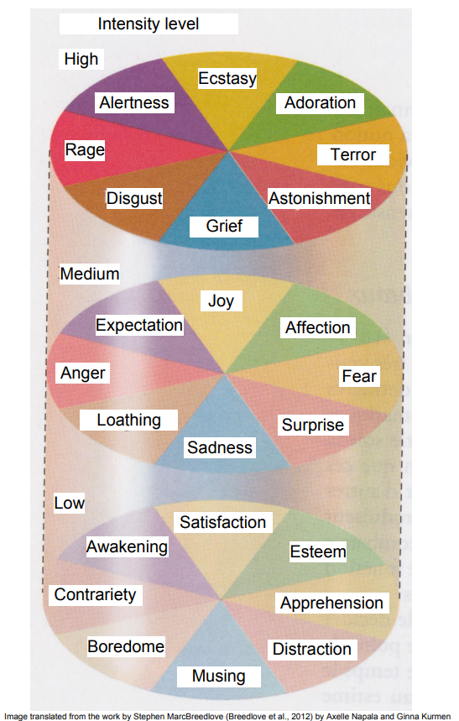
Unlike Virginie Goutte, Stephen Marc Breedlove identifies not six but eight fundamental emotions represented in figure 9. These emotions would be assembled in pairs of antagonists each represented by one facing the other in the diagram: joy / sadness, affection / loathing, anger / fear, expectation / surprise. Medium-intensity emotions are considered core emotions and vary according to their intensity.

Stephen Marc Breedlove clarifies that the number of emotions, whether six or eight, is not formally established. There is no way to count emotions with certainty. Most researchers, however, rely on the study of facial expressions unambiguously recognizable by another person. It is for this reason that he takes the party, like the researchers behind these studies, to identify eight.

Figure 9 - Fundamental emotions.
This figure is taken from the work by Stephen MarcBreedlove (Breedlove et al., 2012) to schematically present fundamental emotions according to their level of intensity. They are classified into antagonistic pairs, at different levels of intensity and divided into modalities. This model is close to that of Robert Plutchik who also associates each emotion with a basic animal behavior (for example, terror which leads to freezing, anger to attack, etc.) which is discussed in the text.

Pascale Toscani also discusses social emotions that "are triggered by social situations and play an important role in our lives" (Toscani et al., 2017). The author explains that the intensity and triggers vary from one individual to another depending on education, family environment or culture for example. She cites compassion, envy, pride, embarrassment, shame, jealousy, guilt, contempt and admiration as social emotions. Even though these emotions are caused by social factors, they are still unique to the individual and felt in a subjective and internal way.

Mechanisms of emotion
Jean-Jacques Paillera took up Antonio Damasio's point of view to explain the triggering of an emotion. According to him, the perception of an emotionally competent stimulus provokes its representation in the cerebral areas linked to the sensory organs perceiving the stimulus. He calls this phenomenon the presentation. Emotion triggering sites are stimulated by signals. The stimulation is only possible if the triggering sites correspond to the signals sent. This is what he calls induction. These sites will then activate, elsewhere, other so-called execution sites. The cascade of events that follows will become an emotion" (Pailler, 2004).

Stephen Marc Breedlove presents four theories explaining the mechanism of emotions. Figure 10 summarizes these conceptions.

The first theory represented in Figure 10.a is a popular theory according to which "autonomic reactions are caused by emotions" (Breedlove et al., 2012). The author specifies, however, that "the relationship between emotion and physiological arousal is much more subtle than that" (Breedlove et al., 2012).

The second theory presented (Figure 10.b) is that of William James and Carl G. Lange, according to which emotions are perceptions of somatic changes, that is to say that emotion is felt when the activation of the body (by stimuli) is perceived by the individual. This conception was later discarded because it "did not provide a satisfactory explanation of emotion [although] this theory contributed to the notion that the experience of emotion involves a 'reading' of the individual's somatic state" (Breedlove et al., 2012).

The third theory (figure 10.c) is that of Walter Cannon and Philip Bard. These physiologists disagreed with the previous theory because "the experience of emotion likely begins long before somatic changes appear" (Breedlove et al., 2012), and this would be justified by the slowness of the latter. According to them, somatic reactions are "alert responses of an organism to a sudden threat [or event], which produce maximum activation of the sympathetic system in order to prepare the organism" (Breedlove et al., 2012) to react. The emotions would then have a psychobiological function that would allow the individual to face the environmental variations. In this theory, it would be up to the brain to decide which emotion in particular constitutes an adequate response to a stimulus. The cortex would then decide "the most appropriate emotional response and at the same time activate the autonomic system so that the body is ready to react in the way the brain considers appropriate" (Breedlove et al., 2012).

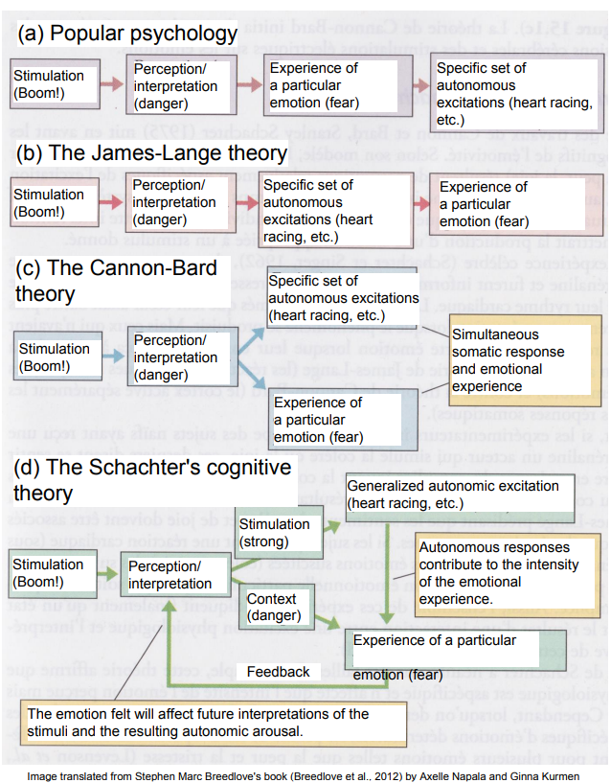

Figure 10 - Theories on emotional mechanisms.
This figure comes from Stephen Marc Breedlove's book (Breedlove et al., 2012) and schematically presents emotional mechanisms according to four different theories. The example used is that of a deflagration ("Boom!").

Stanley Schachte remains at the origin of the last theory (figure 10.d) quoted by Stephen Marc Breedlove. According to him, "emotional manifestations result from relatively non-specific perceptions of physiological arousal, to which is added an interpretation, in real time, by an internal cognitive system of the social, physical and psychic situation of an individual'' (Breedlove et al., 2012. The emotion is then produced appropriately to the stimulus by a cognitive intervention. According to Stephen Marc Breedlove, this theory also has several flaws concerning the fact that physiological arousal would be non-specific and would only affect the intensity of the perceived emotion without affecting its quality.

These theories are also cited by Marianne Habib, who adds others such as dimensional theories or theories of cognitive evaluation (the reference theories at the present time). In the latter, emotion is defined as a process and not as a state. The perception and the evaluation of the situation have a central place in the cognitive evaluation theories, they place the cognition in the center of the emotional process "since the emotion is the direct result of the cognitive evaluation" (Habib et al., 2018). The author defines cognitive evaluation as a process capable of detecting and evaluating "the importance of the environment for the well-being of the individual. This notion of well-being is based on concepts such as values, needs, beliefs or current goals" (Habib et al., 2018). According to these theories, emotion would be a dynamic and multidimensional process with five components. Four of them are the same as those defined by Stephen Marc Breedlove and presented previously. The fifth is "the cognitive evaluation of objects or situations, which allows the triggering and differentiation of emotions and takes place at the level of the central nervous system" (Habib et al., 2018).

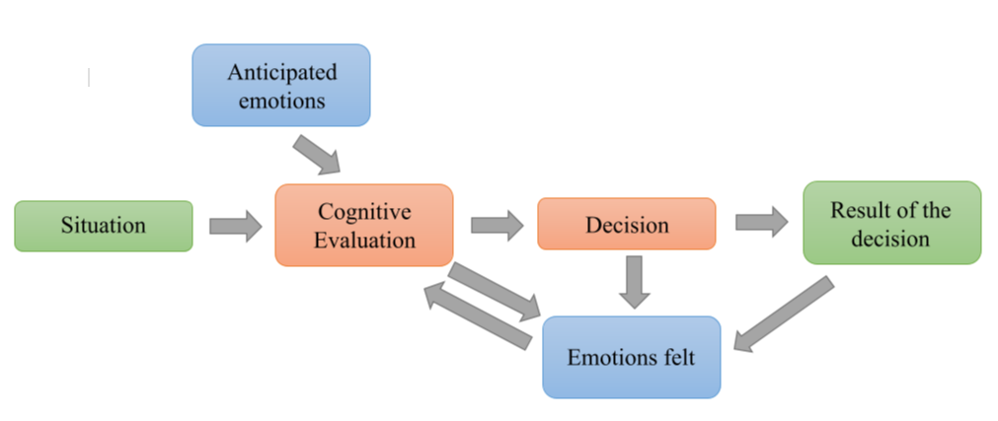

Figure 11 - Theory of cognitive evaluation.
This figure is inspired by Marianne Habib's book and represents the schematization of the place of emotions in the decision-making process according to cognitive evaluation theories.

Figure 11 illustrates Marianne Habib's point and shows that cognitive evaluation is involved in a situation in order to lead the individual to make a decision that will lead to an outcome. Emotions have a predominant place in this model. Indeed, anticipated and felt emotions influence cognitive evaluation. The latter reciprocally influences the felt emotions. The decision also has an impact on the emotions felt as well as the result of the decision. Thus, emotions have a central place in the decision-making process.

Certain areas of the brain are particularly involved in the mechanisms described. The amygdala is responsible for the decoding of emotions, particularly stimuli that threaten the organism. The thalamus and the hippocampus communicate sensory information to the amygdala, which allows it to link the perceived stimuli with the appropriate somatic state. The hippocampus is mainly involved in long-term memory and therefore in the storage and recall of explicit memories. It stores emotional experiences, which allows us to learn from these experiences in order to adapt our behavior when similar situations occur again. The hypothalamus is involved in the activity of the autonomic nervous system and is the link with the endocrine system. The cingulate gyrus connects the two hemispheres of the brain and therefore allows the communication of information between the different brain regions of the limbic system. The four areas mentioned here constitute the limbic system, which is considered "the emotional region of the brain" (Habib et al., 2018).

Anna Tcherkasoff and Laurie Mondillon evoke the capacity of self-regulation of emotions. They explain that "emotional regulation consists in attenuating, intensifying or maintaining a positive or negative emotion [...]. It refers to the processes, both intrinsic and extrinsic, that allow us to learn to recognize, explore, evaluate, and modify an emotional reaction". These processes allow us to modify the duration and/or intensity of one or more emotional components. There are two main ways to regulate emotions: cognitive reappraisal and distraction. The first consists of modifying the method of evaluation of the emotional antecedent in order to alter its emotional significance. Distraction consists in diverting one's attention from the emotional experience to a cognitively demanding task in order to use working memory resources on the focal activity at the expense of the negative emotional information. Emotional self-regulation allows the individual to adapt his social behavior. It would then be a question of "emotional intelligence". This would promote social well-being as well as good health.

Participation of emotions in learning
Slim Masmoudi and Abdelmajid Naceur highlight studies in psychology and neurobiology that show that emotions can have a positive impact on cognitive functions and learning. They cite various research studies that show the importance of emotions in cognitive functioning and their participation when decision making. The authors identify two distinct processes constituents of the latter: logical-mathematical intelligence and emotional intelligence. The first refers to reasoning, logic and rationality. The second would be rather dependent on "skills dedicated to the management of intra- and inter-individual emotions" (Masmoudi & Naceur, 2010) (the capacity for self-regulation). It is the collaboration of these two forms of intelligence that would favor decision making, problem solving, language, etc. This is in line with what was discussed in section 1.3.4 on the fact that "positive" emotions could promote the effectiveness of reasoning and vice versa for "negative" emotions. The authors cite six studies that explore the involvement of emotions in decision making. They also conducted their own exploratory study.

The analysis of these different studies has shown that emotion is not "simply a factor that colors our choices, yet more important, emotion is considered as a specific processing that leaves traces in our cognitive activities of the decision and shapes our decision-making styles" (Masmoudi and Naceur, 2010). The ability of the individual to identify, understand, evaluate and regulate his or her emotions contributes "to the control of mental processes that can support decision making, the perception of useful information that promotes the achievement of a specific goal, the retrieval and regulation of necessary knowledge" (Masmoudi and Naceur, 2010). The result is that emotion allows to put forward the most positively marked actions and to inhibit their antagonists. Emotion also allows to "label" the sub-goals elaborated during a problem-solving task in a positive or negative way. It is therefore established that emotions have an impact on cognitive functions such as reasoning, but the reverse is also true. Indeed, the self-regulation of emotions calls upon cognitive processes such as reasoning in order to maintain or inhibit the emotion at stake. Emotions and cognitive functions interact and collaborate in order to reach decisions, choices that will allow us to reach the set goal.

The results of these studies have allowed us to understand the role that emotions play in decision making and by extension in a problem solving task. It is then possible to make the link between these findings and the learning process in general. Thus, both intra- and inter-personal emotions are involved when the learner is in a learning situation. Acting on these emotions or rather accompanying the learner to act on his emotions can allow him to improve his cognitive performance or at least help him to avoid using them as an obstacle to learning.

In the context of the CreaCube task, there is no interaction with a teacher to accompany him in this sense. However, this does not mean that the learner's emotions do not come into play. This activity does not initially aim to analyze the learner's emotions. However, taking this aspect into account and observing the learner's bodily reactions (e.g. facial) could allow us to identify the points of difficulty or ease of the learner during the task, for example by detecting boredom or interest. In order to understand how a learner learns, identifying these somatic markers during the resolution of the task could allow us to identify the extent to which it is necessary to take the emotions into account during a learning situation.

1.3.8 Mental functions: conclusion

The different cognitive functions presented here allow us to conclude that each of them, at its own level, intervenes in the learning process, collaborating and interacting with each other to enable the learner to make the most of a learning situation. It is their consideration, observation, and analysis that can lead to an understanding of "how the learner learns". As mentioned, this is not so simple because these cognitive functions can equally promote or hinder learning depending on the internal or external context of the learner, and it is difficult to measure each of these factors. However, identifying the mechanisms at stake at each moment of the task can already allow us to learn more about how learning works and the degree of involvement of cognitive functions throughout.

1.4 Metacognition

1.4.1 General information
Another aspect of cognition and mental processes is to be taken into account for learning. Indeed, Jean-Philippe Lachaux explains that metacognition is crucial for learning and the transferability of competencies (Lachaux, 2018).

Olivier Houdé precises metacognition as "the set of processes, practices and knowledge that allow each individual to control and evaluate his or her own cognitive activities, i.e. to regulate them" (Houdé et al., 2018). He specifies that cognitive activity consists of "everything we do when we think" (Houdéet al., 2018).

Jean-Philippe Lachaux mentions metacognitive support during a game, an experiment or a problem-solving task as being essential in order to allow the learner to identify the mental processes involved and thus be able to transfer his or her acquisitions to other situations. Olivier Houdé confirms this point of view by writing: "just as the teacher chooses his or her practices, the student chooses (or refuses) to act cognitively, to respond to the solicitations of attention and effort in the manner required to accomplish the proposed task" (Houdé et al., 2018). Thus the elaboration of the task, the task itself, and its resolution depend on the cognitive and metacognitive investment of the task designer and the learner attempting to solve it. The author notes that "it is essential for the teacher as well as for the student to appropriate in a practical and concrete way his part of the shared cognitive activity, and to understand what conditions its success" (Houdé et al.,2018).

Furthermore, metacognition is brought into play by the mental functions in an evaluation process upstream (prediction) and downstream of the task (evaluation). This is done in relation to the learner's perception of the task, but also to the learner's perception of himself.

In 2004, Margarida Romero studied the role of metacognition in learning, contextualized in an Intelligent Tutoring System (ITS). She cites several definitions of metacognition related to the previous information. Metacognition would then be "awareness of the cognitive experience and acquired knowledge" (Romero, 2004). This awareness would allow the selection, revision and abandonment of "certain cognitive tasks, goals or strategies" (Romero, 2004). Furthermore, the author explores the notions of metacognitive knowledge (knowledge about cognition) and metacognitive skills (processes of monitoring, control and regulation of cognition).

Didier Le Gall and his collaborators agree with the elements previously discussed by defining the notion of metacognition as referring "to the knowledge one has of one's own cognitive processes, their products and everything related to them" (Le Gall et al., 2009). He specifies that it refers to "the active monitoring, regulation and orchestration of these processes in relation to the cognitive objects or data on which they usually focus in order to satisfy a concrete goal or objective" (Le Gall et al., 2009). Cognizance is a component of metacognition. It comes into play during the planning stage, which takes place before the resolution of the task. It refers to a general knowledge that is not dependent on the cognitive activity in progress. Conversely, cognizance referring to a knowledge that depends on this activity comes into play during the execution of the task and allows the regulation of cognition.

1.4.2 How metacognition works

According to Didier Le Gall (Le Gall et al., 2009), planning and control are the main functions of cognitive regulation. The first allows for the development of a plan of action and depends on the learner's metacognitive knowledge, while the second allows to evaluate the effectiveness of this plan during its implementation in the resolution of the task.

Learning plan is made possible by the implementation of metacognitive strategies as regulation techniques. These strategies also make it possible to overcome the difficulties encountered in the revision of goals and/or sub-goals. "They can either be acquired implicitly, through successive trial and error, or be explicitly taught" (Houdé et al., 2018). There are three types of metacognitive strategies: directive (optimizing the achievement of a cognitive goal), preventive (protection against illusions and reasoning biases), and motivational ("aiming at raising awareness of the importance of learning, seeing error constructively, maintaining a flexible representation of one's own intelligence, etc." (Houdé et al., 2018)).

As for Olivier Houdé, he evokes the terms cognitive activity of control and evaluation. He specifies however that all is not controlled and stored in memory. In fact, mental functions and in particular "perception, memory and reasoning have a receptive dimension" (Houdé et al., 2018). Perception can be exercised without (the existence of) a specific goal. It is also possible to learn implicitly (without wanting to, without intending to) and have uncontrolled memory flashes. Nevertheless, "perception, memory and reasoning are controlled by a goal of knowing[...] Most of mental life consists of efforts to identify, recognize, learn, solve problems or recall knowledge" [Houdé et al., 2018]. Cognitive efforts are modulated by metacognition according to four dimensions during a prediction or predictive evaluation stage (first stage of control): "1/ the importance of the goal, 2/ the intrinsic interest of the activity, 3/ the effort likely to be required to accomplish it, 4/ the probability of achieving it, given the present circumstances" (Houdé et al., 2018).

Once the control has been completed and the learner is committed to the task, the monitoring stage follows. A retrospective evaluation of the action implemented following the planning is necessary to verify the achievement of the goal or sub-goal. During this evaluation, implicit predictions (heuristics) allow the comparison between the possible divergence between the characteristics of the result obtained and those expected.

As mentioned above, metacognition intervenes upstream of the task by the prior evaluation of the situation (should we act or not) and then by the planning. Furthermore, it also intervenes "retrospectively, to inform the system about the correct execution of the action. In both cases, prediction or evaluation, what is estimated is the divergence between the 'expected feedback' [...] and the 'observed feedback' (Houdé et al., 2018). When the divergence occurs, an error signal is produced generating an abandonment or a revision of the action. Conversely, if there is no discrepancy, the learner continues the action or accepts the result. “The successive cycles of control-monitoring-control are thus at the basis of all cognitive activity” (Houdé et al., 2018). This phenomenon is represented in Figure 12.

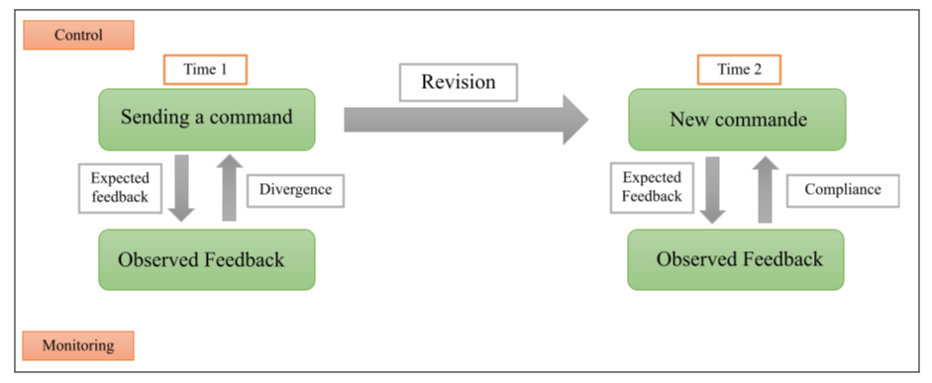

Figure 12 -Cycles of control-monitoring-control of metacognition over time.
This figure is inspired by the diagram made by Olivier Houdé [Houdé et al., 2018]. It represents the control-monitoring-control cycles. Orders correspond to orders given and feedback to progress observations. The upper level is the active level giving orders while the lower level corresponds to the subordinate level providing activity reports.

Moreover, Olivier Houdé explains that affects play an important role in metacognition. He speaks of noetic feelings, i.e., linked to the acquisition of knowledge: "It is a feeling of difficulty that motivates the decision to deal with the problem or not and modulates the effort required. It is the feeling of progress that drives perseverance" (Houdé et al., 2018). The latter are the product of an automatic brain processing that evaluates "the opportunities to act cognitively and [adapts] individual cognition to the difficulties encountered" (Houdé et al., 2018). It is the heuristics (in the sense, here, of associations between certain parameters of the activity and the result obtained) that make this brain processing possible. They make it possible to use predictive or evaluative cues concerning the success of the task in hand. Noetic feelings (in the sense defined above and which allows here a more precise denomination than the term thought) of knowing or ignoring are provoked by the extent of the discrepancy between the expected and observed cues. "Several heuristics can be combined, and give rise to a single noetic feeling that integrates all the predictive information" (Houdé et al., 2018). One of the heuristics involved in cognitive feelings is the fluency heuristic.

The heuristics involved in metacognitive feelings are constructed and realized without the learner's knowledge. Cognitive feelings serve as an interface between implicit automatic processes (the previously mentioned heuristics) and controlled explicit processes.

The author also links intrinsic motivation⁶⁰ and attention with metacognition. He specifies that the learner's commitment depends on his intrinsic motivation towards the task. It is the adaptation of this task to the right extent that will allow the learner to set sub-goals to achieve the goal of solving the problem at hand. In addition, intrinsic motivation influences the forms of attention engaged in the task. There are four types of attentional goals identified by Michelene T. H. Chi and Ruth Wylie in the ICAP model (Chi & Wylie, 2014):

- Passive attention: the learner "merely follows what is said, or at least what he understands. Knowledge remains atomic and not integrated" (Houdé et al., 2018). It gives rise to metacognitive feelings of ease of processing (mastery of a lexicon).

- Active attention: the learner "manipulates the content, takes notes, rereads" (Houdé et al., 2018). Lexical fluency then becomes conceptual fluency. The metacognitive feelings of understanding and pleasure of discovery come into play.

- Constructive attention: the learner "rephrases the content in his or her own words, makes connections between several concepts, etc." (Houdé et al., 2018). Attention is gradually freed from the proposed lexicon and the metacognitive feelings at play in the previous level intensify.

- Interactive attention: the learner "discusses the material with a peer, debates with them about the value of the arguments, etc." (Houdé et al., 2018). It is centered on communication structured by a knowledge issue which implies implicit metacognitive evaluations of plausibility, coherence, relevance and rational justification of what is proposed.

The learner's performance is improved between the first and last attentional forms. Different forms of control and monitoring of cognitive activity are then at play.

1.4.3 Metacognition: conclusion

It is then possible to establish the role that the exploitation of metacognition could play on the resolution of the CreaCube task and more broadly in game-based learning. Indeed, the learner could verbalize his progress throughout the problem solving in order to identify the cognitive processes involved by implementing metacognitive strategies and thus highlight the prior knowledge or the curiosity justifying the learner's actions and progress in the task. Moreover, it would be possible to understand the strategy implemented by the learner to reach the goal by verbalizing the sub-goals that he/she has identified as allowing him/her to reach the solution.

Understanding what the learner mobilizes ("the what") and implements, but also how he implements it ("the how") during a problem-solving task, could help us learn more about the learning process. As for the learner, this would allow him to promote his learning. Indeed, by identifying the processes involved and by justifying his actions and reasoning, he will be able to transfer his acquisitions more easily to a different task. On the other hand, as Jean-Philippe Lachaux (Lachaux, 2018) explains, by multiplying the supports and the forms of tasks while making the most of metacognition, the learner will find it easier to transfer his or her knowledge. This will also allow the learner to bring into play a more efficient attentional form involved in metacognition.

1.5 De la cognition à l’apprentissage humain: conclusion

In the course of this conceptual exploration, the place of cognition in each of its aspects during learning was highlighted. The multidisciplinary aspect of this leads to take into account the diversity and complexity of the interactions at stake in this process. Information, cognizance, knowledge, cognitive functions, metacognition, all these elements are constitutive of human learning. Their implications have been explored and have shown to what extent learning is a process as complex as it is essential to human development. This confirms the importance of understanding how this process works.

Some notions have been approached in a transversal way without having been precisely defined. Motivation, curiosity, intuition, goals, and digital technologies are among these notions and are at the heart of the problematic at the origin of this work. Indeed, the FLOWERS project team has demonstrated that motivation plays a fundamental role in improving the quality of learning. This team has created algorithms that allow this, to a certain extent. In addition, it was discussed in this first part that the involvement of different cognitive functions in problem solving was made possible in part by the goal. More precisely, it is the existence of an intrinsic or extrinsic goal that motivates the learner to engage in a task and a fortiori in a learning task. This is at the heart of the work carried out within the AIDE exploratory action.

Thus, to arrive at a model of the learner and to try to understand how the learner learns, we must explore these notions. In the light of these conceptual insights, the learning process and what constitutes it can be made explicit. This will then lead to the definition of the notions previously mentioned in order to remove ambiguities and to identify their role in this process. Finally, the study of the work carried out by the FLOWERS team will allow us to complete the ontology in charge of representing in a symbolic way the learner who learns during a problem-solving task.

2 The role of motivation in learning

2.1 Learning process

Jean Frayssinhes and Florent Pasquier describe learning as a "cerebral reaction to a stimulus, a novelty" (Frayssinhes and Pasquier, 2018). They also specify that the brain "must be in interaction, [...] awake, motivated, concentrated" and that it "arouses emotions that are linked to memory" (Frayssinhes and Pasquier, 2018).

Alain Lieury defines learning as "the systematic modification of behavior in response to exercise" (Lieury, 2017). There are various levels of learning that would be related to "the complexity of the nervous system, particularly the brain" (Lieury, 2017).

In this sense, it seems obvious that different factors can influence the learning process. The cognitive aspects involved and necessary for this process have been detailed previously. In addition, several theories have been developed over the years in order to clarify the mechanisms involved and their evolution over time and the progress made in this field. These theories will therefore be presented here and will allow us to clarify the concepts that have not been clarified until now.

2.1.1 Theories of human learning

According to Mohammed Chekour, the contribution of learning theories and their evolution allows us to advance in the understanding of the learning process: "learning theories aim to explain the phenomenon of knowledge acquisition" (Chekour et al., 2015). He cites five of them that have succeeded him: behaviorism, cognitivism, constructivism, socio-constructivism and connectivism. We are talking here about theories of human learning and not theories that formalize machine learning: the link between the two fields remains to be built.

Behaviorism
Behaviorism is also called behavioral learning theory because it focuses on the study of behavior. Mohammed Chekour explains that this theory "is a theory of learning that focuses on the study of observable behavior, without appealing to internal brain mechanisms or mental processes that are not directly observable" (Chekour et al., 2015).

The psychologist John Watson is at the origin of behaviorism and was inspired by the physiologist Ivan Pavlov on conditioning to develop the theory of "stimulus-response".

Alain Lieury discusses conditioning and sensory-motor learning as primitive modes of learning that require tens or even hundreds of trials. He illustrates this phenomenon with a Pavlovian experiment on salivation in dogs during the digestive process. The dog salivates reflexively at the sight or contact of food (unconditional stimulus), and the experiment consists in associating this unconditional stimulus with a conditional stimulus, the sound of a metronome. After 30 trials, the dog salivates as much at the sound of the metronome as at the sight of food. In humans, the conditional stimulus is found when learning to ride a bike, type, or drive a car, for example.

Frédéric Alexandre has also studied the Pavlovian theory. He explains that responses to stimuli are stereotyped and are the consequences of learned associations (conditioning). These responses are also called "Pavlovian reflexes". According to the author, Pavlovian learning allows for the anticipation of the positive or negative characteristics of an unconditioned stimulus as soon as the conditional stimulus arrives, thus preparing the individual for the event that will occur (Alexandre, 2021).

Today, conditioning and sensorimotor learning are re-grouped under the term implicit memory (Lieury, 2017). More precisely, emotional conditioning and conditioned reflexes are associative learning linking a stimulus to an emotional or behavioral response, as in the Pavlovian framework. Beyond that, procedural memory allows the acquisition of motor skills (which concerns habits and competencies), possibly complex (riding a bike is the most often cited example, which once memorized no longer requires precise recollection for reuse). Moreover, the priming effect is an increase in abilities following prior exposure to pertinent information.

Mohammed Chekour also quotes Gustav Theodor Fechner concerning the stimulus-response model. He "compares the individual to a black box, of which we know nothing about what happens inside, but of which we can predict certain behaviors since by proposing particular stimuli we always obtain the same results at the end" (Chekour et al., 2015). The model from this theory is shown in Figure 13.

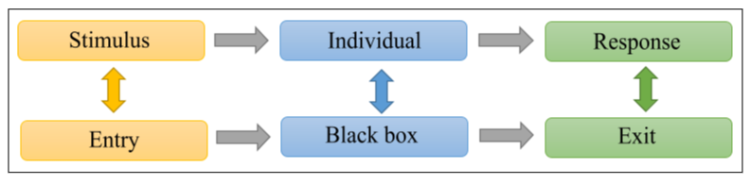

Figure 13 - Fechner's behavioral model.
This figure is inspired by the diagram presented in the article by Mohammed Chekour (Chekour et al.,2015). It represents Fechner's behavioral model. The colored arrows represent the comparisons between the learning individual and what is scientifically observable according to the behaviorist learning theory. The gray arrows represent the succession of learning stages.

The author explains that, for behaviorism, learning is considered "a lasting change in behavior resulting from particular training" (Chekour et al., 2015). For example, according to Fechner's model, the stimulus could correspond to a notion discussed in class and the response would be the manifestation of an expected behavior showing that the notion is assimilated as knowledge. This is made possible by repetition, and positive reinforcement. The observation of unexpected behavior, suggesting that the learner has not integrated the knowledge from the transmitted notion, implies the need to repeat the process until the expected behavioral response is observed. When the response conforms to expectations, positive reinforcement comes into play to validate the integration of knowledge. "In this theory, the learner is a student who listens, watches, reacts, and tries to reproduce in front of a teacher who is an emisor of information, of knowledge, which presents, describes, schematizes, plans and verifies" (Chekou ret al., 2015). This means that the learner does not really attribute any meaning to the knowledge thus restored and that he is not aware of the different stages of his learning.

Mohammed Chekour highlights the ease of application of this theory while pointing out the fact that it is insufficient to lead to realistic modeling of learning: "If this theory is adequate in the perspective of introducing the digital machine, it seems too poor to last" (Chekour et al., 2015).

Emmanuel Duplàa identifies two limits to the cognitivist (or what he calls computationalist) theory: "the first concerns the "Von Newmann bottleneck" which forces the establishment of sequential rules for the processing of symbolic information; the second lies in the fact that symbolic processing is localized and that the loss or malfunctioning of a part of the symbols or rules of the system causes a malfunctioning of the whole" (Duplàa & Talaat, 2011).

Cognitivism
Cognitivism, also called rationalism, focuses on ways of thinking and solving problems. This theory was developed by George Armitage Miller and Jerome Seymour Bruner at the birth of artificial intelligence. The cognitivist point of view is to consider that "learning cannot be limited to a conditioned recording, but rather must be seen as requiring a complex processing of the information received" (Chekour et al., 2015). This theory is based on the structure of memory which "involves the organization of information and the use of strategies to manage this organization" (Chekour et al., 2015). Knowledge is thus organized according to its type: declarative, procedural, or conditional. Consequently, the integration strategies are different since the different types of knowledge are not represented in the same way in the memory. According to Mohammed Chekour and according to cognitive psychology, "declarative knowledge responds to WHAT, procedural knowledge to HOW and conditional knowledge to WHEN and WHY" (Chekour et al., 2015).

Frédéric Alexandre explains more precisely what is implied by these questions and adds the "where", knowing that the "when" corresponds to a temporal localization, whereas the "where" is a spatial localization.

According to him, the "what" and the "why" make it possible to connect the internal body and the external environment. The "what" question would be a means of encoding a conditional stimulus (current goal of the behavior) as well as its emotional impact. The "why" corresponds to the characteristics of the motivational impact on the body. It is useful for encoding the impact of unconditional stimuli or the bodily cost of a response to obtain it. This question helps to identify why the individual acts (for what purpose) and why he or she is willing to expend energy (to what level) to do so.

The author goes on to say that the questions "where" and "how" make the link between the extended body and the external environment. The "where" allows us to gather information about the location of an object in the external environment and this in relation to the body (or to certain parts of the body). This is what also allows us to orient ourselves in the environment. Finally, the question "how" refers to the need to learn how objects can be modified by the action of certain body parts (Alexandre, 2021).

Cognitivism considers that the learner "is an active information-processing system, similar to a computer: he perceives information from the outside world, recognizes it, stores it in memory, and then retrieves it from his memory when he needs it to understand his environment or solve problems" (Chekou et al., 2015). It is no longer just a matter of acquiring observable behaviors, as suggested by behaviorist theory, but of integrating knowledge as an external reality into one's mental schemas. This implies diversity in the learning process since, according to this theory, individuality is a factor that influences the way information is processed.

Mohammed Chekour presents, however, a limit to the cognitivist theory concerning the motivational aspect which must be taken into account in the realization of the model because it is this aspect that leads the learner to invest his resources in the learning task.

Constructivism
According to Pierre Cieutat and Sylvain Connac, constructivism or cognitive construction theory is based on the fact that learning "is not adding, but transforming an existing internal organization, in view of an environment that induces appropriation" (Cieutat & Connac, 2017). Jean Piaget is at the origin of this theory "based on the idea that knowledge is elaborated by the learner on the basis of a mental activity" (Kerzil, 2009).

According to Jennifer Kerzil the learner must appropriate knowledge through exploration as well as through active learning and practice. Knowledge is then built from experience, the goal is that the learner creates its own meaning of the situations and problems it encounters. "The learning process then consists of starting from the action to think in order to achieve the resolution of the problem encountered" (Kerzil, 2009).

The author explains that operating schemas will be mobilized so that the learner will be able to either "incorporate the perceived information into his cognitive structure (assimilation), or modify his cognitive structure in order to incorporate the new elements from the situation (accommodation)" (Kerzil, 2009). This is represented in Figure 14.

Mohammed Chekour quotes Jean Piaget's point of view concerning the definitions of assimilation and accommodation: "assimilation and accommodation form an indispensable couple for the cognitive activity whose different balancing processes will be developed in the balancing of cognitive structures [...] Assimilation designates the reintegration of new external elements into a pre-existing internal structure; accommodation designates the adaptation of the organism to the external variations that it fails to assimilate" (Chekour et al., 201).

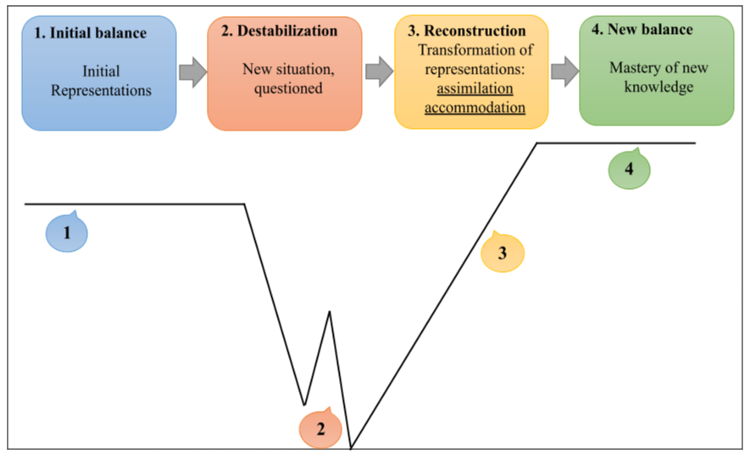

Figure 14 - Learning according to constructivism.
This figure represents the four successive stages encountered during learning, from a constructivist point of view. (1) The learner's initial equilibrium is made up of his or her representations, prior knowledge based on experience. (2) A new situation or a problem to be solved follows which causes an imbalance. (3) The reconstruction phase is made up of the assimilation and accommodation processes which allow for the incorporation of new representations (assimilation) or the modification of the initial representations by incorporating the new elements (accommodation). (4) It is when the new knowledge is mastered that a new and richer state of equilibrium is reached.

The author also quotes Peter Doolittle and lists the eight essential conditions for constructivist pedagogy:

- Present complex learning situations similar to those encountered in everyday life.
- Encourage interaction and collaboration among learners.
- Explain the meaning of learning to learners.
- Learning should be built from what the learner has learned.
- Provide ongoing formative assessment.
- Make learners accountable for their learning.
- Facilitate learning by guiding the learner.
- Use different perspectives to present content.

According to the author, constructivism is still an interesting theory today because it allows learners to be involved in their learning by preserving their autonomy and allowing them to progress at their own pace. This is achieved through the use of diversified, collaborative, or cooperative tools.

Socio-constructivism
As its name suggests, the social constructivist theory is based on the principles of constructivism, emphasizing the social role of learning, a model developed by Lev Vygotsky, according to whom learning also involves social interaction. Mohammed Chekour explains that learning tasks must be in the learner's zone of proximal development, i.e., tasks that are neither too difficult nor too easy, which increases the effectiveness of learning and helps maintain the learner's interest in the task (intrinsic motivation). The particularity of socio-constructivism is to encourage debate (socio-cognitive conflict) by having learners work in groups. Moreover, the author adds that "in this model, errors also correspond to a support point for the construction of new knowledge" (Chekour et al., 2015).

Connectivism
The theory of connectivism was born out of the evolution of learning, or rather of learning tools. The introduction of new technologies in the learner's daily life is also integrated in the educational system. "Developed by George Siemens and Stephen Downes, connectivism questions the process of learning in the digital age and in a networked world by drawing on the limitations of behaviorism, cognitivism, constructivism, and social constructivism" (Chekour et al., 2015). George Siemens defines learning as a process taking place in environments and with changing elements beyond the learner's total control. The author identifies several elements essential to learning according to the connectivist theory:

- The basis for decision making is changing rapidly.
- "New information is being acquired constantly" (Chekour et al.,2015).
- Knowing how to distinguish important information from unimportant information is crucial.
- "The ability to recognize when new information changes the landscape based on decisions made yesterday is also critical" (Chekour et al., 2015).

The development of information and communications technology "has allowed to introduce new educational potential, approaches and pedagogical methods more playful, where interactivity plays an important role, to diversify the tools used and to adapt more to the learning process of the learner" (Duplàa and Talaat, 2011). In this sense, Chun-Yen Chang cites serious games and educational cognitive robotics. These activities have serious advantages because the learner is then an actor in his learning (he produces) during "situations for which traces are collected, which can be replayed to see oneself producing and above all which can be parameterized to be as close as possible to the needs of the student’s cognitive work, in this relationship between mental effort to be provided and help to be received in order to progress" (Chang et al., 2015).

Emmanuel Duplàa explains that connectionism allows the "parallel processing necessary for complex tasks as well as distributed processing that guarantees immunity in case of a problem in one part of the system" (Duplàa andTalaat, 2011). This is in contrast to the limitations encountered in cognitivist theory and is in line with George Siemens' view of connectivist theory, or learning in a networked world. Emmanuel Duplàa cites François Guité who characterizes connectivism "as a model of learning that recognizes the social upheavals caused by new technologies, which mean that learning is no longer just an individualistic and internal activity, but it is also a function of the environment and the communication tools available" (Duplàa and Talaat, 2011).

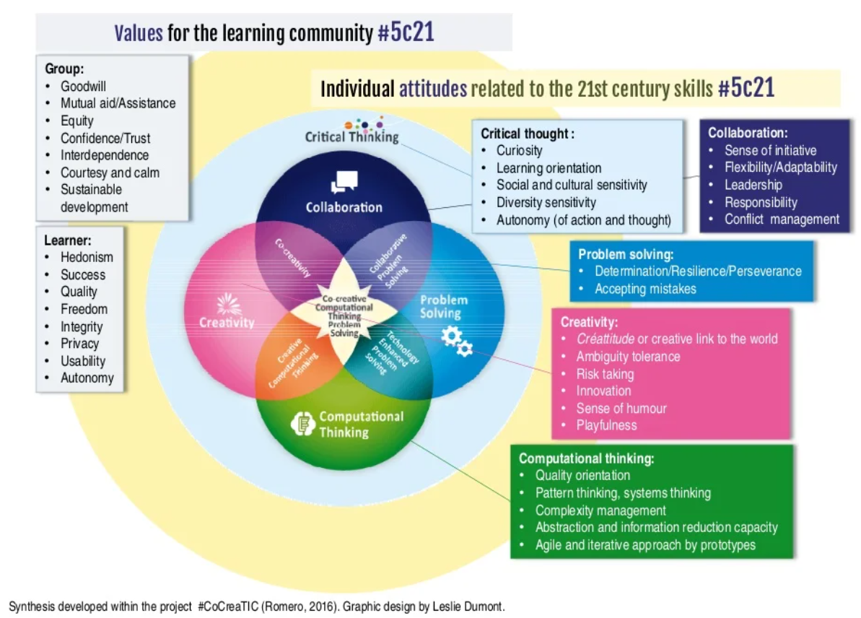

Figure 15 - 21st Century Skills
This image, created by Leslie Dumont as part of the conference "Should digital technology be integrated into the school, in fact?" by MargaridaRomero⁷¹, is a Venn diagram representing 21st century skills mobilized during educational activities.

In 2020, Margarida Romero and Gérard Giraudon analyzed a video by Derek Muller with the aim of demystifying the use of digital and new technologies in the educational system (Romero & Giraudon, 2020). They recall the fundamental impact of the social process in learning and the role of the teacher in this process. Therefore, they explain that computational approaches can be a support, an evolution for education but not a revolution. Margarida Romero also addresses this in a lecture in 2018. In it, she differentiates the types of digital use in educational activities. Indeed, learning is promoted when the activity developed by the teacher mobilizes the skills represented in Figure 15. Digital technology is then an instrument used by the teacher to build new learning activities.

In Figure 15, the learner is represented in the center. He acquires, mobilizes and associates the skills represented by the four colored circles around him. The following relationships are identified:

- Collaboration + Problem Solving = Collaborative Problem Solving
- Problem Solving + Computer Thinking = Problem Solving Using Computers
- Computer Thinking + Creativity = Creative Computer Thinking
- Creativity + Collaboration = Co-creativity

These relationships are integrated into a first set of individual attitudes which is critical thinking represented by a yellow circle in the diagram. These attitudes are associated with values specific to the learner as well as with values held by the group. These values and attitudes are necessary within the learner's social group and essential to learning. They create an environment that is conducive to the development and mobilization of competencies.

All of these elements are found in the eight principles of connectivism as seen by George Siemens and summarized by Mohammed Chekour:

- Learning and knowledge lie in the diversity of opinions.
- Learning is a process linking specialized nodes or sources of information.
- Learning can reside in non-human devices.
- The ability to know more is more critical than what is currently known.
- Nurturing and maintaining connections is necessary to facilitate continuous learning.
- The ability to see connections between domains, ideas, and concepts is a basic skill.
- Obtaining accurate knowledge with the ability to update it is the intent of connectivist-based learning.
- Decision-making is a learning process in itself. The importance one gives to information varies over time, depending on changes in the environment of that information.

Although the advantages of this theory have been demonstrated, it is not unanimously accepted in the scientific community. Indeed, Plon Verhagenne does not consider connectivism to be a theory of learning but rather a pedagogical trend that "essentially discusses the type of knowledge that the student must acquire and the skills to be developed in order to make these acquisitions. The connectivist model focuses more on the organization of learning and does not indicate anything about how the student learns, and therefore about the actual process of learning" (Duplàa and Talaat, 2011).

Emmanuel Duplàa also cites Bill Kerr as a detractor of connectivism. The latter "does not consider connectivism as a radical change at the theoretical level. In particular, he thinks that there are already theories that can be used in the digital age and does not see much difference between connectivism and the theory of distributed cognition" (Duplàa and Talaat, 2011).

Learning theories: conclusion
The different theories presented have successively shed light on and shown developments concerning the foundations of learning. Each one has its advantages and limitations.

The CreaCube problem solving task, at the center of this work, does not belong to one theory in particular but benefits from several of them.

Indeed, this task mobilizes, among other things, the learner's sensory-motor skills. During the problem solving process, the learner is filmed so that it is possible to observe his or her behavior in relation to the learning tool used. It is then possible to make the link between the stimulus-response system of behaviorism and the learner's action during the detection of affordances, for example, when the learner detects the switch and flips it. It is then possible to make the link between this example and the notion of Pavlovian reflex discussed by Frédéric Alexandre.

Moreover, in this task, the learner is not considered as a black box (as it is the case in behaviorism), but as a complex and active system that mobilizes cognitive functions. In particular, the learner uses his memories to solve the problem using his prior knowledge (for example, his knowledge of the components of a vehicle in order to respond to the instruction). This refers to the complex information processing found in cognitivism. Furthermore, the learner is considered according to the three worlds of cognition, i.e., a body (external environment) that interacts with the learner's internal environment and the external environment, as studied by cognitivist theory.

In the continuity of this and in reference to constructivist theory, the learner is taken into account as an active complex system whose cognitive construction allows the mobilization of his prior knowledge as well as its updating during the problem-solving task. The learner learns from the situation, from his experimentation and appropriates the knowledge. He is able to make inferences to arrive at the resolution of the problem (for example, a vehicle has wheels placed on a horizontal plane in order to move forward, this cube has wheels, so the wheels of this cube must be positioned on the horizontal plane). During this task, the learner can either integrate new knowledge through a process of assimilation or update existing knowledge through a process of accommodation.

Finally, the connectivist theory combines with the previous ones to promote learning, through a robotic object, in a playful way that mobilizes all the resources of the learner in everything that constitutes him and his environment. The cubes are a robotic learning object that encourages the learner's interest and curiosity and thus his commitment to solving the learning task. It is the novelty and variety of the pedagogical tools that allow the learner to transfer his knowledge to various situations by adapting to what constitutes him as an individual. Indeed, in the example of the CreaCube task, there is no single correct solution and learning is not conditional on the success of the task. Learners can call upon various resources according to their own knowledge, creativity, etc., to succeed in solving the problem posed because there are many ways to solve it. Moreover, even a learner who fails in the task learns by manipulating, by trial and error, by being curious, etc.

2.1.2 Acquisition methods

The theoretical aspect of the different forms of human learning comes from the learning theories previously explained. They lead to the study of methods of acquisition

The objective here is to briefly complete the previous development by explaining concretely what happens during learning, from the point of view of the learner's experience and the observables that can be measured, without repeating the previous elements, while drawing a parallel with machine learning.

Jean-François Richard writes in the preface to Anh Nguyen-Xuan's book (Nguyen-Xuan, 2021) that there are different modes of acquisition of human learning that would be at the origin of cognitive skills. He cites four of them:

- The first is problem solving. It consists in "learning guided by the search for a goal that one strives to reach" (Nguyen-Xuan, 2021). The CreaCube task being a problem-solving task, this acquisition method is particularly interesting to analyze. Machine learning that is closest to this method is the one acting by reinforcement. The agent is put in a situation and makes decisions according to its current state. It learns through a trial-and-error mechanism, through experience. As the decision-making process progresses, the environment sends feedback to the agent in the form of "reward" or "punishment". This influences the rest of the decision-making process, in order to improve it.

- The second method allows the learning of rules, intentionally or not, from examples. This makes it possible to study how the learner learns without intending to learn or, on the contrary, to study the development of discovery strategies. The learner loses control of the learning situation, whereas his or her actions can change the situation in the first method . From the information thus obtained, he then discovers the constraints and learns how to succeed in the task. In machine learning, it is possible to link this method to supervised learning. The latter makes it possible to arrive at a response predicted by the machine when faced with input data compared to examples. This comparison allows the adjustment of the parameters in order to progressively reduce the error.

- The third method is centered on the knowledge pre-existing to the learning. The learner is thus trained to solve tasks under the same conditions. He must then mobilize the knowledge acquired during these learning situations to solve a task of the same order but with additional conditions. The notion of novelty is pointed out here. Moreover, the two previous modes also use pre-existing knowledge, whether for problem solving or for learning by example. Unsupervised machine learning could correspond to this mode of acquisition in the sense that it is based on a priori elements.

- The fourth method deals with the notions of intentional and unintentional learning. The latter are closely linked in this fourth method e (unlike the second mode where they appear separately). It is then a question of learning by causal relations (for example, relations of cause and effect). The author cites examples of physical (top/bottom) and conceptual (same/different) acquisition during development. Extensive research concerning machine learning by causal inference is conducted in order to model this method of acquisition. Philippe Brouillard explains that by "integrating principles from the domain of causality [to deep learning models, which are purely statistical], it becomes possible to model changes incurred when the environment undergoes modifications” (Brouillard, 2021). He adds that "some of the desired capabilities of artificial intelligence (generalizing, developing, and using conceptual models) that are not present in current models seem attainable by integrating concepts from the domain of causality" (Brouillard, 2021).

These acquisition methods are mobilized in the CreaCube task in order to study human learning. The first method concerning problem-solving is at the heart of this task. When solving this task, prior knowledge is mobilized and plays an important role: understanding of the instructions, accumulated knowledge about the components of a vehicle, etc. This refers to the third method of acquisition, which is the learning of the vehicle. This refers to the third mode of acquisition. Finally, the fourth mode is essential in the context of this task, since it is thanks to this mode that the learner can adapt to his environment and take into account the changes that take place when handling the cubes, for example. Moreover, the examples of causal relations cited previously by the author are quite representative of what is at stake here: this cube is below or above that one (physical acquisition), they connect to each other on this face but not on that one (physical acquisition or even conceptual acquisition if the link is made with the difference between the affordances), or this face has wheels which makes it different from the others (conceptual acquisition), etc.

Related to this, Margarida Romero refers to the Learning Mechanics and Game Mechanics (LMGM) framework as a way to relate pedagogical intentions to elements of learner actions (Romero et al., 2018).

2.1.3 Problem resolution

According to Patrick Lemaire, "a problem is a situation in which a person seeks to achieve a goal and does not necessarily have the procedure to achieve it in memory" (Lemaire and Didierjean, 2018). This type of situation can be intellectual (for example, problems to be solved at school) or everyday, collective, or personal (for example, finding a car or solving a conflict between oneself and another person).

According to the author, two theories are to be considered in problem-solving: the gestalt approach and the cognitivist approach. The first "proposes to see the problem-solving activity as a perceptive activity" (Lemaire and Didierjean, 2018) and implies looking at the problem from another angle to find the solution. The cognitive approach, or the so-called information processing approach, "emphasizes the continuous dimension of the route to a solution and not its suddenness" (Lemaire and Didierjean, 2018).

Gestalt approach
This approach considers that the objective of problem solving is to arrive at a Gestalt. The latter "is a form or configuration of the elements of the situation that is similar to the solution sought. [...] the product of all perceptual and cognitive processes is the formation of a Gestalt" (Lemaire and Didier-jean, 2018). According to the Gestalt theory, the mental recombination of the elements of a problem in order to obtain a stable configuration or Gestalt corresponds to the resolution of a problem. As this theory is based on the perceptual aspect of problem solving, it consists of "assembling the parts into a coherent whole" (Lemaire and Didierjean, 2018).

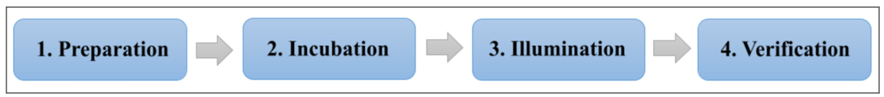

Figure 16 - The stages of problem solving according to Gestalt theory.
This figure represents the 4 successive stages of problem solving according to the gestalt theory.

In order to solve a problem, the learner must first recognize the existence of the problem, i.e., notice a difference between the current state (or starting state) of the situation and the goal state (or desired state). The achievement of this goal is conditioned by the implementation of a certain number of mental operations.

Four steps have been identified by Gestaltists to arrive at the resolution of a problem. Figure 16 illustrates these four steps.

- Preparation. This stage takes place when the learner acknowledges the existence of the problem and the data that constitute it. As mentioned above, he/she notices the gap between the starting state and the goal state.

- Incubation. It is during the incubation period that the learner makes attempts that fail, which leads him to stop his attempts (at least consciously) to solve the problem and put it aside for a period of time.

- Illumination. It occurs after the previous phase. The learner then has an insight: "in English, insight means sudden illumination [...], the solution to the problem thus suddenly appears" (Lemaire and Didier-jean, 2018) to the learner.

- Verification. This step serves to confirm the insight. The learner proceeds to the verification of the insight. This is where the correspondence between the solution that suddenly appeared and the actual solution to the problem is verified. This allows the learner to answer the question: does the solution correspond to the goal state set at the beginning?

This approach is similar to a sequence of divergent then convergent thinking that structures the mechanism of creativity, detailed above.

Furthermore, Patrick Lemaire explains that this approach has limitations. The implicit propositions involved in this conception have no established validity. However, this does not necessarily mean that there are no unconscious mental processes in problem-solving. From the point of view of (non-Gestalt) psychologists, problem-solving requires an elaborate description of the mental operations involved in achieving the solution of the problem. "Some would add: 'precise enough that we can artificially reproduce this chain of operations on a computer and make the computer do what a human subject does in the same way as the subject' " (Lemaire and Didierjean, 2018). According to the author, the gestalt approach would be applicable to a particular category of problems related to the involvement of the insight. It would then be unlikely that all problems would be solved by the systematic and sequential implementation of the previously defined processes. However, this approach has made it possible to explore the processes involved in problem-solving. It also has the advantage of being able to be compared with computational models such as the one developed by Etienne Koechlin's team and explained, for example, in Maël Donoso's thesis (Donoso, 2013).

The cognitivist approach
The cognitivist approach considers problem-solving as a process of information processing. According to them, problem-solving concerns problems with particular characteristics:

- They do not require specific prior knowledge.
- Their level of difficulty implies a certain time of resolution as well as certain reflection, without the problems being insoluble.
- Their properties can be formalized in the form of a computer simulation or in a mathematical form, so as to allow a comparison of performance between the learner and the simulation. "This comparison often leads to very interesting information about the functioning and architecture of the human information processing system" (Lemaire and Didierjean, 2018).

Modeling the learner during a problem-solving task places the learner in a situation with a goal to be reached without the achievement of this goal being immediate and obvious. It is a way for the learner to mobilize, verify and/or consolidate his or her prior knowledge, as well as to receive new information to acquire new knowledge. Alain Lieury evokes the transfer of learning in relation to the flexibility of the brain, thanks to which "a first learning facilitates the second" (Lieury, 2017). It is thus possible to make the link with the mobilization of prior knowledge during a learning task such as problem-solving, for example. This is exactly the problem posed in the CreaCube study.

Anh Nguyen-Xuan indicates that solving a problem implies understanding, representing the problem. This induces, at least, the necessity to describe the starting state and the goal-state (the state reached by the learner after solving the problem) as well as to describe the means that can be used to solve the task. The understanding of the problem to be solved would then constitute "a new knowledge for the person who has just built a network of relations linking the various data he has identified" (Nguyen-Xuan, 2021). In other words, the understanding of the problem and the establishment of a link between the elements that constitute it are knowledge. However, the author specifies that it differs from prior knowledge since it does not integrate long-term memory. Despite this, it may or may not "contribute to reinforcing the knowledge" [Nguyen-Xuan, 2021] previously mobilized.

Cognitivists distinguish between poorly-defined and well-defined problems.

"In a poorly-defined problem, the initial and final states of the problem are sometimes only partially specified" (Lemaire and Didierjean, 2018).The operations required to solve the problem are also not clearly identified. These problems are then judged as being both the most interesting and the most difficult to study. Studies conducted on these types of problems have shown that subjects transform them into well-defined problems in order to reach resolution. This process consists first of all in specifying the starting state and the goal state by elaborating precise sub-problems, and it is the resolution of each of these sub-problems that would lead to the resolution of the problem. Moreover, this type of problem solicits both general and specific knowledge. Thus, a learner who has specific knowledge about the information in the problem has less difficulty in establishing the sub-problems. As for general knowledge, it is mobilized when the learner does not have specific knowledge about certain information of the problem. The CreaCube task is of this type.

"A well-defined problem is one in which the starting situation [(initial state)] and the goal to be achieved [(goal state)] are clearly stated" (Lemaire and Didierjean, 2018). In a well-defined problem, the criteria derived from the goal to be reached allow the solution to be evaluated. It is the achievement of the goal that allows us to say that the problem is solved. By studying the resolution of this type of problem, researchers wish to identify the sequence of mental operations involved in the resolution process. Patrick Lemaire cites the "means-ends" analysis strategy developed by Newell and Simonen 1972 in the General Problem Solver (GPS) theory. "The means-ends analysis consists in comparing the present state of the problem and its target state and then selecting an operator that will reduce the difference" (Lemaire and Didierjean, 2018). It is a recursive process that involves, on one hand, the analysis of the difference and on the other, the selection of operators allowing the reduction of the difference between the starting state and the goal state until the solution of the problem is obtained. This strategy assumes two types of skill:

- "the skill to detect the difference between the desired state and the current state of the problem" (Lemaire and Didierjean, 2018);
- "the skill to implement an action that will reduce this difference" (Lemaire and Didierjean, 2018).

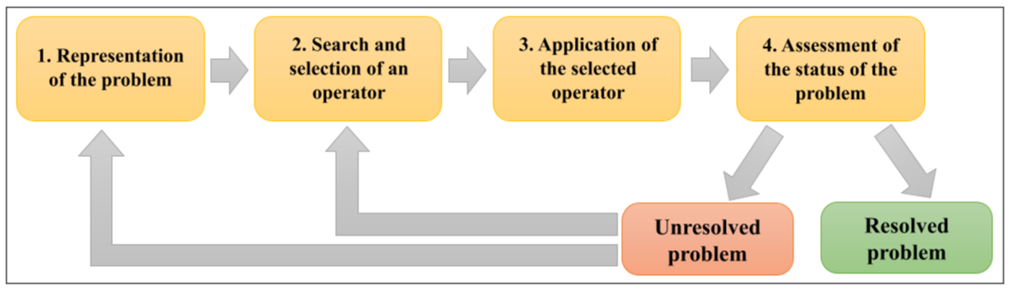
Figure 17 - Stages of problem solving according to the cognitivist theory.
This figure represents the stages of problem solving according to the cognitivist theory and more precisely the General Problem Solver theory.

The General Problem Solver theory is a computational theory (it has been implemented and tested by simulations). It has been designed in such a way as to allow the resolution of various problems based on very precise postulates about cognitive processes. It implements four stages of information processing that lead to the resolution of the problem posed. These stages are represented in figure 17 and explained below:

- The representation of the problem. It is during this step that the problem space is constructed. The problem space is composed of the initial state, the final state of the problem as well as its constraints. It allows the retrieval of pertinent information in long-term memory (identification of the similarity between this situation and a previously experienced situation). This space is constructed by the learner and not given to him/her at the outset with the subject of the problem. It will be affected by everything the learner knows about the problem and its resolution.

- The selection of the operator. During this step, the learner looks for a pertinent operation to perform in order to change the initial state of the problem. It is possible that sets of operators are already associated in the problem space and some can be selected or invented. The smaller the problem space, the easier it is to identify the appropriate operators. Conversely, the larger the problem space, the more difficult it is to find the operator and the more the learners prefer to use heuristics. The choice of operator is conditioned by the level of reduction of the gap between the initial state and the goal state (the more the operator reduces the difference between the two states, the more adequate it is considered to be).

- The application of the selected operator. A new state of the problem is reached here which may or may not correspond to the goal state, and which may or may not be close to it. The goal state can be reached with only one operator or can require several.

- The evaluation of the problem state. The state reached, by the action of the previously selected operator, is evaluated here. The current state can correspond to the goal state and the learner considers that the problem is solved. Conversely, the current state differs from the goal state and the learner resumes the resolution process at step 1 (he re-evaluates his representation of the problem) or at step 2 (he searches for and selects a new operator).

"The implementation of each of these steps is strongly influenced by general constraints on human cognition, such as the limits of working memory or as declarative and procedural knowledge stored in long-term memory, as well as by certain individual characteristics" [Lemaire and Didierjean, 2018] of learners.

The General Problem Solver model consists of two essential components in the problem solving process: the representation of the problem and the search for the solution.

The first component, the problem representation, has been modeled in the context of the General Problem Solver theory. The resulting modeling is called UNDERSTAND. "It is a reading program that extracts the deep structure (syntactic and semantic) of sentences and builds, from there, a global description of the problem and its parts" (Lemaire and Didierjean, 2018).

The second component, the search for the solution, is divided into two methods: algorithms and heuristics.

Backward search, analogy, and means-ends analysis are examples of heuristics. The last two (analogy and means-ends analysis) have already been discussed earlier. The first example, backward search, is limited to a certain class of problems with a clearly defined goal. This form of heuristic "starts by identifying the goal to be reached, the initial state of the problem, and seeks to go from the goal to the initial state" (Lemaire and Didierjean, 2018) (for example, when the problem to be solved is a maze). This type of search can also be used to better identify easy-to-reach sub-goals.

Problem-solving requires creativity, especially when looking for operators. However, this requires the ability to explore new paths by breaking out of the classical patterns of thinking. Creativity and thus problem-solving can be hindered by two obstacles: functional fixedness and contextual anchoring (also called the Einstellung effect).

Functional fixedness is the inability to assign other functions to an object than its usual function. As in the candle problem, it is to be able to discover other possible functions of an object in a given context, and therefore other affordances in the sense defined in this document. When an individual can overcome this limit, they can be more creative and solve more complicated problems.

Contextual anchoring or the Einstellung effect is a "mental fixation effect observed in problem solving. To solve a problem, subjects use the same strategy as the one used for a series of previous problems, even if the strategy is not the most adapted to solve this particular problem" (Lemaire and Didierjean, 2018). The learner then finds it difficult to detach himself from the solution he already knows, whereas another, more creative solution would be more pertinent and effective. This first idea is fixed, anchored in the context.

From the present state to the goal state
Throughout this work, there has been talk of goal, sub-goal, and goal state. However, the term goal has not been precisely defined, even if common sense allows us to understand the elements discussed above. Here, it seems necessary to give a definition. "A goal is everything that an individual strives to achieve. [...] More specifically, a goal is a future-focused cognitive representation of a desired end state that guides behavior" (Reeve, 2017).

As stated earlier, problem solving involves reducing the difference between the present state and the target state (the goal). This difference corresponds to a gap, a divergence, an incongruity. This would have motivational properties that make it possible to remedy this incongruity by developing an action plan in order to reach the goal state and thus regain congruity.

The Test-Operate-Test-Exit model represents the cognitive mechanism "by which plans drive and direct behavior" (Reeve, 2017). The first step (test) of this model corresponds to an evaluation of the current state versus the goal state. Incongruence occurs if there is a discrepancy between the two states, which leads to the development of an action plan (the "operate" stage. It is when the actions implemented allow to obtain the state of congruity at the next test that the process stops (step "leave"). Conversely, when the first test phase does not reveal any discrepancies, there is congruence, which allows the process to go directly to the "exit" stage without having to perform any actions.

According to Johnmarshall Reeve, there are two types of gaps: gap reduction and gap creation.

The first type is based "on feedback that detects divergence and underlies action plans and corrective motivation" (Reeve, 2017). This feedback is in fact feedback from the environment regarding the learner's level of performance in terms of the difference between the current state and the goal state. It is a negative feedback loop that reduces discrepancies: "a discrepancy occurs, an action is taken, and the negative feedback (the discrepancy is reduced) ends that action" (Reeve, 2017).

The second type is based on a proaction system "in which the person envisions and defines in advance a higher-level future goal" (Reeve, 2017) that does not yet exist in the problem space. In this case, it is a positive feedback loop: "a discrepancy is created, an action is taken, and the positive feedback energizes further discrepancy creation" (Reeve, 2017). This loop expands the divergence.

Divergence or incongruence (or gap) is the basis of the motivation that generates action, whatever its type. Gap reduction corresponds to corrective motivation, it is reactive, seeks to overcome the deficiency and refers to a feedback system. On the other hand, gap creation corresponds to goal-setting motivation, it is proactive, seeks growth and refers to a prevention system.

“Corrective motivation activates a decision-making process, in which the individual considers many ways to reduce the present-ideal mismatch: change the plan, change the behavior (increase the effort), or leave the plan altogether" (Reeve, 2017). It is a dynamic and flexible process that pushes the learner to pursue the most appropriate action. Corrective motivation is what allows the action plan to be re-evaluated in order to achieve problem resolution.

Goal setting "generates motivation by focusing [learners'] attention on the discrepancy (or incongruence) between their present level of achievement [...] and their ideal level of achievement [...]. Researchers refer to this divergence [...] as the 'goal-performance gap'" (Reeve,2017). This increases performance, especially in a problem-solving task.

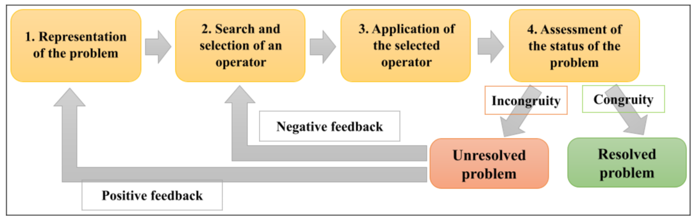
Figure 18 - Problem solving based on the General Problem Solver theory and the Test-Operate-Test-Exit model.
This figure takes again figure 17 based on the General Problem Solver theory by adding the elements of the TOTE (Test-Operate-Test-Exit) or TOTQ in French (Tester-Operate-Tester-Quitter) model.

Taking into account all these elements, it is possible to establish a parallel between the General Problem Solver theory and the Test-Operate-Test-Exit model. For this purpose, figure 17 has been reworked to try to integrate this new information. Figure 18 is the result. The steps of the problem solving have been preserved but some processes have been clarified. Indeed, at the end of the evaluation, the incongruity (discrepancy between the present state and the goal state) or the congruity (concordance between the two states) are put forward and allow to reach a conclusion on the state of the problem: solved or not solved, goal reached or not reached. The most difficult part is to identify when the negative and positive feedback intervene. The "operate" stage of the model could correspond to stage 2 of the theory behind this figure. From the "problem not solved" state to the return to step 2, it would be the negative feedback process that would intervene. Indeed, it refers to the corrective motivation that allows the action plan to be re-evaluated and therefore new operators to be selected. On the other hand, in a less obvious way, it would be the positive feedback that would lead the learner to return to step 1 at the end of the evaluation. This refers to goal-setting motivation. Indeed, it is during the representation of the problem that goals are identified. However, in this type of feedback, each new goal set must be more difficult than the previous one. If, at the end of the evaluation, the problem is not solved but the goal state is not different from the previous one, it is not possible to speak of positive feedback. Moreover, if returning to Step 1 leads to setting a new goal, it will necessarily be a lower level to make it easier to resolve the problem. Therefore, the positive feedback could be true for setting new sub-goals leading to the goal state, provided that this end state has not been set up front. In view of this, the model depicted in Figure 18 is not entirely correct.

Regarding the previously mentioned reservations about the positive feedback process, it was necessary to revise Figure 18. It is in figure 19 that this has been done. It is possible to see the notion of sub-goal appearing there. In order to reach the goal state (which corresponds to the resolution of the problem), it will be necessary to identify, during the representation of the problem, a sub-goal that is easier to reach than the goal state. The evaluation of the implementation of the plan establishes whether there is incongruity or congruity. In the first case, the sub-goal is not achieved. There is then a negative feedback leading to the revision of the plan through corrective motivation. In the second case, congruence refers to the achievement of the subgoal. This achievement can lead to two new states through two new processes. If the subgoal is reached and there is congruence with the goal state, then the problem is solved. Conversely, it is the positive feedback process that comes into play leading to a new representation of the problem with the identification of a new and more difficult sub-goal. This process involves goal-setting motivation.

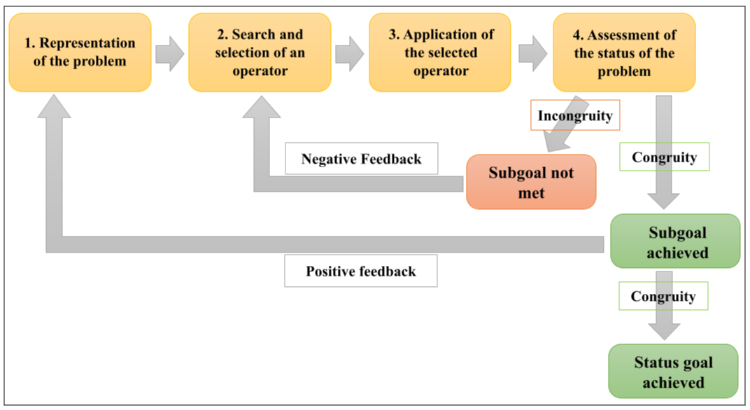

Figure 19 - Problem solving based on the General Problem Solver theory and the Test-Operate-Test-Exit model: improved version.
This figure takes again figure 18 based on the General Problem Solver theory with the elements of the TOTE (Test-Operate-Test-Exit) or TOTQ model in French (Tester-Opérer-Tester-Quitter) and by integrating the distinction between goal and sub -goal.

Problem-solving: conclusion
This part allowed us to establish the theoretical framework of problem solving by addressing the Gestalt and cognitivist currents. It emerged that the Gestalt approach was a relative precursor to other research conducted in this field. However, it is the cognitivist approach that is the most pertinent to the subject under study. This approach allowed us to identify and define the notions essential to the understanding of the problem solving process as well as the importance of goals in this process.

In the context of the CreaCube problem-solving task, the problem space is constructed by the learner in order to represent the elements and means to be used to reach the goal state: to assemble the four cubes to constitute a vehicle that moves autonomously from point A to point B. It establishes the sub-goals to be reached to constitute this vehicle. For example, a vehicle has wheels so the sub-goal is to find wheels. The plan of action is then to explore, manipulate the cubes to look for and identify wheels. It can reach this sub-goal and thus arrive by positive feedback at the setting of a new sub-goal after having proceeded to a new representation of the problem: for example, a vehicle has an engine, the sub-goal then consists in finding an engine. Conversely, the learner may not reach this sub-goal, calling on corrective motivation which will allow him/her to review and refine his/her plan of action: for example, taking each cube one by one, exploring each face... Once this process has been repeated several times, the learner may reach the last sub-goal which will then correspond to the goal state and lead to the success of the task.

Within this work, and even more so in this part, the notion of motivation appeared as transversal and essential to solve a problem-solving task. Here, it was a question of corrective motivation and goal-setting motivation. The notions of intrinsic and extrinsic motivation, curiosity and commitment were also mentioned in the previous sections. They are at the heart of the subject treated here and more specifically of the subject treated by the FLOWERS team. They will therefore be discussed in more detail, in particular through the analysis of the work carried out within the FLOWERS team.

2.2 Motivation

2.2.1 General Information

Alain Lieury explains, in 2020, that different terms in everyday language are used, more or less indifferently, to talk about motivation without having the same meaning. He therefore proposes to define motivation "as the set of biological and psychological mechanisms that allow the triggering of action, orientation (towards a goal or, conversely, away from it) and finally intensity and persistence: the more motivated one is, the greater and more persistent the activity" (Lieury & Léger, 2020). This makes the link with the different elements discussed in the previous sections on cognitive processes and the mechanisms of problem-solving.

The author had already used this definition in another work in 2017 (Lieury, 2017) and in which he differentiated two types of needs: innate needs or primary needs in connection with biological mechanisms (hunger, thirst...) and learned needs or motivations qualified as secondary rather in connection with psychological mechanisms. This second type of needs would result from learning or at least would become more complex with learning.

Jean-Philippe Abgrall defines motivation as a dynamic process resulting from two needs: perceived competence and self-determination. Perceived competence would be "the representation that one has of one's cognitive abilities, i.e. metacognition" (Abgrall, 2012). Self-determination would correspond to the "representation of oneself in society, in one's environment" (Abgrall, 2012).

He specifies that emotions play a decisive role in these two types of representation. "Positive" emotions will favor positive representations and a fortiori motivation. Conversely, "negative" emotions will be the source of avoidance strategies (in opposition to motivation). In this case, "perceptions are generally distorted by the overly important affective side which takes precedence over the reality of the cognitive and the negation of the person" (Abgrall, 2012). The representations that the learner has of himself within his environment as well as those that he attributes to others have an important influence on the learner's cognitive engagement in the resolution of a learning task.

This commitment will also be a function of "his orientations, his general choices, his convictions" (Abgrall, 2012) and determines a positive or negative personal involvement: this is called the conative.
To summarize, according to Jean-Philippe Abgrall, motivation is influenced by the conative, the cognitive and the affective functions.

Furthermore, Fabien Fenouillet has studied in detail different theories of motivation in order to establish precise definitions. He begins by giving a simplified definition based on behavioral impact: "motivation is what explains the dynamism of behavior" (Fenouillet, 2016). With this definition, he returns to the etymological meaning of the word motivation, according to which motivation would explain, justify, support and make a behavior, an action, a movement persist.

By confronting several theories and definitions with this simplified definition, the author arrives at a general definition that takes into account the individuality of motivation: "motivation designates a hypothetical protean intra-individual force, which can have multiple internal and/or external determinants, and which makes it possible to explain the direction, the triggering, the persistence and the intensity of the behavior or action" (Fenouillet, 2016).

The author refers to motivation as an "internal force" with various effects belonging to one of four categories:

- Direction. “Motivation is a force that directs the individual towards certain goals. Motivated behavior has meaning that can be interpreted or analyzed in terms of the outcome(s) produced" (Fenouillet, 2016).

- Triggering. "One of the most visible effects of motivation is related to behavioral change. [...] Triggering is therefore not related to a simple behavioral adjustment, but reveals the presence of a new motivation" (Fenouillet, 2016).

- Persistence. "Adopting a behavior over time can be explained from a motivational point of view from the moment that its maintenance requires the voluntary exercise of a certain force . [...] Explaining persistence therefore consists in understanding the nature of this will to make the action or behavior last" (Fenouillet, 2016).

- Intensity: "Intensity is definitely the least ambiguous motivational effect. The production of an effort is necessarily explained by the presence of a force. [...] An individual can produce an effort with the objective of appearing motivated .... In this case, the aim is to appear motivated, regardless of the purpose of the activity considered" (Fenouillet, 2016).

Fabien Fenouillet explains that even if the effects produced, mentioned above, allow to partially characterize motivation, they do not allow to define its nature. "This is a problem made all the more complex by the fact that many motivational theories rely on conceptualizations in terms of purpose, interest, desire, need, or curiosity to talk about motivation" (Fenouillet, 2016). It seems then difficult to establish a global definition of motivation that would make it possible to explain its nature without being specific to a particular concept. The author then proposes to give a theoretical definition that would be based on the most general categories possible. In particular, he cites the example of the theory of self-determination, which categorizes motivation as being either intrinsic or extrinsic. "Motivation assumes not only that there is a motive for the individual's behavior but also that the individual is able to anticipate the effects of that behavior if he or she decides to act" (Fenouillet, 2016). This definition is part of an integrative model (represented in figure 20) aiming to "propose a global classification of motivational theories and is based on relatively general categories" (Fenouillet, 2016).

The author defined seven conceptual sets grouping the conceptual categories of motivation:

- Primary motive. "Primary motives, which aim to explain the origin of motivation from a psychological point of view, are of two kinds: instincts and needs" (Fenouillet, 2016). The instinct is what pushes an individual to make an action directed towards a goal of which he is not conscious. The needs can be physiological (hunger, thirst, etc.) or psychological (in connection with the social relations for example).

- Secondary motive. They are to be differentiated from primary motives because "they do not try to explain the absolute origin (from the psychological point of view) of the behavior and they admit that the environment can contain factors able to be at the origin of the motivation" (Fenouillet, 2016). This set gathers twelve conceptual categories: value, goal, interest, self-esteem, drive (energy, dynamism), dissonance, emotion, curiosity, intention, personality trait and original motives.

- Prediction. Prediction is one of the two facets of the goal. The goal referring to prediction is in fact the anticipation of the realization of a final state. The subjective probability of success or failure is based on this anticipation: the term expectation is used to describe this. This set comprises four conceptual categories: expectation-value relationship , expectation-value distinction , control expectation and imaginary prediction.

- Decision-making. In this set, it is "the selection of an action by the individual among all possible alternatives" (Fenouillet, 2016) that is presented as one of the issues of motivation. Volition is here an explanatory variable of decision making and is associated with motivation to make a choice. This set includes two conceptual categories: commitment and decision.

- Strategy. This set goes beyond the theoretical aspects treated in the previous sets. It emphasizes that setting a goal does not allow motivation to influence performance if the way to achieve it is not identified. "If the individual does not know the best strategy to implement, motivating him or her through the assignment of a goal may even be counterproductive" (Fenouillet, 2016). This set integrates two conceptual categories: the cognitive strategy and the emotional strategy.

- Behavior. "The term behavior has a dual meaning: in a narrow sense, it is primarily referred to the action that the subject performs on a situation (the reaction to a stimulus in the behaviorist model), in a broader sense, the term behavior refers to all psychological functions and processes" (Fenouillet, 2016). To understand motivation, it would be necessary to understand the intention behind the observable behavior. Motivation triggers, directs, increases the intensity and persistence of behavior.

- Result. The result corresponds to "the outcome of an action or behavior" (Fenouillet, 2016). When evaluating a result, motivation can be one factor among others (factor of performance, resignation or well-being). Other results are "explicable only in relation to a motivational explanation" (Fenouillet, 2016). Flow (or flux) is a form of result. It is "an optimal experience arising when skills are neither exceeded nor underused. [...] Flow is conceived as an experience that provides an intrinsic reward" (Fenouillet, 2016).

These sets are represented by the purple squares in Figure 20. The relationships between each of these sets are shown by the different colored arrows.

Self-regulation (in yellow) acts at three levels of motivation: the secondary motive (that of action), decision making (the means, costs and benefits of the choice made are reconsidered) and at the level of strategies (modification of strategies to ensure optimal learning or effective stress management).

Satisfaction (in green) is a return of the result to the initial motive: the individual is satisfied when the result responds to the motive initially identified.

Orientation (in blue) is the opposite relationship of satisfaction: it starts from the motives and goes towards the result. This relation explains the orientation of the behavior (the motive would then orient the behavior).

Expectation (in gray) goes from the prediction to the result. It corresponds to the latency between the elaboration of the probabilities of failure or success and their verification. The evaluation (in orange) is the feedback allowing to adapt these predictions or to adjust the behavior. These two relationships have a strong impact on motivation.

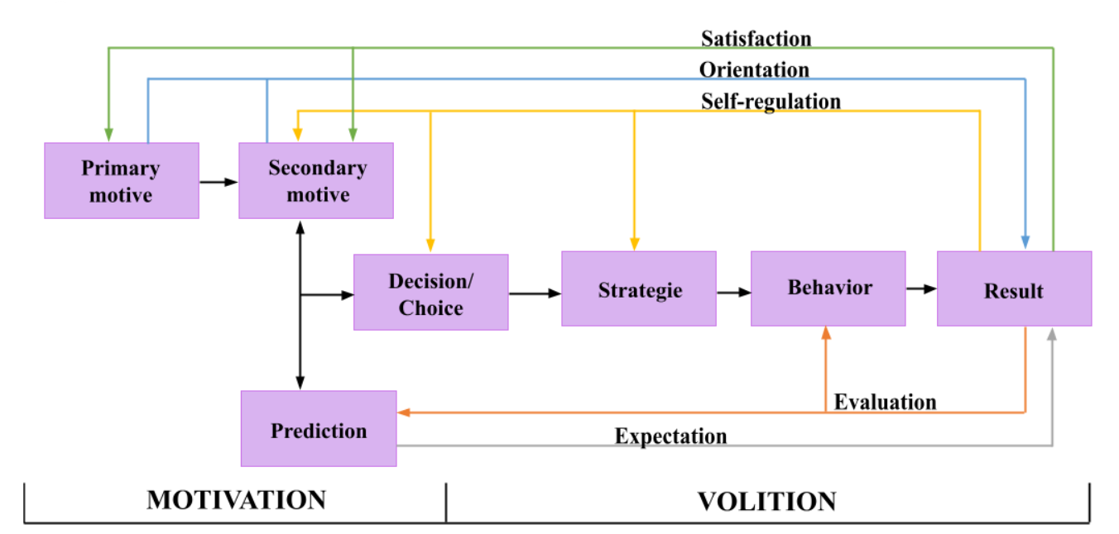
Figure 20 - Integrative model of motivation.
This figure is inspired by a diagram made by Fabien Fenouillet (Fenouillet, 2016) and represents the integrative model of motivation.

Figure 20 is divided into two parts referring to motivation and volition. These two parts are in fact two stages of motivation.

The motives and the prediction are part of the purely motivational stage. Decision-making is a boundary that separates it from the volitional stage. It is the orientation of the behavior (goal, need, interest, etc.) that comes into play here. This allows us to understand what is at the origin (trigger) of this behavior as well as its intensity.

The second step has its source at the decision-making level. "The central question, for many volitional models, is to understand what this will is made of which makes the behavior persist in order to achieve the result which effectively motivates the individual" (Fenouillet, 2016).

These two notions can be linked to that of desire and intention in Michael Bratman's belief-desire-intention model to reflect the balance between spending time deliberating in order to choose a course of action and investing in carrying it out (Rao, 1995).

On the other hand, like Fabien Fenouillet, Alain Lieury differentiates intrinsic motivation from extrinsic motivation. The latter could be related to reinforcement, that is, an individual is more motivated to complete a task the greater the reward. Conversely, "the intrinsic motivations (curiosity, manipulation) would only have an interest in the activity itself" (Lieury and Léger, 2020).

2.2.2 Extrinsic motivation

According to Johnmarshall Reeve, extrinsic motivation "results from environmental incentives and consequences [internal and/or external.] [It] comes from a consequence that is separate from the activity itself" [Reeve, 2017].

Johnmarshall Reeve differentiates three types of needs involved in extrinsic motivation:

- Physiological needs. A physiological need is a "biological condition within the body that synchronizes its brain structures, hormones, and major organs to regulate bodily well-being and correct bodily imbalances that may be threats to growth, development, and life" (Reeve, 2017). Hunger and thirst are physiological needs. Extrinsic motivation then results from in-citations in the person's internal environment and having consequences on that same environment.

- Psychological needs. A psychological need is "an innate psychological process that underlies the proactive desire to seek interactions with the environment that promote personal development, social development, and psychological well-being" (Reeve, 2017). Autonomy is an example of a psychological need.

- Implicit motives. An implicit motive is "a developmentally acquired process (socialization) that drives one to seek out and spend time experiencing events that have been associated with positive emotions during the person's socialization history" (Reeve, 2017). Success is an example of an implicit motive.

In contrast to physiological needs, psychological needs and implicit motives require interactions with the external environment and involve the needs for competence and social belonging. It is psychological needs and implicit motives that are particularly involved in learning tasks such as problem-solving.

The author cites Baldwin and Baldwin's 1986 model of operant conditioning. Operant conditioning is a process by which the learner learns to function effectively in the environment. That is, "learn and engage in behaviors that produce attractive consequences [...] and also behaviors that avoid unpleasant consequences" (Reeve, 2017).

S : R → C
(1)

Equation 1 is the conceptualization of behavior according to the operant conditioning model where:

- S is the situational signal (or stimulus).
- R is the behavioral response.
- C is the consequence.
- The colon between S and R "shows that the situational signal sets the opportunity for the behavioral response (but does not cause it)" (Reeve, 2017).
- The arrow between R and C shows that it is the behavioral response that causes the consequence.
- S : R "explains the motivational scope of incentives. [...] Incentives solicit, encourage, and bribe people to engage in behaviors that they otherwise would not have undertaken" (Reeve, 2017).
- R → C shows the motivational scope of the consequences.

This model shows that extrinsic motivation is lead by a stimulus (stimulus driven) perceived in the environment (internal and/or external).

On the other hand, Alain Lieury uses the theory of self-determination of Edward Deci et Richard Ryan to differentiate four types of extrinsic motivation. This theory is not only based on the principle that humans need self-determination and that this is involved in all forms of motivation (intrinsic and extrinsic) but also in amotivation, which is equivalent to the absence of autonomy or to constraint.Moreover, self-determination would be modulated by the need for perceived competence as well as by the need for social belonging (notions discussed in section 2.2.1). All this is summarized in Figure 21.
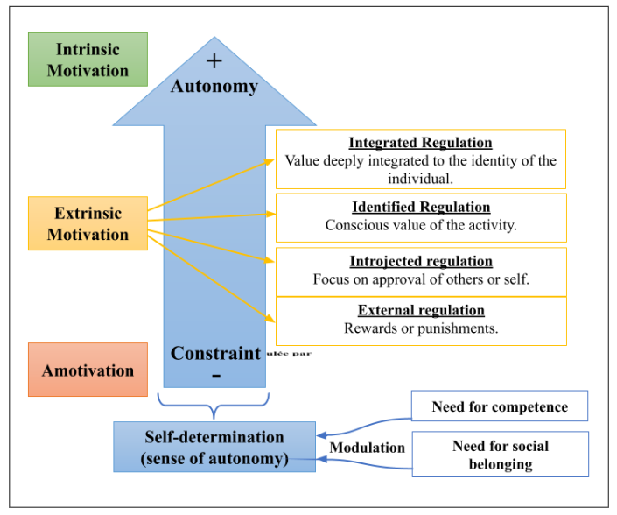

Figure 21 - Edward Deci and Richard Ryan's theory of self-determination.
This figure illustrates the theory of self-determination. It shows that "the different forms of motivation are determined by a continuum of self-determination" (Lieury, 2017). The latter is modulated by the need for competence and the need for social belonging.

In this figure, the feeling of autonomy (or self-determination) is represented by a large blue arrow and starts from the lowest level which corresponds to the constraint to reach the highest level, autonomy. As said previously, amotivation represents the lowest level, that is to say demotivation: "when the individual no longer sees any relationship between what he does and the results of his activity or that this activity makes no sense to him" (Lieury, 2017). The highest level of autonomy corresponds to intrinsic motivation (which will be discussed in more detail in section 2.2.3). Extrinsic motivation is at an intermediate level of self-determination. The individual is then regulated in different ways by the external environment.

Extrinsic motivation would then be distinguished in four forms:

- External regulation: "the individual is regulated by external reinforcements (the student goes to school by legal obligation)" (Lieury, 2017).

- Introjected regulation: the rules at the origin of this regulation are no longer external but internal (the learner does an action for fear of disappointing for example).

- Identified regulation: the activity carried out by the learner has value for him and he knows it, he has identified it.

- Integrated regulation: the activity is not interesting but corresponds to the learner's deepest values (e.g. putting away the chair when leaving the classroom).

All four forms of extrinsic motivation assume the presence of a goal. This is consistent with what was discussed in the previous sections, where the goal is a source of extrinsic motivation. However, the model presented at the beginning of this section shows that extrinsic motivation can also be driven by stimuli (situational incentives). It is then possible to identify two main categories of extrinsic motivation: goal driven and stimulus driven.

The following section will explain the origin and the implications of intrinsic motivation on behavior, especially during a learning task.

2.2.3 Intrinsic motivation

Intrinsic motivation is a different mechanism than extrinsic motivation. It allows for intrinsically rewarding behaviors such as exploration and curiosity, without necessarily being related to an internal or external organic stimulus.

According to François Guillemette, "motivation promotes the development of autonomy when it is intrinsic, that is to say when what pushes the learner to commit and persevere in his learning is an advantage that he found in the learning itself (intrinsic) and not in a fallout from the learning (extrinsic)" (Guillemette, 2004). It is then the object of learning and / or the act of learning itself that arouses interest. The author explains that intrinsic motivation (or curiosity) positively influences learning through its action on cognitive processes: increase in the intensity of attention, the ability to concentrate, the efficiency of memory or even courage when making a decision in the face of an unknown situation. Commitment, participation and persistence in a learning task are indicators of intrinsic motivation.

Stanislas Dehaene writes that curiosity is a force, aroused by new information, that would encourage the learner to explore. It would be the manifestation of intrinsic motivation (Dehaene, 2018). He adds that curiosity directs the learner towards new or surprising but accessible elements. That is, neither too simple to understand nor too complicated. The author cites the work of Frederic Kaplan and Pierre-Yves Oudeyer on these aspects.

The phenomenon previously mentioned in terms of complexity and intermediate novelty sought by curiosity is called flow or optimal experience. Philippe Carré cites Csikszentmihalyi who established the characteristics of flow (Carré and Fenouillet, 2019):

- "The task being undertaken is achievable, but challenging and requires a particular skill."

- "The individual is fully focused on what he or she is doing, without distraction."

- "The intended target is clear and the current activity provides immediate feedback."

- "The individual exercises control over his or her actions."

- "Preoccupation with self disappears, but, paradoxically, the sense of self is enhanced as a result of the optimal experience."

- "The perception of duration is altered."

On the other hand, Alain Lieury cites experiments that have shown that intrinsic motivation is diminished by the integration of rewards (monetary rewards, for example) into the task in the same way as constraints (supervision, social evaluation, limited time, etc.). That is, a previously rewarded activity ceases to elicit intrinsic motivation once it no longer presents a reward, whereas the same activity with no reward at all continues to elicit curiosity (Lieury, 2017). He also highlights the impact of the feeling of perceived competence (or self-esteem) on intrinsic motivation: "this competence component was added to explain that good results generally reinforce motivation, and the opposite for poor results" (Lieury and Léger, 2020). The need for self-determination or free will also impacts intrinsic motivation: the results of a task would then be improved when the individual is free to perform the task without supervision, without other constraints, without reward and with the feeling of being competent in solving the task.

Regarding learning, a negative self-determined feeling (feeling incompetent) favored by too high a level of difficulty, or constraints (social judgment, evaluation, etc.) can cause abandonment or resignation during learning tasks. In this situation, the learner would not be in the flow. Conversely, the author explains that active pedagogy, that is to say the involvement of learners in the choice of tasks and in the means to be implemented to solve them, would make it possible to promote the feeling of self-determination and intrinsic motivation.

2.3 The role of motivation in human learning: conclusion

In section 2, the study of the learning process allowed us to identify different theories that contribute to the understanding of what learning is and how it works. Different modes of acquisition were also cited, including problem-solving, which is used in the Crea-Cube task. It appears that these theories influence this problem-solving task in various ways and to varying degrees. In addition, setting subgoals and identifying the goal state are essential not only for the learner to solve the task but also to represent and model it.

Moreover, research conducted on motivation (in terms of learning) shows that it can be of two types: extrinsic or intrinsic. The CreaCube task integrates these two types of motivation. Indeed, the stimuli sent by the instruction and by the objects trigger extrinsic motivation with, in particular, the identification of the goal state by the learner and the setting of sub-goals that will allow him to reach this final state. On the other hand, the playfulness and autonomy left to the learner to solve this task leads to intrinsic motivation acting as a motor for his exploration and creativity.

As previously mentioned, the FLOWERS team has studied the process of intrinsic motivation in learning as well as its modeling. The researchers of this team have not only created algorithms that allow to promote the engagement of this motivation in educational tasks but also to lead the learner to remain in a state of flow throughout his learning so that his curiosity remains mobilized.Their work will thus be studied in the following section (section 3).

3 Modeling intrinsic motivation in learning

The FLOWERS (FLOWing Epigenetic Robots and Systems) research team has, among other things, been interested in the role of intrinsic motivation in learning. It has sought to develop algorithms that promote curiosity during learning by using digital applications with an educational purpose. This is what will be discussed in this section.

Furthermore, the collaboration between this team and the Mnemosyne team within the AIDE (Artificial Intelligence Devoted to Education) exploratory action, which aims to develop a model of the learner, will also be discussed here.

To do this, the problem-solving task (CreaCube) will allow us to collect different data in order to arrive at their symbolic representation in the form of an ontology. This model will take into account the motivations that lead the learner to act in his environment in order to solve the task and thus try to better understand the mechanisms that allow the learner to learn.

3.1 The involvement of curiosity in learning

Pierre-Yves Oudeyer explains that curiosity is a form of intrinsic motivation that is fundamental to making learning more effective. It makes the learner more active in his or her learning and encourages spontaneous exploration and memorization. This is made possible by an intrinsic reward system that is activated when the learner experiences a gain in information, novelty or complexity. Csikszentmihalya's theory of flow is very important here, since it is a matter of offering the learner activities with a level of novelty and intermediate complexity to encourage curiosity. Novelty would mobilize attentional resources in such a way as to increase the duration of involvement, perseverance in the activity.

The theory of learning progress would explain what "an activity with an intermediate level of complexity" means. This theory proposes to conceive of the brain as a predictive machine intrinsically motivated to pursue activities for which the degree of uncertainty decreases as learning takes place, which would correspond to the process of improving predictions. This means that the learner loses interest in the task if it is too easy or too complicated. In this case the uncertainty prediction would be either too low to generate learning, or too high without being able to be reduced (i.e., the activity would be too difficult to observe a progression in learning).

In addition, research conducted in neuroscience and psychology on curiosity postulates that there would be a unidirectional causal link between learning and curiosity. Indeed, the brain would be motivated to find an activity for which the level of novelty and complexity would be "intermediate" which would generate a state of curiosity allowing the improvement of learning and memorization. However, at this stage, the model shows that learning itself has no impact on the state of curiosity whereas the theory of learning progress would include a positive feedback between learning and intrinsic motivation directed by curiosity.

Figure 22 illustrates this duality. The first point of view addressed corresponds to Figure 22a, according to which the intrinsic motivation (first blue rectangle) to seek an intermediate level of novelty and complexity would lead (orange arrow) to the state of curiosity (second blue rectangle), which in turn leads to an intrinsic reward (green arrow) in feed back. The state of curiosity reached promotes learning and memorization (third blue rectangle). There is no feedback in this process. This would imply that learning would not have an impact on curiosity or intrinsic motivation.
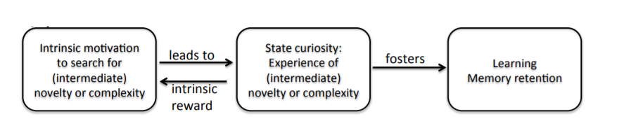
- Unidirectional causal link between learning and curiosity.

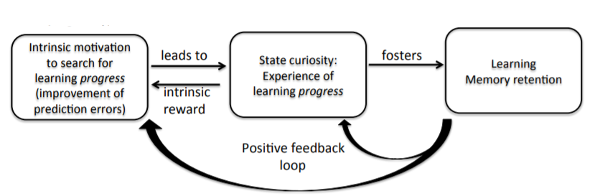
- Learning progress theory: causal link with positive feedback.

Figure 22 - Relationship between learning and curiosity.
This figure is made by Pierre-Yves Oudeyer (Oudeyeret al., 2016). Figure 22a is a representation of the unidirectional causal link between curiosity and learning according to research conducted in neuroscience and psychology. Figure 22b represents the same causal link but according to the learning progress theory that incorporates a positive feedback loop between learning and the curiosity state.

The theory of learning progress is illustrated in Figure 22b and shows the same causal relationship except that a positive feedback loop (blue arrows) allows us to understand that learning and memorization causally influence the state of curiosity and intrinsic motivation. This phenomenon would then allow the learner to persevere in the task and maintain a state of curiosity as long as it generates a progression in learning (that is to say as long as it presents a level of novelty and of intermediate complexity adapted to the progress of the learner in his learning). It is this progression in learning that maintains the state of curiosity, thus promoting learning itself and memorization. The feedback loop acting on intrinsic motivation makes it possible to readjust the predictions according to the errors (differences between the learning predictions previously made and the learning actually achieved).

In a context where the learner would have a choice between several activities, spontaneous active exploration (according to the learning progress theory) will direct him towards the activity which, according to his predictions, will allow maximum progress in learning by avoiding activities judged too easy or too difficult. The learner will persevere in this activity until there is no more progress in learning. He will then resume an exploration phase in search of another activity that will again allow him to achieve maximum progress.

In order to understand precisely what is at stake for the learner and his environment during this exploration phase, it is necessary to give a definition of it. According to Jacqueline Gottlieb, exploration is a process consisting of choosing actions whose purpose is to obtain information. Actions with an exploratory purpose are different from physical actions. These exploratory actions may, however, involve physical actions. The difference between these two types of actions is that physical actions are intended to change the learner's external or internal environment, to interact with the learner physically (e.g., grabbing an object). Exploratory actions do not seek to impact the environment but aim to gather information about that environment and change the learner's epistemic state.

Furthermore, Frédéric Alexandre [Alexandre, 2021] specifies that the learner explores in order to obtain new information, but that he can do so in two ways: either by following a strategy, or randomly (when there is no other solution). At the same time, the author explains that exploration can be done by internal simulations (covertly) or by real actions (overtly). The choice between these two forms of exploration is made by taking into account the cost that they generate and their feasibility. Simulation can be less costly and will therefore be preferred. However, its implementation may be impossible in some cases, so real actions will be preferred. On the other hand, real actions can also be less costly from the start, which will rule out the choice of simulation.

These explanations of the role of exploration in learning, and more specifically in learning progress, complement the work of Joy Paul Guilford cited in section 1.3.4 regarding his involvement in creativity, in section 2.1.1 where Jennifer Kerzil makes the link with constructivist learning theory, or in section 2.2.3 where François Guillemette defines intrinsic motivation.

Finally, Pierre-Yves Oudeyer and Jacqueline Gottlieb explain that computational models based on a mathematical formalism have been developed to study curiosity-driven reinforcement learning. Some of these models will be presented in section 3.2.

3.2 Computational models of curiosity

3.2.1 Intelligent Tutoring Systems
Benjamin Clément and his collaborators from the FLOWERS team have been working on Intelligent Tutoring Systems (ITS) and have developed algorithms that improve learning performance by acting on learner motivation through the use of digital activities, as observed experimentally. The author explains that these tutoring systems allow for a more accessible, more effective education and at the same time collect objective measures on learning. They consist of four main models:

- Cognitive model. It defines the domain of knowledge or the steps to be taken to solve problems in a particular domain.

- Learner model. It considers how the learner learns, the evolution of his cognitive state during particular learning activities.

- Learning model. It defines the activities to be presented to learners based, in a general way, on the cognitive model and the learner model.

- User interface model. It allows to represent the way interactions with the learner take place and how problems are proposed to them.

The authors aim to create an intelligent tutoring system by working at the level of the learning model in order to identify the sequence of activities that would maximize the learner's average skill level for the set of skills being worked on. The work focuses on how to select the activities that would provide the best learning experience based on an estimate of the learner's skill level, progression, and knowledge from the cognitive model and the learner model. The researchers want to offer each learner the activities that will provide the best learning progress.

The approach consists in taking into account the activities estimated to bring the maximum learning gain, this at the execution of the activity and based on the learner's results. Three main advantages have been identified:

- Lower dependence on the cognitive/learner model. The independence of the learning model (as independent as possible from the cognitive/learner model) requires that the intelligent tutoring system explore and experiment with various activities to estimate their potential for learning progress for each learner. The experiments should be sufficiently informative about the student's current skill level as well as estimate the effectiveness of each exercise in improving those skills. This has been called the "exploration/exploitation" trade-off in machine learning, where new activities must not only be tried to find out which are the best, but also simultaneously select the best ones for the learner to actually learn.

- Effective optimization methods. These methods make no specific assumptions about how learners learn and only require information about the estimated learning progress of each activity. The author makes the assumption that activities that are estimated to provide a good learning gain over the course of the activity should be selected more often. He cites the Multi-Armed Bandits formalism.

- More motivating experience. This refers to the zone of proximal development which seeks to foster the emergence of the state of flow in order to enhance learning.

3.2.2 Contextualization of the algorithms
Their work has included the development of two machine learning algorithms (specifically, reinforcement learning):

- RiARiT (Right Activity at Right Time) which explicitly estimates the learner's level of various components of competence (Knowledge Components : KC). The algorithm uses these estimates to propose activities to the learner.

- ZPDES (Zone of Proximal Development and Empirical Success) which uses a graph and follows the learner's progress to choose the activities to propose.

In both cases, a Pedagogical Activity Space is defined beforehand. It is a set of activities that the learner can carry out to acquire competencies or components of competency.

To design their algorithms, the authors were inspired by a Multi-Armed Bandit EXP4 (Exponential Weights for Exploration and Exploitation) algorithm. This variant of the Multi-Armed Bandit algorithm helps to automatically determine, by random draw, the share of exploitation and exploration at a time t, i.e., whether the player should continue using a given machine or try others at that time .

From the point of view of learning, and in the context studied by the authors, their algorithms make it possible to propose to the learner a sequence of activities which has the greatest probability of maximizing learning progress and consequently of allowing him to preserve the state of flow during the learning session.

Thus, the Multi-Armed Bandit mechanism is used in these algorithms, except that it is no longer slot machine arms that are recommended but human learning activities, and this with the help of machine learning algorithms by reinforcement. The gain of money is replaced by the learner's progress in learning.

To link this to the approach identified in the previous section (3.2.1), it is important to remember that the authors have chosen to favor the learning model by minimizing as much as possible, in particular, the dependence on the cognitive/learner models. This implies that no (or little) information concerning the learner's skills and particularities is given as input. At the same time, the information concerning the activities is also limited. For this, the pedagogical expert (e.g. a teacher) defines the activity space and, if necessary, some roughly defined constraints on the pedagogical sequence.

The ZPDES algorithm respects this principle since it has no a priori information on the learner's skills and very little on the problem. It uses the zone of proximal development and empirically estimates learning progress.

The RiARiT algorithm, on the other hand, is much more dependent on cognitive/learner models, since it uses a table of data on expected levels of competence for each activity parameter, in order to relate the learner's competences to the activity parameters. His estimates of learning progress are directly related to this relationship.

To go further, and in the hypothesis that these algorithms could participate in the modeling of the learner during a problem solving task generating a learning gain, it is possible to establish a link with the CreaCube task. Indeed, the modeled learner must perform a certain number of actions to solve the task. Here, the algorithm would not propose an activity but an action to perform. The notions of exploitation and exploration remain true in the sense that the learner can explore the cubes totally at random, explore in a more directed way (implication of the notion of probability while preserving a part of randomness) or exploit the acquired competencies and/or cognizances. This can be further clarified with the study of algorithms in the next section (3.2.3).

3.2.3 Presentation of algorithms

The efficiency of the algorithms depends on several elements. First of all, an expert (or several) must define the activity space in which the learner will evolve. Then, since these algorithms are based on a Multi-Armed Bandit (MAB) type algorithm, it is necessary to understand the main principles before being able to study them more precisely.

Activity space
Each activity in the activity space is characterized by parameters (e.g. type of activity) that can take different values (e.g. type A or type B). These parameters and their respective values define all the possible activities that can be instantiated within this space. These parameters can be organized into groups according to their nature and meaning. The groups can be structured hierarchically since some parameters depend on other parameters in order to be used in an activity. Furthermore, not all groups of parameters are necessarily used to define all activities in the space.

An activity is characterized by a combination of parameter values selected in each group of the activity space (necessary for its characterization) in respect of the hierarchy. An activity space groups all possible distinct combinations of parameter values that can define an activity in this space.

Figure 23 is an example of the process of selecting an activity in an activity space. In this space, group 1 is the first in the hierarchy. It groups the "type of activity" parameters. This group is composed of a single parameter (T) with 2 values (1 and 2). The activity can therefore be of type T1 or T2. Following the hierarchy, each type T of activity must pass through a particular group of difficulty (group 2 for T1 or group 3 for T2). Each of these groups has a parameter (level) with three values (1, 2 and 3). Then, group 4 is the last one of the hierarchy and allows the attribution of modalities. This group has two parameters (shape and color) with respectively 2 (square and circle) and 3 values (Black, Blue and Red). The combination of the example leads to the proposal of an activity of type T2 (group 1), of level 1 difficulty (group 3) and has two modalities (group 4): square, blue.

The algorithms mentioned above will allow efficient use of this activity space in order to offer pertinent, personalized and motivating activities for the learner. They will be studied in more detail in the following paragraphs.

Multi-Armed Bandit
The Multi-Armed Bandit EXP4 algorithm consists, globally, in assigning an initial weight to each action, which quantifies the interest of this action in the current task. An action is then drawn according to both the weights and chance, in relation to a probability of gaining. The probability of gaining is estimated thanks to the exploration/exploitation trade-off. This trade-off requires making a choice between what is known in order to obtain a reward close to what is expected (exploitation), and what is uncertain in order to possibly learn more (exploration).

Initially, the exploration part is stronger since no reward is known. It is the observation of the reward obtained that makes possible to update the weights attributed and consequently the probabilities of gain. Thus, the activities giving a good level of learning progress (reward) must be those selected most often. Since learning progress is not a stable reward, it requires specific mechanisms to follow its evolution. Indeed, an activity can cease to provide learning progress once the learner has reached a certain level of expertise in the skill being worked on or in the activity itself. This implies that the rewards differ from one learner to another. This is why the EXP4 variant of the Multi-Armed Bandit algorithm was selected by Benjamin Clément and his collaborators.

A set of "expert agents" is then taken into account and the model makes a choice based on the proposals of each internal expert agent. In the case presented here, the experts are a set of variables that follow the evolution of the reward provided by each activity. These "expert bandits" are used to evaluate the quality of each activity parameter value during the learner's work session.

Thus, Benjamin Clément explains that, for each parameter within a group, the quality of its values is evaluated by an "agent-expert bandit". An expert follows the reward provided by each value over the last few samplings to compute its quality. At a given time, the value to use for each parameter is sampled according to the probabilities. This sampling methodology leads to selecting stochastically (by chance) a value, proportionally to its quality and its exploration rate. When the exploration rate is low, the value of the parameter is chosen according to its quality. Conversely, when the exploration rate is high, low quality parameter values have a higher probability of being selected. To generate an activity, this process is performed in a recursive manner on the groups involved in the activity generation, according to the hierarchical dependencies between the parameter groups. This leads to a stochastic drawing of the activity, resulting from the combination of each sampled parameter value according to the assessment of their quality by each agent-expert (Clément, 2018]).

The selected activity is proposed to the learner for resolution. The reward level obtained (learning progress) allows the expert-agents to update the quality of each parameter value used. All this would cause the exploration of all the activities generated in the activity space. This leads the author (Clement, 2018) to identify two resulting drawbacks:

- The type and difficulty of the exercises offered could change too often and reduce learner motivation and engagement.

- It may not be possible to explore all activity parameters to estimate their learning progress.

In order to overcome these drawbacks, the author was inspired by the theory of the Zone of Proximal Development (ZPD) and the concept of flow. It is then a pedagogical expert (or several) who defines the activity space and, consequently, the hierarchy of activities within it as well as the parameters/value pairs. The aim is to propose only the most pertinent activities and to keep the learner in the zone of proximal development or in the flow zone.

The level of difficulty of the activities related to the skill level of the learner determines what state the latter is in during learning, as shown in Figure 24. Thus a level of difficulty that is too high in relation to the level of competence of the learner will generate a state of anxiety. Conversely, an insufficient level of difficulty compared to the skill level will cause a state of boredom. The state of flow is reached when the skill level and the level of difficulty are almost proportional. The zone of proximal development is one level above, that is, the proposed activity is slightly above the learner's current abilities, allowing the maximum level of learning progress to be generated while maintaining learner motivation and engagement. Furthermore, the use of the zone of proximal development makes it possible to reduce the need for quantitative measurements initially necessary for the expert and makes it possible to provide a more predictive choice of activity.

The ZPDES algorithm
The aim of the ZPDES algorithm is to propose to the learner the activities that allow for maximum learning progress while reducing as much as possible the dependence of the model on the cognitive/learner models. It is the zone of proximal development established by a pedagogical expert that makes it possible to define the set of activities that can be proposed in a way that is consistent with the learner's estimated level of competence. Benjamin Clément and his collaborators have represented this in the form of a graph as shown in Figure 25.

In the example shown in Figure 25, the activity graph is represented in three states. It shows three types of activity (orange disks) of varying difficulty. The difficulty of the activities increases according to their type (C is more difficult than B which is more difficult than A). A type groups several activities of increasing level (A3 is more difficult than A2 which is more difficult than A1).

The initial state (Figure 25a) shows that Activity 1, type A, was proposed to the learner (blue circle). It is located in the zone of proximal development (yellow zone) and has the lowest level of difficulty.

In Figure 25b, the learner has completed the activity and passed (green circle). The algorithm then proposes another activity in the zone of proximal development that has evolved thanks to the update of the learner's progress level. The level of progress has been updated according to the result obtained in the first activity. The second proposed activity (blue circle) is of the same type but of a higher level of difficulty.

Figure 25c shows the next state of the graph. Here, the learner has not succeeded in the previously proposed activity (black circle). The zone of proximal development has been adapted again, taking into account the level of progress. Since the A2 activity was not successful, intermediate level activities were added to the zone and the higher level activity was removed (A3). Therefore, Activity B1 was proposed.

The activities can be proposed with a certain amount of randomness among the activities of the zone of proximal development likely to maximize the level of progress, that is to say the state (success or failure) of the activities previously performed (the closest). Thus, in graph 25c, if the learner succeeds in activity B1, it is possible that activity B2 or C1 will be proposed to him according to the evolution of the zone of proximal development which is defined according to the level of difficulty of the activities in the graph and the state of success of the previous activities.

To summarize, one (or more) pedagogical experts create the activity space represented as a graph. The activities are distributed in the graph according to their type and level of difficulty, as in figure 25. The graph is traversed according to the learner's results and the evolution of the zone of proximal development.

The zone of proximal development is established by taking into account the hierarchy of the activity space graph in order to maintain the learning progression. The zone encompasses the activities of the graph with a higher level of difficulty than the activity performed by the learner. The learning progress is the reward of the algorithm.

Once the zone of proximal development is established, the algorithm stochastically proposes an activity contained in the zone. That is to say that the choice of the activity depends on probabilities calculated with a random part (exploration) while taking into account the level of competence (exploitation). This is the exploration/exploitation compromise.

The learner performs the proposed activity. His or her success or failure allows the reward to be updated, i.e., the level of progress that also takes into account the results of the previous activities. When progress stagnates, the zone of proximal development evolves to propose more difficult activities. Similarly, if the reward decreases, the zone of proximal development is re-evaluated, thus proposing another type of activity of the same level or a lower level activity.

The RiARiT algorithme
The RiARiT algorithm is heavily informed about the activity domain and the learner, which makes it quite dependent on the learner's model. The information needed by the algorithm is used to design the cognitive model by estimating the learner's skill level based on their responses to each activity and the definition of a set of skill components for each activity. The resulting model is also used to tailor the zone of proximal development.

RiARiT takes a table as input containing the skill components worked on in the activity space. This activity space is itself characterized by activity parameters and values. The author uses what are called q-values. The q-values (quality values) are continuous numbers between 0 and 1, where 1 means that the value of the parameter provides the entire level of competence that it is possible to acquire with this parameter for the competence component worked on. Conversely, a q-value equal to 0 indicates that the value of the parameter does not allow the acquisition of this competence component.

The algorithm takes into account these components and parameters, set by one (or more) expert, to establish the zone of proximal development. To do this, it estimates the learner's skill level and adjusts the zone according to the difference between the expected level (set in the table) and the estimated level in order to propose the most relevant activity at a given time t. It is this difference that constitutes the algorithm's reward for each component.

Specifically, if the estimated skill level is lower than the expected skill level, then the learner's level was underestimated (the activity was too easy), resulting in a positive reward. Conversely, if the estimated skill level is higher than the expected skill level, then the learner's skill level was overestimated (the activity was too difficult), resulting in a negative reward.

When the learner gives a correct answer and the reward is positive then the estimated skill level is updated. Similarly, when the learner gives a wrong answer and the reward is negative, the estimated skill level is also updated. However, in other cases, the estimated skill level is kept until the next update.

The area of proximal development is also updated based on the new estimated competence value.

Alternatively, the evolution of the zone of proximal development can be based on explicit values of the learner's level of competence. The pedagogical expert can specify the minimum level of competence required in a given competence component. Thus, each parameter value will be explored only if the learner's skill level is above the threshold value. Pedagogical experts are allowed to define the threshold for which a given parameter is removed from exploration, its agent-expert bandit is then deactivated.

This is consistent with theories of intrinsic motivation, which clearly suggest that motivation and learning increase if the level of activities offered is just a little above the current level.

In conclusion, this algorithm uses a lot of information about the domain of activity. The pedagogical expert defines tables with the relationship between parameter values and competency components, as well as a set of minimum competency levels to activate a new parameter value. The relationship between the success of an activity, the estimated skill level, and the required skill level of an activity allows two things:

- Estimate the level of the learner.

- Calculate rewards for this activity.

The information required for this algorithm is more computed over time than many other Intelligent Tutoring Systems, as this a priori information can be very difficult for a pedagogical expert to give when the number of activities, or competence components, is high. Automatic methods for filling in this knowledge already exist and are being actively researched.

Comparison of the RiARiT and ZPDES algorithms
Experiments have been conducted to test the effectiveness of these algorithms (Clémentet al., 2014b) (Clément et al., 2014a) (Clément et al., 2015) (Clément, 2018). It appears that learners make more and faster progress using these algorithms. The RiARit algorithm being based on a priori data is somewhat more efficient than ZPDES. However, it is not easily transferable to other domains with more data because the inventory of components and parameters would be too large to be feasible. The difference in efficiency with ZPDES, in terms of learning progress, is small enough to favor the latter, especially for domains with too much or insufficiently defined starting data.

Moreover, the use of these algorithms as Intelligent Tutoring Systems has not only promoted learning progress but also maintained the state of flow in learners [Oudeyer et al., 2016]. On the other hand, they do not allow the identification of the cause (environment, tool, learner's peculiarities, etc.) and the subject (a competence component or an activity parameter, etc.) of the errors made during the activity sequence. This implies, on the one hand, the possibility of using machine learning to arouse the curiosity and intrinsic motivation of learners and thus promote progress and, on the other hand, to supervise these activities in a human way so as to identify the difficulties of each learner in order to work on them differently or to act on the learning conditions.

3.3 Modeling intrinsic motivation in learning: conclusion
This section has highlighted the role of intrinsic motivation in learning. The work of the FLOWERS team has allowed us to understand the mechanisms of Intelligent Tutoring Systems and the role that digital technology can play in improving learning by taking into account intrinsic motivation.

The algorithms of the FLOWERS team and the experiments conducted show the importance of adding the motivational dimension to the ontological model of the learner initiated within the exploratory action AIDE.

References
Abgrall, J.P. (2012). Stimuler la mémoire et la motivation des élèves. esf éditeur.
Alexandre, F. (2021). A global framework for a systemic view of brain modeling. Brain Informatics. https://hal.archives-ouvertes.fr/hal-03143843
Besnier, J.-M. (2021). Les théories de la connaissance. Presses Universitaires de France. https://www.cairn.info/les-theories-de-la-connaissance--9782715406032.htm
Breedlove, S. M., Rosenzweig, M. R., & Watson, N. V. (2012). Psychobiologie. De ma biologie du neurone aux neurosciences comportementales, cognitives et cliniques. de boeck.
Brouillard, P. (2021). Apprentissage de modèles causaux par réseaux de neurones artificiels. Université de Montréal. https://papyrus.bib.umontreal.ca/xmlui/handle/1866/25096
Burglen, F. (2005). Etudes du mécanisme de binding en mémoire de travail et de la boucle phonologique chez le patient schizophrène. Université Louis Pasteur, Strasbourg.
Carré, P., & Fenouillet, F. (2019). Traité de psychologie de la motivation. Dunod. https://www.cairn.info/traite-de-psychologie-de-la-motivation--9782100783045.htm
Censabella, S. (2007). In Bilan neuropsychologique de l’enfant. Mardaga. https://www.cairn.info/bilan-neuropsychologique-de-l-enfant--9782870099643-page-117.htm
Chang, C.-Y., Tijus, C., & Zibetti, E. (2015). Les apprentissages à l’heure des technologies cognitives numériques. In Administration & éducation. https://www.cairn.info/revue-administration-et-education-2015-2-page-91.htm?contenu=article
Chappell, T. (2019). Plato on knowledge in the Theaetetus. Stanford Encyclopedia of Philosophy.
Chaudet, B. (2009). Donnée, information, connaissance. https://brunochaudet.wordpress.com/2009/03/30/donnee-information-connaissance/
Chekour, M., Mohammed, L., & Janati-Idrissi, R. (2015). L’évolution des théories de l’apprentissage à l’ère du numérique. Association EPI. https://www.epi.asso.fr/revue/articles/a1502b.htm#BPAGE
Chi, M. T., & Wylie, R. (2014). The icap framework :Linking cognitive engagement to active learning outcomes. Educational Psychologist, 49(4).
Cieutat, P., & Connac, S. (2017). Constructivisme ou enseignement explicite ? Les cahiers pédagogique - Cercle de recherche et d’action pédagogiques. https://www.cahiers-pedagogiques.com/constructivisme-ou-enseignement-explicite/
Clément, B. (2018). Adaptive personalization of pedagogical sequences using machine learning. Artificial Intelligence [cs.AI]. Université de Bordeaux. https://hal.inria.fr/tel-01968241/file/CLEMENT_BENJAMIN_2018.pdf
Clément, B., Roy, D., Oudeyer, P.-Y., & Lopes, M. (2014a). Developmental learning for intelligent tutoring systems. IEEE ICDL-Epirob - The Fourth Joint IEEE International Conference on Development and Learning and on Epigenetic Robotics. https://hal.inria.fr/hal-01061195v2
Clément, B., Roy, D., Oudeyer, P.-Y., & Lopes, M. (2014b). Online optimization of teaching sequences with multi-armed bandits. 7th International Conference on Educational Data Mining. https://hal.inria.fr/hal-01016428
Clément, B., Roy, D., Oudeyer, P.-Y., & Lopes, M. (2015). Multi-armed bandits for intelligent tutoring systems. Journal of Edu-cational Data Mining, 7(2). https://hal.inria.fr/hal-00913669
Conein, B. (2004). Cognition distribuée, groupe social et technologie cognitive. In Réseaux. https://www.cairn.info/revue-reseaux1-2004-2-page-53.htm
Connac, S. (2018). Neuroéducation et pédagogie. Éducation et socialisation. Les Cahiers du CERFEE, 49. https://journals.openedition.org/edso/3556
Damasio, A. R. (1998). motion in the perspective of an integrated nervous system. Brain Research Reviews, 26. https://edisciplinas.usp.br/pluginfile.php/5706589/mod_resource/content/1/emotion-in-the-perspective-of-an-integrated-nervous-system.pdf
Dehaene, S. (2018). Apprendre ! Les talents du cerveau, le défi des machines. Odile Jacob.
Delacour, J. (2001). Conscience et cerveau : La nouvelle frontière des neurosciences. Neurosciences & cognition. https://www.cairn.info/conscience-et-cerveau--9782804137663-page-5.htm
Dietrich, A. (2004). The cognitive neuroscience of creativity. Psychonomic Bulletin & Review, 11. https://doi.org/10.3758/BF03196731
Donoso, M. (2013). Le cerveau stratège : les fondements du raisonnement dans le cortex préfrontal humain. Université Pierre et Marie Curie, Paris 6. http://www.theses.fr/2013PA066535
Duplàa, E., & Talaat, N. (2011). Connectivisme et formation en ligne. In Distances et savoirs (Vol. 9). https://www.cairn.info/revue-distances-et-savoirs-2011-4-page-541.htm
Evans, J. (2011). Dual-process theories of reasoning : Contemporary issues ans developmental applications. Developmental Review, 31(2-3).
Faugloire, E. (2007). Approche dynamique de l’apprentissage de coordinations posturales. Université Paris Sud - Paris XI. https://tel.archives-ouvertes.fr/tel-00128845/document
Fenouillet, F. (2016). Les théories de la motivation. Dunod.
Frayssinhes, J. (2019). Compétence, expérience, connaissances et savoirs transférables. https://hal.archives-ouvertes.fr/hal-02939062/document
Frayssinhes, J., & Pasquier, F. (2018). Neurosciences et apprentissages via les réseaux numériques. Éducation et socialisation. Les Cahiers du CERFEE, 49. https://journals.openedition.org/edso/3920
Garnier, C., & Sauvé, L. (1999). Apport de la théorie des représentations sociales à l’éducation relative à l’environnement - conditions pour un design de recherche. CIRADE, université du Quebec.
Gasc, M. (2016). Étude de la fonction symbolique chez des enfants de 3 à 5 ans présentant un retard de parole et/ou de langage. http://thesesante.ups-tlse.fr/1756/1/3405A201611.pdf
George, C. (1997). Polymorphisme du raisonnement humain. Presses Universitaires de France.
Godin, C. (2004). Dictionnaire de philosophie. Paris Fayard.
Goldman, S. (2005). La croyance : aux confins mystérieux de la cognition (25th ed., Vol. 2). https://www.cairn.info/revue-cahiers-de-psychologie-clinique-2005-2-page-87.htm
Gottlieb, J., Oudeyer, P.-Y., Lopes, M., & Baranes, A. (2013). Information-seeking, curiosity, and attention : computational and neural mechanisms. Trends in Cognitive Sciences. http://www.pyoudeyer.com/TICSCuriosity2013.pdf
Goutte, V., & Ergis, A.-M. (2011). Traitement des émotions dans les pathologies neurodégénératives : une revue de la littérature. In Revue de neuropsychologie (Vol. 3). https://www.cairn.info/revue-de-neuropsychologie-2011-3-page-161.htm?contenu=article
Guilford, J. P. (1956). Structure of intellect. Psychological Bulletin.
Guillemette, F. (2004). Favoriser l’apprentissage en favorisant la motivation intrinsèque. Observatoire de la pédagogie en enseignement supérieur. https://oraprdnt.uqtr.uquebec.ca/Gsc/Portail-ressources-enseignement-sup/documents/PDF/Motivation_intrinseque_motivation_extrinseque.pdf
Habib, M., Lavergne, L., & Caparos, S. (2018). Psycho-logie cognitive. Armand Colin.
Han, J., Shi, F., Chen, L., & Childs, P.R. (2018). A computational tool for creative idea generation based on analogical reasoning and ontology. In Artificial Intelligence for Engineering Design Analysis and Manufacturing.
Hart, J. T. (1965). Memory and the feeling-of-knowing experience. J Educat Psychol, 56(4), 208-216. https://psycnet.apa.org/record/1965-13971-001
Hoareau, V. (2018). Etudes des mécanismes de maintien en mémoire de travail chez les personnes jeunes et âgées : approches computationnelle et comportementale basées sur les modèles tbrs et sob-cs. Université Grenoble Alpes. https://tel.archives-ouvertes.fr/tel-01746120
Houdé, O. (2018b). L’école du cerveau. Margada.
Houdé, O. (2018a). Le raisonnement. Presses Universitaires de France.
Houdé, O., Borst, G., André, C., Berthoz, A., Changeux,, J.-P., Damasion, A., Damasio, H., Eustache, F., Fayol, M., Lachaux, J.-P., Peigneux, P., Prado, J., Proust, J., Jeanne, S.-F., & Johannes, Z. (2018). Le cerveau et les apprentissages. Nathan.
Kadosch, M. (2019). L’analogie, modèle de l’abduction. http://www.marcel-kadosch.eu/lanalogie-modele-de-labduction/
Kerzil, J. (2009). In L’ABC de la VAE. Erès. https://www.cairn.info/l-abc-de-la-vae--9782749211091-page-112.htm
Khanfir Kallel, I. (2019). Mécanismes de raisonnement possibiliste pour l’aide à la décision et l’interprétation de scènes. Traitement du signal et de l’image. https://hal.archives-ouvertes.fr/tel-02868499
Kleinginna, P., & Kleinginna, A. (1981). A categorized list of emotion definitions with suggestions for a consensual definition. Motiv Emotion, 5.
Lachaux, J.-P. (2018). Éduquer la métacognition, la clé du succès pour les enfants ! In Cerveau et psycho.
Lee, V. (2018). A Short History of the Learning Sciences. In R.E. West, Foundations of Learning and Instructional Design Technology : The Past, Present, and Future of Learning and Instructional Design Technology. EdTech Books. https://edtechbooks.org/lidtfoundations
Le Gall, D., Besnard, J., Havet, V., Pinon, K., & Allain, P. (2009). Contrôle exécutif, cognition sociale, émotions et métacognition. In Revue de neuropsychologie (Vol. 1, pp. 24-33). https://www.cairn.info/revue-de-neuropsychologie-2009-1-page-24.htm?contenu=article
Leleu-Galland, E., Gallois, J.-B., & Létang, M. (2021). Comment apprend le cerveau ? Nathan.
Lemaire, P., & Didierjean, A. (2018). Introduction à la psychologie cognitive. deboeck supérieur.
Lieto, A. (2021). Cognitive Design for Artificial Minds. Wikipedia. https://en.wikipedia.org/wiki/Cognitive_architecture
Lieto, A., Oltramari, A., & Vernon, D. (2018). The role of cognitive architectures in general artificial intelligence. Cognitive Systems Research, 48, 1-3. https://www.sciencedirect.com/science/article/abs/pii/S138904171730222X?via%3Dihub
Lieury, A. (2017). 35 grandes notions de psychologie cognitives. Dunod.
Lieury, A., & Léger, L. (2020). Introduction à la psychologie cognitive. Dunod. https://www.sciencedirect.com/science/article/abs/pii/S138904171730222X?via%3Dihub
Masmoudi, S., & Naceur, A. (2010). Du percept à la décision : Intégration de la cognition, l’émotion et la motivation. De Boeck Supérieur. https://www.cairn.info/du-percept-a-la-decision--9782804137984.htm
Mercier, C., Alexandre, F., & Viéville, T. (2021a). Reinforcement symbolic learning. The 30th International Conference on Artificial Neural Networks.
Mercier, C., Roux, L., Romero, M., Alexandre, F., & Viéville, T. (2021b). Formalizing problem-solving in computational thin-king : an ontology approach. IEEE International Conference on Development and Learning.
Métayer, M. (2012). Qu’est-ce que la philosophie ? À la découverte de la rationalité. Pearson (Erpi).
Miller, G.A. (1956). The magical number seven, plus or minus two : Some limits on our capacity for processing information. Psychological Review.
Morgagni, S. (2011). Repenser la notion d’affordance dans ses dynamiques sémiotiques. In Intellectica. Revue de l’Association pour la Recherche Cognitive. https://www.persee.fr/doc/intel_0769-4113_2011_num_55_1_1170
Morin, E. (1999). La tête bien faite. Repenser la réforme. Réformer la pensée. Paris, Seuil.
Morin, E. (2011). La voie. Pour l’avenir de l’humanité. Paris, Fayard.
Nguyen-Xuan, A. (2021). Les mécanismes cognitifs de l’apprentissage. iSTE éditions.
Noël, M.-P. (2007). In Bilan neuropsychologique de l’enfant. Mardaga. https://www.cairn.info/bilan-neuropsychologique-de-l-enfant--9782870099643.htm
Norman, D. (1988). The Psychology of Everyday Things. Basic Books.
Oudeyer, P.-Y., Gottlieb, J., & Lopes, M. (2016). Intrinsic motivation, curiosity and learning : theory and applications in educational technologies. Progress in brain research. https://hal.inria.fr/hal-01404278/file/oudeyerGottliebLopesPBR16Preprint.pdf
Pailler, J.-J. (2004). Spinoza avait raison. joie et tristesse, le cerveau des émotions, d’antonio r. damasio. In Revue française de psychosomatique. https://www.cairn.info/revue-francaise-de-psychosomatique-2004-1-page-165.htm?contenu=article
Purves, D., Augustine, G.J., Fitzpatrick, D., Hall, W. C., LaMantia, A.-S., & White, L. E. (2015). Neurosciences. de boeck supérieu.
Rao, M. G. (1995). Bdi-agents : From theory to practice. Proceedings of the First International Conference on Multiagent Systems (ICMAS’95).
Reeve, J. (2017). Psychologie de la motivation et des émotions. De Boeck supérieur.
Romero, M. (2004). Métacognition dans les eiah. LIUM. Le Mans. https://www.researchgate.net/publication/237012128_Metacognition_dans_les_EIAH
Romero, M., David, D., & Lille, B. (2018). Creacube, a playful activity with modular robotics. Games and Learning Alliance. https://www.researchgate.net/publication/329040986_CreaCube_a_playful_activity_with_modular_robotics
Romero, M., & Giraudon, G. (2020). Le numérique va révolutionner l’éducation . . . vraiment ? https://hal.inria.fr/hal-02895694
Rougier, N. (2015). L’intelligence artificielle, mythes et réalités. https://interstices.info/lintelligence-artificielle-mythes-et-realites/
Roux, L., Romero, M., Alexandre, F., Viéville, T., & Mercier, C. (2020). Développement d’une ontologie pour l’analyse d’observables de l’apprenant dans le contexte d’une tâche avec des robots modulaire. https://hal.inria.fr/hal-03013685v2
Stordeur, J. (2014). Comprendre, apprendre, mémoriser : les neurosciences au service de la pédagogie. de boeck éducation.
Szczepanski, N. (2012). Méthodes efficaces de raisonnement en logique modale. entre de Recherche en Informatique de Lens, Université d’Artois. http://www.cril.univ-artois.fr/~szczepanski/res/Methodes%20efficaces%20de%20raisonnement%20en%20logique%20modale%20-%20Szczepanski%20Nicolas.pdf
Tardif, E., & Doudin, P.-A. (2016). Neurosciences et cognition : Perspectives pour les sciences de l’éducation. de boeck supérieur.
Toscani, P., Eustache, F., Devière, F., Allard, B., Asseline, S., Aubin, C., Avrillon, C., Avrillon, D., Beauperin, C., Bernard, M.F., Bourdin, F., Bourget, C., Campedel, M., David, B., Delanoue, J., Garnier, A., Gauvrit, A., Gouyette, J., Helsens, O., … Zendrera, N. (2017). Les neurosciences de l’éducation, de la théorie à la pratique en classe. Chronique Sociale. Auteur(e)s membres du GRENE :Groupe de Recherche En Neurosciences Educatives.
Vacher, Y. (2011). La pratique réflexive. Recherche et formation, 66. http://journals.openedition.org/rechercheformation/1133

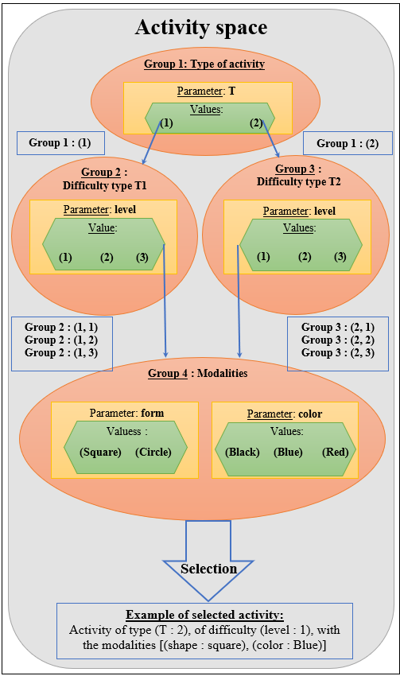
Figure 23 - Selection of an activity in the activity space

This figure is inspired by a diagram by Benjamin Clément [Clément, 2018]. It represents an example of activity selection in the activity space (gray shape) with four hierarchical groups (orange shapes). Each group has one or more parameters (yellow rectangles) which themselves have values (green shapes). The thin blue arrows show the hierarchy between the groups while the big blue arrow represents the selection process pointing to a big blue rectangle. This one is a selection possibility (an example of activity selection). The small blue rectangles on the left and right represent the possible combinations of values at the end of each group.

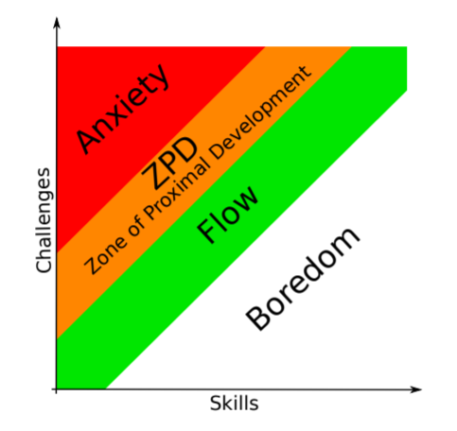
Figure 24 - Zone of proximal development and Flow.

This figure is a diagram made by Benjamin Clément (Clément, 2018). It is a graph representing the states in which a learner may be when performing an activityª. The level of difficulty is on the y-axis while the learner's skill level is represented on the x-axis.

ª"Basawapatna et al. (2013) propose the concept of Zones of Proximal Flow where they come up with the idea of the Zone of Proximal Development being located in between regions of Flow and anxiety" (Clément, 2018).

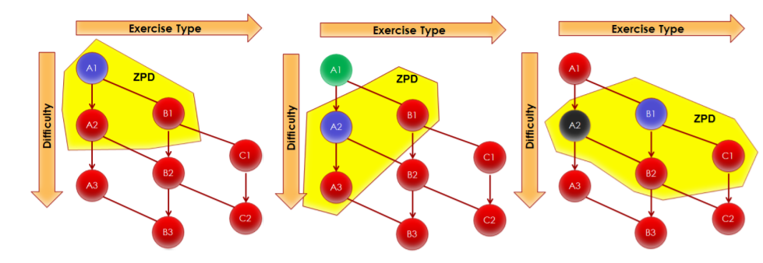
(a) (b) (c)

Figure 25 - Example of an activity graph with evolution of the zone of proximal development.

This figure is a diagram done by Benjamin Clément (Clément et al., 2015). It is an example of a breakdown of activities made by an educational expert. The activities are organized by level of difficulty and type. The zone of proximal development (ZPD) represents all the activities de l’espace d’activité pouvant être proposées pour favoriser le plus efficacement possible le progrès d’apprentissage.

https://www.inria.fr/fr/aide-nouvelle-action-exploratoire-chez-inria
https://team.inria.fr/mnemosyne/en/aide/
https://creamaker.wordpress.com/
In the context of educational activities in psychology and psychiatry, a medium (media in the plural) is what characterizes the manipulable object at the origin of learning. For example, play dough, paint, and cubes are media.
Affordances represent the potential and intuitive uses of an object.
https://flowers.inria.fr/
https://www.meirieu.com/BIOGRAPHIE/biographie.htm
https://www.meirieu.com/COURS/pedaetscienceseduc.pdf
In the Anglophone context, learning sciences began to develop in the 1980s as an interdisciplinary field (Lee, 2018).
http://ife.ens-lyon.fr/publications/edition-electronique/revue-francaise-de-pedagogie/INRP_RF043_5.pdf
https://www.associationneuroeducation.org/a-propos
According to Kant, a schema is "a process or means by which a pure concept becomes effective by the implication of an intuition".
https://fr.wikipedia.org/wiki/Connaissance_(philosophie)
Philosophy of knowledge.
Perception of one's own body.
"Altogether, this defines the sensory and motor information flows of a brain + body system, acting and learning in the external environment to satisfy some needs, expressed as internal states" (Alexandre, 2021).
https://creamaker.wordpress.com/
https://flowers.inria.fr/research/kidlearn/
From the cognitivist point of view, consciousness is divided into two forms: "On one hand, 'cognitive' consciousness, characterized by its reference ('intentionality') to 'real' or abstract objects, bringing into play languages, calculations, forms of memory and long-term exploration, associated with oriented behaviors; on the other hand, consciousness as a lived experience, a subjective experience characterized uniquely, not by an object, but by its intrinsic properties, its quality" (Delacour, 2001).
https://www.inserm.fr/dossier/memoire/
In cognitive psychology, "the span is the limited amount of information (words, numbers etc.) that can be stored in short-term memory". (Miller, 1956).
Storage capacity increases mainly between 3 and 8 years of age and then more slowly until adulthood (up to 4 or 6 items between 3 and 8 years and up to 7 items in adulthood). As for information processing, the period with the greatest evolution is between 6 and 13 years old (Tardif & Doudin, 2016).
There is the possibility that old memories are replaced by new ones. The duration of storage would then be influenced by the storage capacity in this case, but this is not proven.
to a certain extent because too violent emotional states can also have the opposite effect.
https://gerflint.fr/Base/Pologne1/types.pdf
Binding is a notion that has no equivalent French term but that can be defined. According to Violette Hoareau, "binding is a term used to describe the fact of linking different characteristics or elements in the same object. For example, if a red color and a square shape are presented on a screen, these two elements can be simply bound into a single element: a red square. The term can also define connecting different events into a single coherent episode" (Hoareau, 2018). In addition, Franck Burglen differentiates perceptual binding from memory binding. The previous definition refers to the former and is automatic, whereas the latter is not automatic and has "a cognitive cost" (Burglen, 2005) that is more or less borne according to the individual's characteristics (age or pathology, for example). It consists of the intention to memorize the association of different information. The author cites an experiment in which different individuals were asked to memorize an image grouping together three images.
https://lecerveau.mcgill.ca/flash/a/a_07/a_07_p/a_07_p_tra/a_07_p_tra.html
A syllogism is a line of reasoning involving premises (at least two) and a conclusion. A proposition (premise) relates a subject and a predicate. However, the term syllogism refers to deductive reasoning because it uses logic.
"Analogy is a core cognition process used to produce inferences as well as new ideas using previous knowledge and experience" (Han et al., 2018).
Analogy is described as the ability to perceive and use relational similarity across different contexts, which is widely regarded as a fundamental component of creativity in science and art" (Han et al., 2018)
see https://fr.wikipedia.org/wiki/Similarit%C3%A9_s%C3%A9mantique#Similarit%C3%A9_s%C3%A9mantique_vs._proximit%C3%A9_s%C3%A9mantique
In the Anglo-Saxon sense, similarity (beyond semantic similarity) is quantified as something whose value increases when the distance between the two elements decreases: see https://en.wikipedia.org/wiki/Similarity
This is what is formalized in Bayes' theorem used in decision theory: "Bayes' theorem aims to calculate the a posteriori probabilities of an event according to the a priori probabilities of this event. A priori and a posteriori are understood in relation to the cognizance of an information". http://tecfaetu.unige.ch/staf/staf-h/voisard/staf17/projet/cours/cours_4.pdf . Here we use our a priori knowledge about the frequency of colds and lung cancer.
The potentialities suggested to the learner (affordances) are dependent on his or her goals, beliefs, acquired knowledge and past experiences (Norman, 1988).
According to Arne Dietrich, creativity ex-nihilo has never been observed. Four types of creativity are distinguished, all based on mechanisms (emotional or cognitive and deliberate or spontaneous) of new combinations and selections of existing elements (Dietrich, 2004).
Functional rigidity occurs when the learner is unable to change the way he or she uses a habitual object, i.e., to bypass the automatisms of using that object.
Executive functions will be presented in section 1.3.5.
See the previous paragraph about abductive reasoning.
"Operation that consists in admitting a proposition because of its link with a previous proposition held to be true" https://www.cnrtl.fr/definition/inference
The premises correspond to the assertions that allow, through reasoning, to reach a conclusion.
Models are objects that verify these logical propositions
For example: logical terms, formulas, demonstrations, etc.
For example: set of natural integers, groups, universe, etc.
For example: meaning or truth.
More precisely, for the so-called 1st order mathematical predicates (the most used formalism) there is completeness, i.e. equivalence between a formula verified in all models and a syntactically proven formula.
https://www.youtube.com/watch?v=vSjCIsA0on0
According to Olivier Houdé, heuristics are "rapid, automated responses that impose a low cognitive cost and a low working memory load" (Houdé, 2018a).
Algorithms are "slower, more costly strategies in terms of cognitive load than heuristics, but they always lead to a good result because they rely on the rules of deductive logic" (Houdé, 2018a).
For more information: https://www.hds.utc.fr/~tdenoeux/dokuwiki/_media/en/publi/book-cepuades-test.pdf
In section 1.3.3, paragraph "Long-term memories", subparagraph "Interactions between episodic and semantic memory".
Egocentric language is also called inner language or subvocalization.
Coordination can be defined as the arrangement of the parts of a whole for a given purpose, in a mutual ordering" (Faugloire, 2007).
System in the sense of the components of the biological organism as well as those of its environment.
"The term emotion should be rightfully used to designate a collection of responses triggered from parts of the brain to the body, and from parts of the brain to other parts of the brain, using both neural and humoral routes. The end result of the collection of such responses is an emotional state, defined by changes within the body-proper, e.g., viscera, internal milieu, and within certain sectors of the brain, e.g., somatosensory cortices; neuro-transmitter nuclei in brainstem" (Damasio, 1998).
The term feeling should be used to describe the complex mental state that results from the emotional state. That mental state includes: (a) the representation of the changes that have just occurred in the body-proper and are being signaled to body-representing structures in the central nervous system (or have been implemented entirely in somatosensory structures via ‘as-if-body-loops’); and it also includes (b) a number of alterations in cognitive processing that are caused by signals secondary to brain- to-brain responses, for instance, signals from neurotransmitter nuclei towards varied sites in telencephalon" (Damasio, 1998).
An 'emotionally competent stimulus' (ECS) is detected by a filtering perceptual apparatus, among the stimuli of the environment, real or remembered by a given situation. [...] The competence of the ECS (its triggering character) is recognized as such, either innate or acquired" (Pailler, 2004).
https://www.lippc2s.fr/wp-content/uploads/2013_Tcherkassof-Mondillon_Emotion_Chapt_deBoeck.pdf
Section 1.3.4, paragraph "Reasoning and emotions".
on the cognitive processes involved and necessary to solve the task
Intrinsic interest (or intrinsic motivation) will be defined in Section 2.
In this case, these associations are implicitly formed.
Noetic feelings are also called "cognitive feelings".
"Feeling of knowing", a notion introduced by Joseph T. Harten 1965 (Hart, 1965) and cited by Didier Le Gall (Le Gall et al., 2009) in 2009.
the speed of a response predicts the correctness and coherence between the representations evoked by a question" (Houdé et al., 2018)
See section 3
https://fr.wikipedia.org/wiki/Amor%C3%A7age_(psychologie)
The author specifies his thought by giving these examples: "The behaviorist teacher will be inclined to use exercisers, quizzes, educational games and/or animations when designing and carrying out distance learning" (Chekour et al., 2015).
As a reminder, the three worlds of cognition are represented in Figure 1
Cognitive structures mobilized by a person when faced with a situation or a problem.
This may remind us of what was discussed in section 1.3.4, paragraph "From human reasoning to its modeling, where it is precisely about how to model these elements outside the learner's control.
Connectionism would be the discipline at the origin of connectivism. Here, Emmanuel Duplà referred to its modeling.
https://pixees.fr/faut-il-integrer-le-numerique-a-lecole-en-fait/
"The hypothesis of distributed cognition was formulated in a particular context where researchers in cognitive sciences were preoccupied with the design of computerized artifacts to carry out collaborative tasks. It has progressively become a research program for cognitive sciences whose objective is to widen the unit of analysis of cognitive processes. It is therefore not reduced to an analysis of interaction situations between a human agent and a computerized tool because the ambition of the program is to understand how human cognition works" (Conein, 2004).
Assimilation: the learner does not know what a switch is, he learns that the system turns on or off when he operates it. He then integrates a new knowledge concerning the switch object, by assimilation.
Accommodation: the learner knows that a switch is used to turn on a light, he learns that the switch allows the vehicle to be started. The learner then proceeds to an accommodation, an update of his knowledge on the switch object.
See section 2.1.3
Overall, the Learning Mechanics and Game Mechanics (LMGM) model aims at providing a concise means to relate pedagogy intentions and ludic elements within a player’s actions and gameplay" (Romero et al., 2018).
According to Köhler, the English term insight is derived from the German term Einsicht. The Office québécois de la langue française relates it to the French term "intuition". https://fr.wikipedia.org/wiki/Insight_(psychologie_cognitive)
"Problems requiring specific knowledge would be, for example, physics or mathematics exercises. Problems not requiring specific knowledge are problems like the Tower of Hanoi or the dehorned chessboard problem" (Lemaire and Didierjean, 2018).
“Reflection is the cognitive process that is engaged when faced with a situation and that remains limited to the analysis of the latter" (Vacher, 2011). It aims at rationalizing the perception of a situation. Reflection should not be confused with reflexivity ("reflexivity encompasses reflection, it is both reflection on the situation and reflection on reflection" (Vacher, 2011)) or with reasoning (See section 1.3.4).
This structuring has influenced different cognitive architectures discussed by Antonio Lieto (Lieto, 2021; Lieto et al., 2018) but will not be discussed here.
We are talking here about analogy: "analogy is a heuristic that looks for similarities between a problem to be solved and a problem solved in the past" (Lemaire and Didierjean, 2018).
"A heuristic is a rule of unsystematic actions or a general strategy that can lead to an answer (correct or not) quite quickly" (Lemaire and Didierjean, 2018).
“An algorithm is a rule or sequence of actions that, if applied correctly, necessarily results in a correct answer" (Lemaire and Didierjean, 2018).
"The search in the problem space can implement two algorithms: a random search or a systematic search" (Lemaire and Didierjean, 2018).
In Karl Duncker's candle problem https://en.wikipedia.org/wiki/Candle_problem, an object must be used in an unconventional way to solve a seemingly insoluble problem.
It will be an intermediate step leading to the goal state.
That is, goals should be set so that their difficulty increases with each positive feedback.
Catherine Garnier defines the concept of representation as "a mental phenomenon that corresponds to a more or less conscious, organized and coherent set of cognitive, affective and value-related elements concerning a particular object. It includes conceptual elements, attitudes, values, mental images, connotations, associations, etc. It is a symbolic universe, culturally determined, where spontaneous theories, opinions, prejudices, action decisions, etc. are forged" (Garnier and Sauvé, 1999).
Emotions, their classification, their level of intensity as well as their mechanisms were discussed in section 1.3.7. In particular, their impact on cognitive processes, decision making and learning in which motivation is involved is discussed.
What he thinks others think of him.
From the Latin moveo meaning to move
Which can take many forms.
"Volition theories rely on the concept of will⁹⁵ which is a form of motivation that explains why the individual maintains his action over time to achieve one or more goals
To explain the persistence of action; self-determination theory believes that the self seeks to satisfy its basic needs" (Fenouillet, 2016).
These twelve categories will not be defined here. Some of these concepts have been discussed and defined in the previous sections and others will be discussed in more detail later in this work (such as goal-directed motivation or curiosity).
The goal can also refer to the anticipation of the final state. It is then a goal in the sense of a motive.
“Probability that a given level of effort will produce a certain level of performance. [...] The term instrumentality [qualifies] a second-level expectation that establishes the probability that a level of performance will produce a given outcome" (Fenouillet, 2016).
Here, expectation is used as a synonym for "self-efficacy". It is defined as "an individual's belief in his or her ability to organize and execute the course of action required to produce desired outcomes" (Fenouillet, 2016). The impact on value is no longer considered in the relationship between expectation and the probability of an outcome occurring.
"Outcome expectation is subject to beliefs of control [...] This belief of control specifies the extent to which the self can produce desired events or prevent undesired events" (Fenouillet, 2016).
It is here a subjective component of the prediction that is considered. It is a prediction that is not based on objective probabilities but on beliefs derived from past experiences.
It is necessary to differentiate the pre-decisional phase from the post-decisional phases. It is during the first that "the individual deliberates on the different motivations that push him to act" (Fenouillet, 2016). During the post-decisional phases "the individual's reflection is no longer to know why he acts but how to do it. In other words, once the individual has taken the decision to engage in action, he no longer questions the motivation that led him to the action. He is committed" (Fenouillet, 2016). The notion of persistence and prolongation in the activity have a central place in the concept of commitment.
“The principle of decision [...] seems to be based on an evaluation of costs and benefits that can take multiple forms [...]. This evaluation can be understood as a calculation, which supposes that Man is a rational being" (Fenouillet, 2016). This is based in particular on human reasoning.
“Cognitive strategies are plans, generally explicit means, that an individual implements to achieve an end" [Fenouillet, 2016]. They are implemented when effort alone is not enough to achieve a performance.
Emotional strategies "are plans or means, more or less explicit to the individual, implemented to manage emotions in general and anxiety in particular" (Fenouillet, 2016).
“Measuring student motivation solely on academic performance, for example, may suggest that the student is not motivated if performance is not increasing when it may only be the effect of behavior on performance that is not visible" (Fenouillet,2016).
https://en.wikipedia.org/wiki/Belief/T1/textendash%20desire/T1/textendash%20intention_software_model
This work was carried out within the FLOWERS team and will be discussed in detail in section 3.
Term behind the name of the FLOWERS team.
The team https://flowers.inria.fr/
https://www.inria.fr/fr/aide-nouvelle-action-exploratoire-chez-inria
https://team.inria.fr/mnemosyne/en/aide/
https://creamaker.wordpress.com/
Extrinsic motivation driven by stimuli and/or goals and intrinsic motivation driven by curiosity.
Intrinsic motivation is defined in section 2.2.3. It differs from extrinsic motivation (defined in section 2.2.2).
The theory of flow was presented in detail in section 2.2.3.
That is, the degree of similarity or distance between the perceived stimulus and the internal representations present in memory: "approach or avoidance of novelty would depend on the degree of novelty, ie, the degree of distance/similarity between the perceived stimuli and existing internal representations in the brain" (Oudeyer et al., 2016).
"This hypothesis proposes that the brain, seen as a predictive machine constantly trying to anticipate what will happen next, is intrinsically motivated to pursue activities in which predictions are improving, i.e., where uncertainty is decreasing and learning is actually happening" (Oudeyer et al.,2016).
"This means that the organism loses interest in activities that are too easy or too difficult to predict (ie, where uncertainty is low or where uncertainty is high but not reducible) and focuses specifically on learnable activities that are just beyond its current predictive capacities" (Oudeyer et al., 2016).
"The brain would be motivated to search for (intermediate) novelty or complexity, and then when finding it would be in a curiosity state that would foster learning and memory retention" (Oudeyer et al., 2016).
"Multiple paradigms have been devoted to the study of exploration and have used a common definition of this process as the choice of actions with the goal of obtaining information. Although exploratory actions can involve physical acts, they are distinct from other motor acts in that their primary goal is not to exert force on the world, but to alter the observer’s epistemic state. For instance, when we turn to look at a new storefront, the goal of the orienting action is not to affect a change in the external world (as we would, for instance, when we reach for and grasp an apple). Instead, the goal is to obtain information" (Gottlieb et al., 2013).
Literally, "Intelligent Tutoring Systems".
Intelligent Tutoring Systems (ITS) have been proposed to make education more accessible,more effective and simultaneously as a way to provide useful objective metrics on learning" (Clément et al., 2014a).
"A cognitive model that defines the domain knowledge or which steps need to be made to solve problems in a particular domain" (Clémentet al., 2014a).
"A student model that considers how students learn, what is the evolution of their cognitive state depending on particular teaching activities" (Clémentet al., 2014a).
"A tutoring model that defines, based on the cognitive and the student model, what teaching activities to present to students" (Clémentet al., 2014a).
"A user interface model that represents how the interaction with the students occurs and how problems are proposed to the learners" (Clémentet al., 2014a).
Both of these models require too much data on the learner and the activities to be feasible for a class of students for example. They take into account the particularities and difficulties of each learner. The analysis of these particularities must make it possible to identify which activity will bring the maximum level of learning progress. This implies taking individual responsibility for each learner.
"The technical challenge is that these experiments must be sufficiently informative about the student’s current competence level and also to estimate the effectiveness of each exercise to improve those competences (a form of stealth assessment). This boils down to what has been called the “exploration/exploitation” trade-off in machine learning, where we have to simultaneously try new activities to know which ones are the best, but also select the best ones so that the student actually learns" (Clément et al., 2014a).
This formalism will be discussed below.
"We will rely on methods that do not make any specific assumptions about how students learn and only require information about the estimated learning progress of each activity. We make a simple assumption that activities that are currently estimated to provide a good learning gain, must be selected more often. A very efficient and well studied formalism for these kinds of problems is Multi-Armed Bandits" (Clément et al., 2014a).
This was discussed in section 3.1 and corresponds to the intrinsic motivation of the learner when faced with an activity that is neither too easy nor too difficult but just beyond his or her capabilities, as presented in the learning progress theory.
See section 3.1.
The right activity at the right time.
This notion refers to elementary competences involving cognizances and know-how, which are called knowledge components by the authors. It is characterized by the term "composantes de compétence" in the document in French
“The first one is RiARiT, which explicitly estimates the level of the student’s proficiency for different KCs to base its choice of activities" (Clément, 2018).
Zone of proximal development and empirical success.
"The second is ZPDES, which uses a “graph” of activities and tracks progress to choose the next activity; it does not use a student model based on KCs" (Clément, 2018).
"A pedagogical Activity Space is considered to be a set of activities that a learner can practice to acquire skills or knowledge components" (Clément, 2018).
"Bandit manchot" algorithm is used in particular to choose the slot machine which will maximize the player's winnings according to probabilities.
Multi-Armed Bandits is a set of different techniques but based on the same principle. As the details of these techniques will not be discussed in this work, the term "Multi-Armed Bandit algorithm" will be used in order to simplify the discussion.
Exponential weights for exploration and exploitation.
The notion of random choice is important in the difference between exploitation and exploration. Exploration is based more on random choice than exploitation, which is based more on the use of prior knowledge.
http://www.math.univ-toulouse.fr/~jlouedec/demoBandits.html
https://fr.wikipedia.org/wiki/Bandit_manchot_(math%C3%A9matiques)
https://hal.inria.fr/tel-01420663v1/document
As a reminder: "theories of intrinsic motivation clearly suggest motivation and learning improve if exercises are proposed at levels that are only slightly higher than the current level" (Clément et al., 2015).
Assigning rewards based on the match between the prediction and the outcome.
"Our approaches assume that an instructional expert defines a set of skills to acquire, a set of potential activities/exercises to practice and, if necessary, coarse constraints on the pedagogical sequence" (Clément et al., 2015).
See section 3.2.3.
Estimates are based on observation of the learner's success or failure in previous activities.
"Our first approach uses very little knowledge about the problem and is inspired by the zone of proximal development and the empirical estimation of learning progress hence the name “Zone of Proximal Development and Empirical Success” (ZPDES)" (Clément et al., 2015).
"Our second approach further assumes the existence of a simple relation between the activities and the skills. Then, at any given point in time, the system estimates the learning progress obtained for each activity by the student. The system then proposes to the student the activities which provide a higher learning progress, hence the name of the algorithm : the “Right Activity at the Right Time”(RiARiT)" (Clément et al., 2015).
“These parameters and their respective values define all the possible activities that can be instantiated inside the activity space" (Clément, 2018).
"Depending on their nature and meaning, these parameters can be organized in different groups.[...] In addition, these parameter groups can be structured hierarchically, since some parameters depend on others to be used in an activity" (Clément, 2018).
"An activity space groups all possible distinct combinations of parameter values that can define an activity in this space" (Clément, 2018).
"The exploration-exploitation trade-off is a fundamental dilemma whenever you learn about the world by trying things out. The dilemma is between choosing what you know and getting something close to what you expect (“exploitation”) and choosing something you aren’t sure about and possibly learning more (“exploration”)" (Clément, 2018).
“A particularity here is the reward (learning progress) which is non-stationary. This requires specific mechanisms to track its evolution. Indeed, a given activity will stop providing a reward, or learning progress, after the student reaches a certain mastery level of the skill or of the activity" (Clément, 2018).
The general term "expert" is borrowed from Cesa-Bianchi et al (1997). They use it to refer to the strategies used in "expert-advised prediction" algorithms, "combining the predictions of several prediction strategies." (Clement, 2018).
"Thus, the framework introduced here rely on a variant of the EXP4 algorithm, proposed initially by (Auer et al., 2003), which considers a set of experts and make a choice based on the proposals of each expert. In case presented here, the experts are a set of variables that track how much reward each activity is providing (Lopes and Oudeyer, 2012). These bandit experts are used to evaluate the quality of each activity parameter value during the learner’s working session" (Clément, 2018).
See section 3.2.3, paragraph “Activity Space” and figure 23.
"Inspired by the Zone of Proximal Development theory (Vygotsky, 1930-1934/1978) and the concept of Flow (M. Csikszentmihalyi and I. Csikszentmihalyi, 1975), a pedagogical expert has the possibility to specify rules that define an evolving set of possible/activated activities, judged relevant for the student. These activities keep the student in the zone of Flow or in the Zone of Proximal Development (ZPD) based on his successive results'' (Clément, 2018).
"The use of the ZPD offers three advantages : it helps to improve motivation as discussed before, it further reduces the need of quantitative metrics for the educational design expert and it provides a more predictive choice of activities" (Clément, 2018).
"Two sources of inspiration are used to simplify the algorithm [RiARiT]: Zone of Proximal Development (C. D. Lee, 2005) and the empirical estimation of learning progress (Oudeyer and Kaplan, 2007)" (Clément, 2018).
It is the activities closest to the activity performed that constitute the zone of proximal development in order to offer slightly more difficult activities to promote learning progression.
Since it is reinforcement-based machine learning, it adapts its predictions according to the level of reward it receives.
"It is strongly informed about the activities domain and the student. This information will be used to build a cognitive model of the student by estimating the knowledge level of the learner depending on his answer to each activity and the definition of a set of Knowledge Component (KC) related to each activity" (Clément, 2018).
"The q-values notion take its inspiration from the work of Barnes (2005) where she defines a Q-matrix or “attribute by item incidence matrix” to define relations between questions (activities in our case) and concepts (KCs in our case) and contains a one if a question is related to a concept and a zero if not" (Clément, 2018).
"Here the evolution of the ZPD can rely on explicit values of the estimated competence level of the learner. Thus, the expert can specify minimal competence levels in given KC that are required to allow the algorithm to try a given parameter values and activate its related bandit expert. Each parameter value is only explored if the learner is already above this minimum threshold. The teaching experts are allowed to define a threshold for which a given parameter is removed from the exploration, its bandit expert is deactivated" (Clément, 2018).
"This follows well known instructional design methodologies (Gagne and Briggs, 1974) and concords with theories of intrinsic motivation which clearly suggest motivation and learning improve if exercises are proposed at levels that are only slightly higher than the current level (Engeser and Rheinberg, 2008 ; Habgood and Ainsworth, 2011)" (Clément, 2018).
“RiARiT algorithm uses a lot of information about the domain. The teaching expert defines tables with the relation between the parameter values and the KC, and also a set of minimum competence levels to activate a new parameter value. The relation between the success of an exercise, the estimated competence level and the required competence level of an exercise allows two things : a) to estimate the level of the student ; and b) to compute a reward for that activity" (Clément, 2018).
"The information required for this algorithm is more online than a lot of other ITS systems but this amount of information might be really difficult to give for a teaching expert when the number of activities, or KC, is high. Automatic methods to fill such knowledge already exist and is an area of active research (Baker et al., 2008; Dhanani et al., 2014; González-Brenes, Huang, et al., 2014; González-Brenes and Mostow, 2012)" (Clément, 2018).

